07 September
2011

08
Fall

Eric Persson, FourStar PI
Andy Monson, FourStar Post-Doc
David Murphy, Computer System Management
Christoph Birk, Data Acquisition Programmer
- Dan Kelson, Data Reduction Specialist

FourStar Manual

Table of Contents
1 FourStar Overall Description 7
1.1 Optics 8
1.2 Vessel Sections 9
1.3 Detectors and ASICs 10
1.4 Dewars 10
1.5 Focal Plane Mechanisms 10
1.6 Filter and Field Flattener Wheels' Location 11
1.7 Pupil Mechanism 11
1.8 Carts 11
1.9 Data / Control System 11
1.10 Internal Temperatures 12
1.11 External Temperatures 12
1.12 Vessel Vacuum 12
1.13 Liquid Nitrogen Levels 12
1.14 Data Processing 12
2 FourStar Imaging Parameters 13
2.1 Detector Details 13
2.2 Camera Details 15
3 Observing Cookbook 17
3.1 Suggested things to bring 17
3.2 Control Room Computers 18
3.3 Target List 19
3.3.1 Moving to an object in the Target list 20
3.4 Placing the Target in the Right Spot 21
3.5 Taking an Image 26
3.5.1 Fourstar package in IRAF 26
3.5.1.1 FSCOM 26
3.5.1.2 FSMOS 26
3.6 Recommended Strategies and Procedures 27
3.6.1 Dome Flats 28
3.7 Data Transfer 30
3.7.1 Focus Corrections 31
4 Instrument Specialist's Cookbook 32
4.1 Starting the System 32
4.1.1 Powering Up FourStar 32
4.1.1.1 At the FourStar Equipment Room Rack 32
4.1.1.2 On the Nasmyth Platform 32
4.1.2 Interfacing with FourStar 34
4.1.2.1 Control Room, Connecting through VNC 34
4.1.2.2 Starting the FourStar Software 35
4.1.2.3 Organizing FourStar Windows. 36
4.1.2.4 Summary of FourStar’s Critical Systems 37
4.1.2.5 Web Monitoring 38
4.2 Observing Run Preparation 38
4.2.1 Set Data Path 39
4.2.2 Start IRAF/DS9 39
4.3 Observing Run Preparation Checklist 40
4.4 Observing Run Completion Checklist 41
4.5 Routine FourStar Maintainence 42
4.5.1 Window Inspection/start of every observing run 42
4.5.2 Autofill system inspection/start of every observing run 43
4.5.3 Manual dewar filling/twice a week 43
4.5.4 Measure Read Noise 44
4.6 Reduction Pipeline 45
4.7 Shutting down the System 47
4.7.1 Shutting down on the Nasmyth Platform 47
4.7.2 Shutting down the FourStar Computer System 48
4.8 FourStar Shutdown Checklist 50
5 TROUBLESHOOTING 51
5.1 FourStar Error Messages and Minor Problems 51
5.1.1 VNC Screen Sharing slows to a crawl 51
5.1.2 A FourStar message box appears with a motor warning 51
5.1.3 The motors do not appear to be responding 51
5.1.4 Pupil Position reads “?” on startup 51
5.1.5 Read noise is higher than expected 51
5.1.6 Camera Control GUI inaccessible after starting FourStar software 51
5.2 Electronics Rack 1 & 2 Failures 54
5.2.1 General Considerations 54
5.2.2 A Data Acquisition PC fails (Rack 1 or 2) 54
5.2.3 Loss of the Motor Controller Unit (Rack 1) 55
5.2.4 Loss of the Process Controller Unit (Rack 2) 56
5.2.5 Loss of the KVM Switch (Rack 2) 56
5.2.6 Loss of a LakeShore 340 Temperature Controller (Rack 1 or 2) 56
5.2.7 Electronics Rack Overheats (Rack 1 or 2) 57
5.2.8 Other Items (Rack 1 or 2) 57
5.2.9 How to swap out an Item in an Electronics Rack 57
5.3 Control Room or Equipment Room Failures 59
5.3.1 General Considerations 59
5.3.2 The Mac Mini in the control room fails (Control Room) 59
5.3.3 The Control-Room-Mac fails (Equipment Room) 59
5.3.4 A Data-Red-Mac’s fails (Equipment Room) 60
5.3.5 Loss of an Individual RAID Drive Disk Drive Unit (Equipment Room) 60
5.3.6 Loss of a Promise RAID Drive Controller (Equipment Room) 60
5.3.7 Loss of a Promise RAID Drive Power Supply (Equipment Room) 61
5.3.8 Loss of the Brocade Fibre Channel Switch (Equipment Room) 61
5.3.9 Loss of a Netgear GS716T Ethernet Switch (Equipment Room) 61
5.4 Appropriate Response to FourStar Email Alerts 62
5.4.1 FourStar WARNING: Optics-Heater-Power low (XX W) 62
5.4.2 FourStar WARNING: Shroud-Dewar temperature high (XX K) 62
5.4.3 FourStar WARNING: last shroud dewar fill more than XX hours ago 62
5.4.4 FourStar WARNING: LN2-solenoid open for XX minutes 62
5.4.5 FourStar WARNING: LN2-solenoid closed for XX hours 62
5.4.6 FourStar WARNING: Dewar pressure high (XX Torr) 62
5.4.7 FourStar WARNING: LN2-Level(Shroud) is at XX% 62
5.4.8 FourStar WARNING: Detector-Heater-Power low (XX W) 62
5.4.9 FourStar WARNING: LN2-Level(Detector) is at XX% 62
5.4.10 FourStar WARNING: LN2-Processor Alarm/Error 62
5.4.11 FourStar WARNING: E-rack temperature is XX [C] 62
6 APPENDIX 63
6.1 FourStar Software Interface 63
6.1.1 FourStar Setup Descriptions 63
6.1.1.1 Observer Fits Header Keyword 64
6.1.1.2 Change the FourStar Startup Preferences 65
6.1.1.3 Use an Alternate Control Temperature Sensor 65
6.1.2 FourStar Control GUI Description 65
6.1.2.1 Quicklook and Magnifier Display 66
6.1.2.2 Show Motors 68
6.1.2.3 Show H2RG 70
6.1.3 Telescope-Control 70
6.1.4 Temperature Monitors 71
6.1.5 Temperature Controllers 74
6.1.6 LN2 & Sensors 76
6.2 Software / Computer How To’s 77
6.2.1 Accessing the Array Servers Remotely 77
6.2.1.1 KVM Access on the Nasmyth Platform 77
6.2.1.2 VNC to Windows Computers 1-4 78
6.2.1.3 LAN Access to the KVM Switch Using a Web Client 78
6.2.2 View the array parameters, filter wheel contents and combinations 79
6.2.3 View the FourStar log using the Console Application 79
6.2.4 Booting and Rebooting the FourStar Computers 79
6.2.5 Format an External USB Storage Device 80
6.2.6 Use the Camera Simulator Mode for Diagnostics 81
6.2.7 Cloning an Array Server System 82
6.3 Hardware / Mechanical How To’s 84
6.3.1 Focusing across the array (FakeStar in the Lab) 84
6.3.2 Thermal Cycling the Instrument 84
6.3.2.1 Cooling Down 84
6.3.2.2 Warming Up 85
6.3.3 Getting FourStar on the Nasmyth Platform 85
6.3.4 How to Attach FourStar to the Instrument De-rotatator 86
6.3.5 How to Remove FourStar from the Instrument De-rotator 87
6.3.6 Pumping using the main Vaccum Port 87
6.3.7 Use the FourStar TurboPump Cart 88
6.3.7.1 Main Control 88
6.3.7.2 Power Trip Box 89
6.3.8 Synchronization Cable 90
6.4 Network General Overview and Architecture 91
6.4.1 Introduction 91
6.4.2 Physical Distribution of Components 93
6.4.3 System Network Topology 95
6.4.4 Telescope Fiber Optic Cabling 101
6.5 FourStar Motor Controller 104
6.5.1 Overview 104
6.5.2 Description of the Four Star Motion Control Hardware 104
6.5.3 Overview of the FSMC 107
6.5.4 FSMC Front Panel Description 108
6.5.5 FSMC Rear Panel Description 109
6.6 Process Controller 110
6.6.1 Using the Ion Pump 110
6.6.2 Procedure for changing out the Ion Pump 110
6.6.3 Process Controller Menu Screens 112
6.6.4 LN2 SystemHost Commands 118
6.6.5 LN2 System Status Register 121
6.7 Temperature Controller 122
6.8 Reference Pixel Subtraction 123
6.9 Spare parts list 124
6.10 FourStar Cart 1 Drawer Contents 126
6.11 Array Electronics Device Signal Chain 126
6.12 Location of FourStar Documents 126
6.13 FourStar Contact Information 126
6.14 Glossary 126
6.15 FourStar Macros 126
6.15.1 Using default macros 126
6.15.2 How to Create or select a custom macro 126
6.15.2.1 Macro Commands 126
6.15.2.2 Example macro: rot5_26c 126
6.15.2.3 Example macro: dif2 126
6.15.2.4 Example macro: custom 126
6.15.3 Read-Out Schemes 126

FourStar Overall Description
FourStar is the wide-area near infrared camera for the 6.5 m Baade telescope. It has four HAWAII-2RG 2048x2048 detectors for a total of 16 mega-pixels; each pixel subtends 0.159" on the sky and the total field is 10.8x10.8 arc-minutes. Ten filter positions are available (and are filled). The data acquisition system allows the reduction of incoming data in quasi-real time. The goal is to have the data completely reduced during the morning after a night's observing. Observing scripts allow the automatic acquisition of data. The following sections provide brief descriptions of the insides of the instrument. The Critical Design Review notebook contains a complete description of the instrument.

Optics
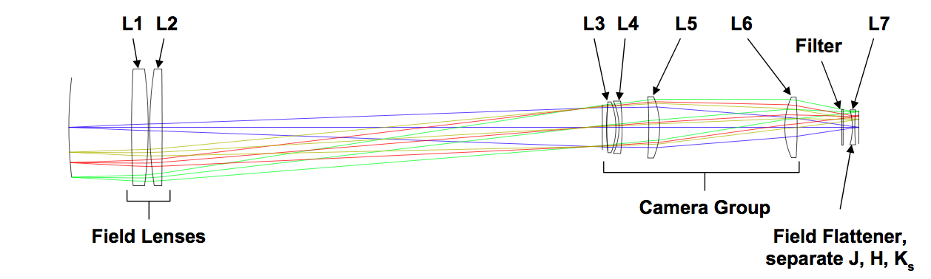
Figure 1.1 Optical Layout of FourStar.
The optics consist of seven lenses L1 - L7 as shown in Figure 1.1. L1 is the dewar window. It and L2 focus the telescope entrance pupil onto a cold stop just in front of L3. L3 - L6 comprise the "camera", which focuses the beam onto the detectors at the desired f-ratio of f/3.6. The camera module (barrel, lens mount, and lenses) is held at a temperature of 200K. L7 is the field flattener; there is one version of L7 for each of the J, H, and K atmospheric windows. The filter wheels are just ahead of L7.

Vessel Sections
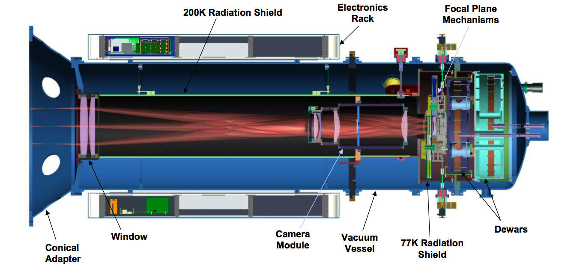
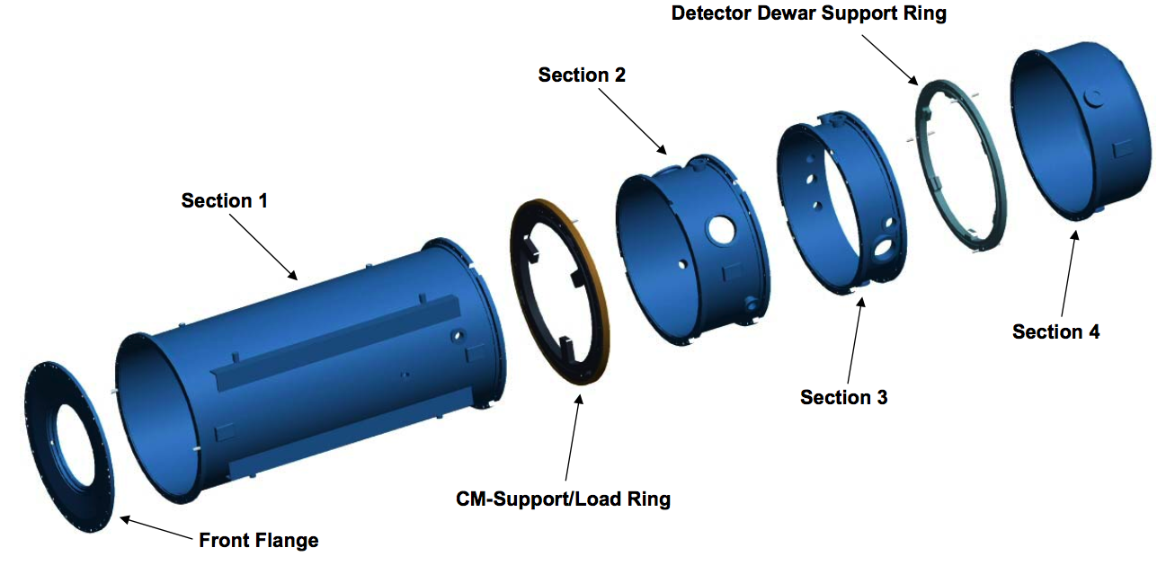

Figure 1.2 Top: A cross-section of the FourStar camera, bottom: An exploded view showing the sections of FourStar.
Figure 1.2 shows a cross-sectional view of the instrument with light entering from the left. There are four vacuum vessel sections that house the optics, mechanisms, detectors, and various sensors. Section 1 is the longest section starting at the front flange and ending at the load ring. Section 2 allows access to three internal thermal transfer clamps and has the front-end electronic connectors. Section 3 is at the focal plane, and Section 4 has the liquid nitrogen dewars and fill ports.

Detectors and ASICs
There are four Teledyne H2-RG 2048x2048 detectors in a close-pack configuration. The pixels are 18 microns across. They are mounted in a detector module that is mechanically and thermally anchored to the detector dewar work surface (cold plate). Accompanying each detector is a "Sidecar" application-specific integrated circuit (ASIC) that digitizes the analog signals from the detector. The (cold) ASICs are connected to four (ambient temperature) "JADE2" cards, which communicate with the data acquisition (Windows PC) computers via USB2 (or optionally through fiber-optic transmitter/receiver pairs).

Dewars
There are two dewars: the shroud dewar and the detector dewar. Both contain liquid nitrogen (LN2). The shroud dewar is centered on the rotation axis and is filled automatically once every 14-16 hours. The detector dewar is offset and must be filled manually about twice a week. The function of the shroud dewar is to cool a radiation shield that extends up to the front window on section 1.

Focal Plane Mechanisms
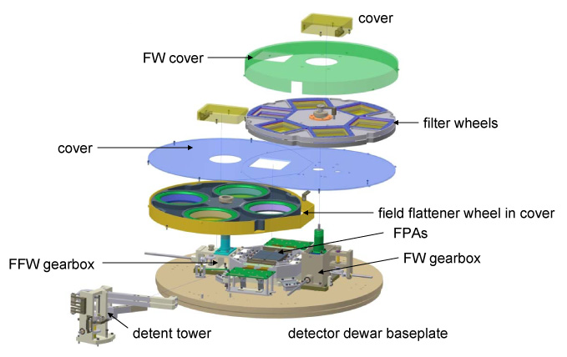
Figure 1.3 The Focal Plane Meachanisms.
The focal plane mechanisms can be examined in detail by referring to Figure 1.3. After passing through L6, the light first encounters the top or upper filter wheel (FWt). It and the bottom filter wheel (FWb) are each mounted on a gearbox (FW gearbox). Each wheel has six positions for a total of 10 positions (an open position in each). The three (JHKs) L7 lenses are mounted in the field flattener wheel (FFW), which in turn is mounted on its own gearbox (FFW gearbox). Each of the three wheels uses a spring loaded bearing on a detent arm, mounted on the detent tower, which mechanically locks each wheel at each position. The three wheels are housed in covers that serve to protect the focal plane from seeing stray light. The last major mechanism is the detector module, which holds the four detectors (FPA’s).
Figure 1.3, which can be found online at: http://obs.carnegiescience.edu/instrumentation/FourStar/MECHANICAL/ekoch/4star/index.html
can be navigated through to show detailed information about the various parts that comprise the focal plane mechanisms.

Filter and Field Flattener Wheels' Location
The drive motors for the three wheels are located external to vessel Section 3. Each has an encoder attached to the motor. Home position micro-switches are located inside the instrument; these cross check the encoder indicators. Micro-switches also encode whether or not a detent arm has fallen into place, i.e., whether a wheel is in a valid position.

Pupil Mechanism
This mechanism is located just ahead of L3 at the image of the entrance pupil. It is an iris diaphragm, which is opened wide for observations at J or H, and closed down to a specific diameter for Ks. The drive motor is located outside vessel section 1 and its encoder is attached to the iris itself.

Carts
There are two carts: Cart 1 transfers most of the weight of the instrument from the load ring through to the Nasmyth platform. As the instrument rotates at Nasmyth, the instrument load ring rolls on the two rollers of Cart 1. Cart 2 is for working on the back end (Sections 3 and 4) in the lab, when it is detached from the Sections 1 and 2. It is not used during observing.

Data / Control System
The primary purpose of the data system is to acquire image data. The function of the control system is to monitor several indicators of the status of the instrument, to effect changes in the positions of the three wheels, and to control the flow of liquid nitrogen into the outer dewar. The control system also communicates with the telescope control system so that data can be acquired automatically. All of the control system electronics, apart from the control computer itself, are located in the two black racks that are mounted on vessel Section 1. Communication between instrument control computer and the electronics is via optical fiber.

Internal Temperatures
Sixteen diodes monitor the internal temperatures of the instrument. These are placed on the two dewars, the detector module, the radiation shield, and the camera module. Two of the sixteen sensors are used in feedback loops with heater resistors to precisely control the temperatures of the camera module (200K) and the detectors (80K). The control is effected via two Lakeshore model 340 temperature controllers, operated by a "meta-controller" system running on the instrument's control computer.

External Temperatures
The temperatures of the vessel sections are measured via six thermistors. These are placed at strategic locations on the four vessel sections. The resistances of the thermistors are converted to temperatures in the "process controller", which has several other functions. The temperatures are used with a model to apply focus offsets to the telescope to correct for thermal variations of the length of the instrument. There are also four thermistors located within the enclosed electronics racks; these ensure that the racks do not overheat.

Vessel Vacuum
A Pfeiffer vacuum gauge monitors the dewar pressure. The gauge is mounted on the vessel and its analog signal is processed by the Process Controller. A Varian ion pump is attached to the vessel; it helps the internal getter (cryo sorption pump) maintain an acceptable vacuum.

Liquid Nitrogen Levels
Capacitors sensitive to the level of LN2 are mounted inside each dewar. A circuit within the process controller returns a digital indication of the levels of LN2. A feedback circuit activates the fill solenoid for the shroud dewar enabling it to fill automatically.

Data Processing
The philosophy of the data reduction system is to provide information to the observer in two forms. A ‘quicklook’ reduction runs contemporaneously with data acquisition and can be queried at any time to monitor the progress of a given set of exposures. A more extensive reduction package can be run in quasi-real time; the goal is to provide completely reduced data during the day following a given night's observing. Raw data can be recorded for reduction at a later time, if desired.

FourStar Imaging Parameters

Detector Details
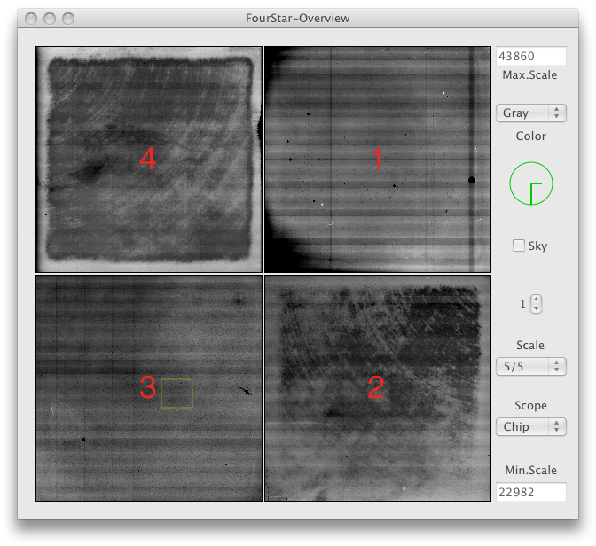
Figure 2.1 A reset picture showing the intrinsic structure of each array.
Each array in FourStar has an intrinisic reset pattern that uniquely itentifies it, as seen in Figure 2.1. These global features disappear in normal exposure sequences except for bad pixels, which are masked during reduction. The images have been constructed to have the same orientation on the sky, which is indicated in the Figure.

Table 2-1 FourStar array parameters. The gain and read noise for each array are shown for the two normal modes of operation.
 | Array ID  Serial Number | Array #1 SN192 | Array #2 SN204 | Array #3 SN209 | Array #4 SN216
 | Well Depth | 155,000 e- | 143,000 e- | 143,000 e- | 136,000 e-
FullWell  Mode | Gain (e-/ADU) | 2.65 | 2.59 | 2.51 | 2.49
 | Read Noise (e-) | 25.5 | 22.1 | 20.5 | 18.9
LowNoise  Mode | Gain (e-/ADU) | 1.38 | 1.35 | 1.30 | 1.29
 | Read Noise (e-) | 19.4 | 16.7 | 16.2 | 15.1

- Dark/patterns: The dark count rate is ~0.3 electrons/sec.
- Dead and hot pixels: Numerous dead and hot pixels are scattered across all 4 detectors; these are masked out in the reduction.
- Minimum Exposure time: 1.456 seconds.

Read out modes: Correlated Double Sample (CDS or Double) is the normal mode for high background observations. Fowler sampling can also be used; as an example, N = 16 endpoints (Multi-16) will reduce the effective readnoise from 15 to 6 electrons rms. The penalty paid for using this mode is that the total elapsed time for an exposure will be increased by N*1.456 seconds.

Gain: There are two modes: high background (FullWell) and low noise. For the broad-band and medium-band H filters the FullWell mode (~2.5 e-/ADU) is used. For narrow-band filters where the background count rate is low, the LoNoise mode (~1.3 e-/ADU) is used.

Linearity and saturation: Like any array, these arrays are not perfectly linear. The raw data are linearity corrected, pixel by pixel, using a polynomial correction in the form: Y_{T} = Y_{R}(1+AY_{R}+BY_{R}²+CY_{R}³), where Y_{T} are the true counts, Y_{R} are the raw counts and [A, B, C] are the non-linear coefficients. The linearity correction can be seen for each array in Figure 2.2 which shows the polynomial recovers linearity to better than 0.5%. Saturation levels occur at a lower number of ADU in the LoNoise mode. Exposures should be adjusted so that total counts (object plus sky) do not exceed 35,000 ADU in the low-noise mode. For the FullWell gain mode the exposures should not exceed 50,000 ADU. .

Temperature stabilization: The detectors are temperature stabilized to 80 K.
Crosstalk: Currently there is no noticeable crosstalk.
Image Persistence: Currently there is no substaintial image persistence; less then 0.5%

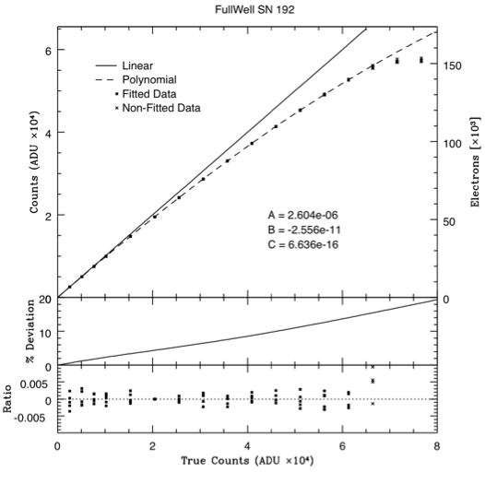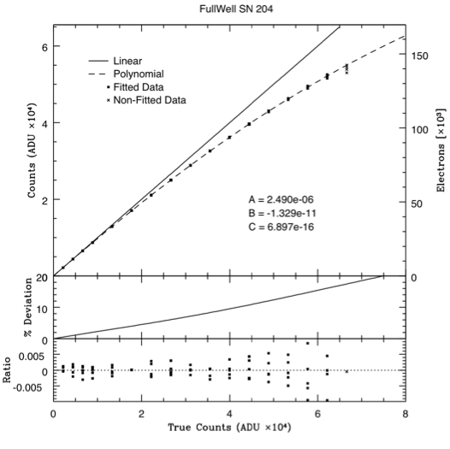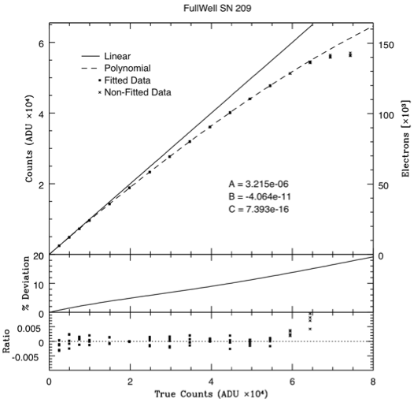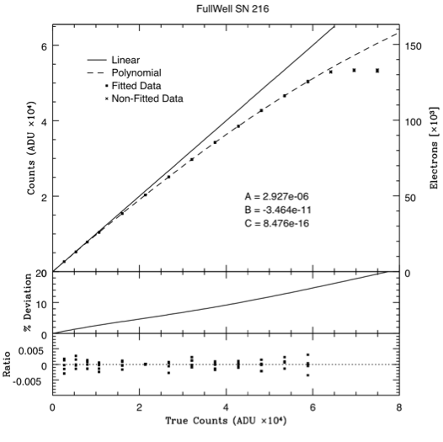

Figure 2.2 FullWell Mode linearity curves for the FourStar arrays

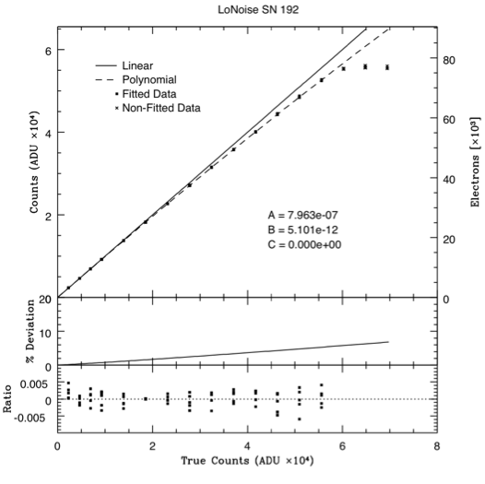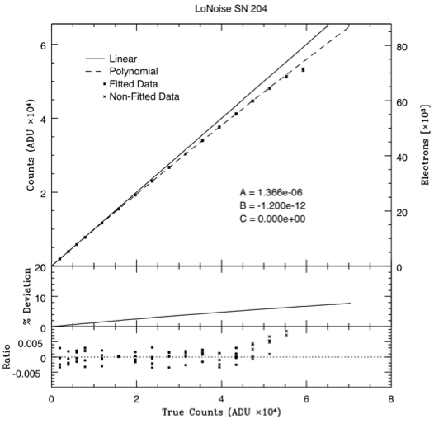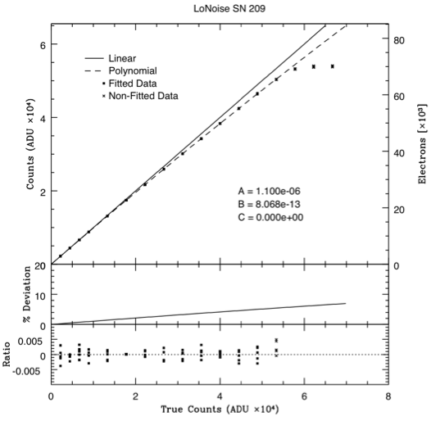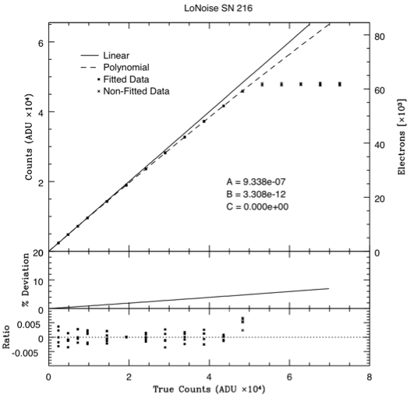

Figure 2.3 LowNoise Mode linearity curves for the FourStar arrays

Camera Details
Sky format and scale: 4096 x 4096 pixels at 0.159 arcsec/pixel; Field of view is 10.8 x 10.8 arcminutes. Due to the reference pixels, the detectors are acually 2040x2040 pixels; see 6.8. The gaps between the detectors are ~2 mm or ~18 arcsec. Account of this should be taken when planning dither sequences.

Filters: There are eight available: J, H, Ks, J1, J2, J3, Hshort, and Hlong. The passband shapes are available at http://obs.carnegiescience.edu/instrumentation/FourStar/OPTICS/filters.html and include all but atmosperic, telescopic and QE transmittance.
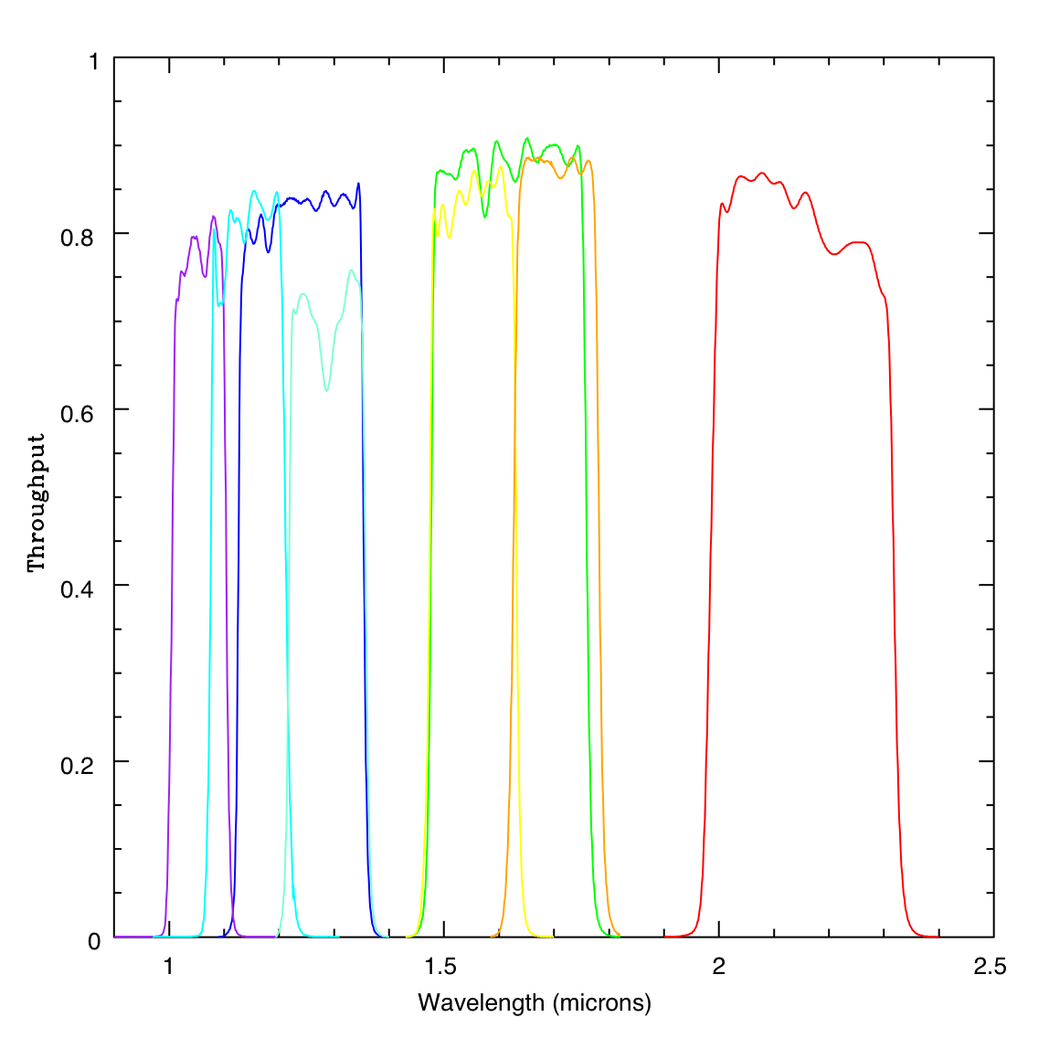
Figure 2.4 FourStar system throughput for each available filter

Image quality and distortion: The camera optics distort the field at the 1.5% level. Image rectification is handled automatically in the data reduction process. World coordinate system (wcs) information is provided in the reduced image headers.

Instrument (vessel) focus: The detector package has been well focused in the lab and this must never be adjusted; see 6.3.1-Focusing across the array. The system focus is dependent on ambient temperature and is compensated by focusing the telescope. This happens automatically.

Offset guider: A standard Magellan offset guider is used. Owing to the large footprint of the instrument entrance window, the offset guide field is restricted to a rather narrow area around its periphery. Occulting of the science field by either probe is avoided automatically.

Observing Cookbook

Suggested things to bring
- An external USB hard drive is the most effective way to transfer data. Depending on the mode of operation a typical observing run can generate 20-60GB.
- An object list and finding charts are useful.

Control Room Computers
When you arrive in the control room, FourStar should be ready for you to use. Either of the control room computers (burro or llama) should be connected to the FourStar Control-Room-Mac.
- The primary monitor will show the screen-sharing window, which should display a number of smaller windows pertinent to FourStar.
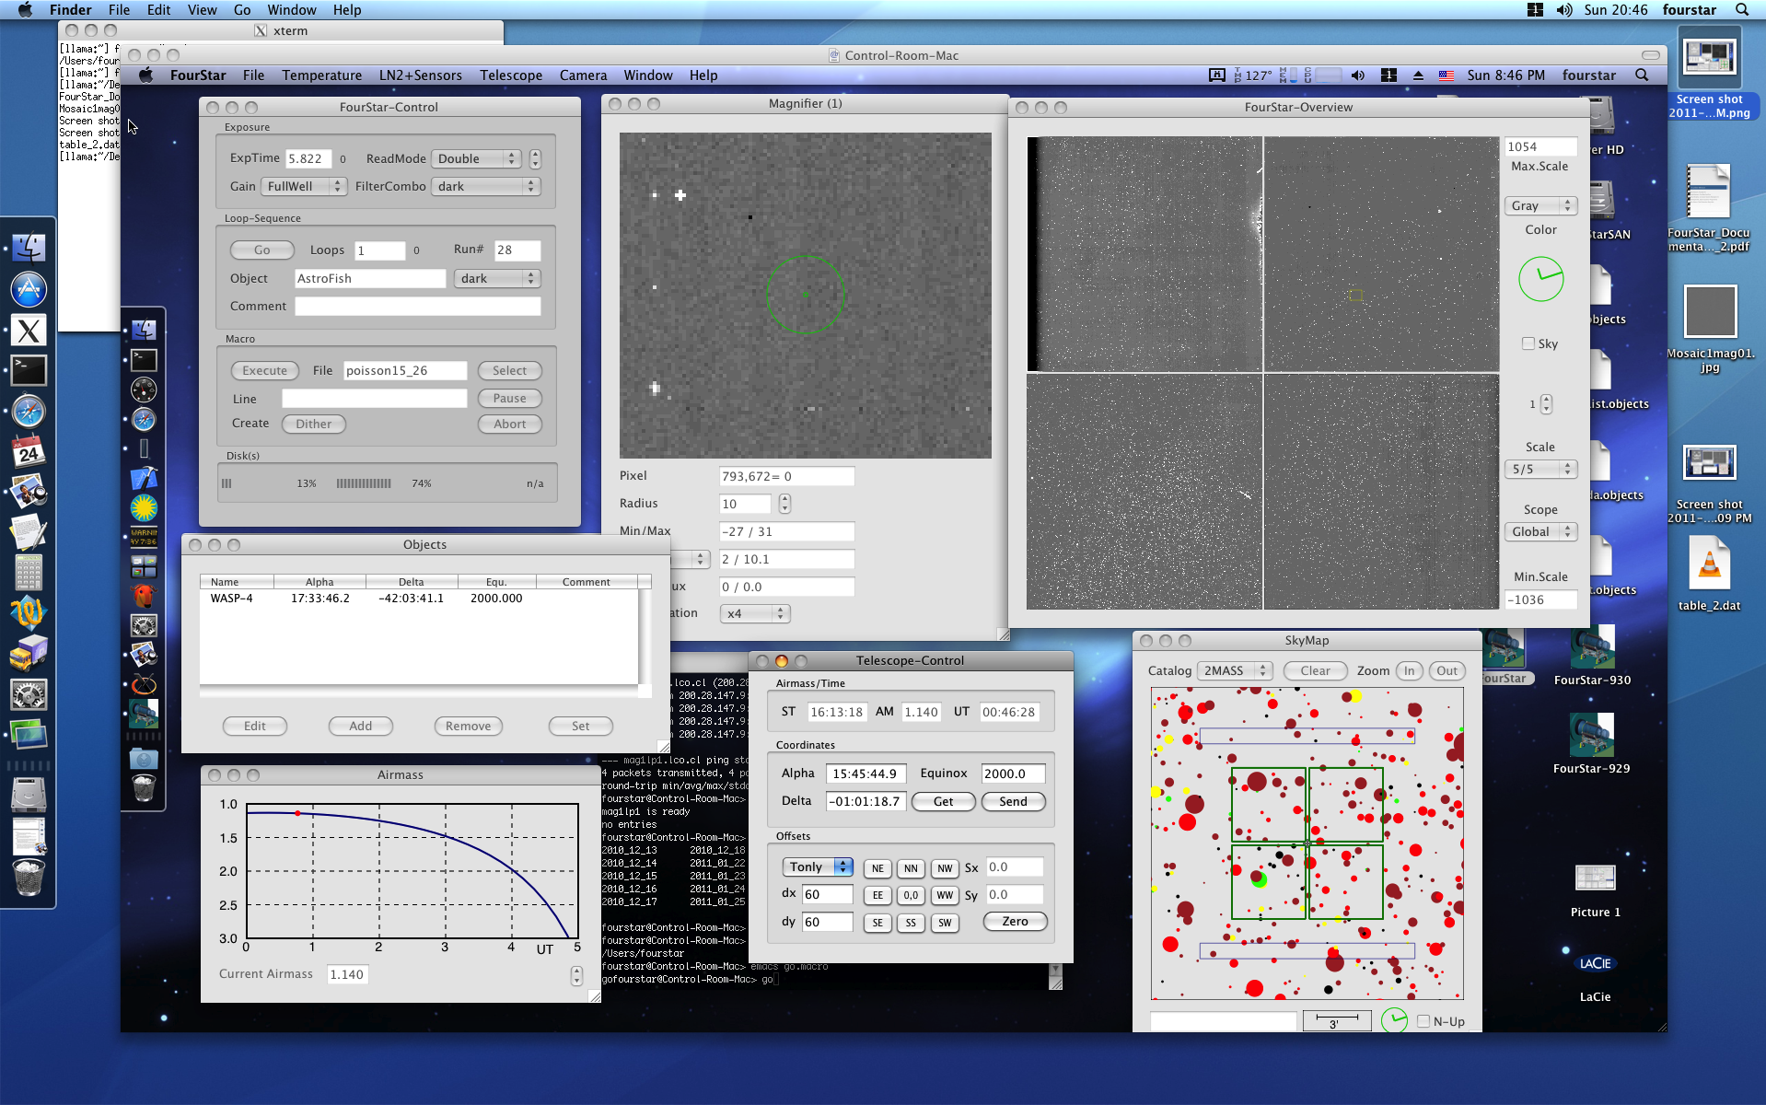

- The secondary monitor may be showing an IRAF session.
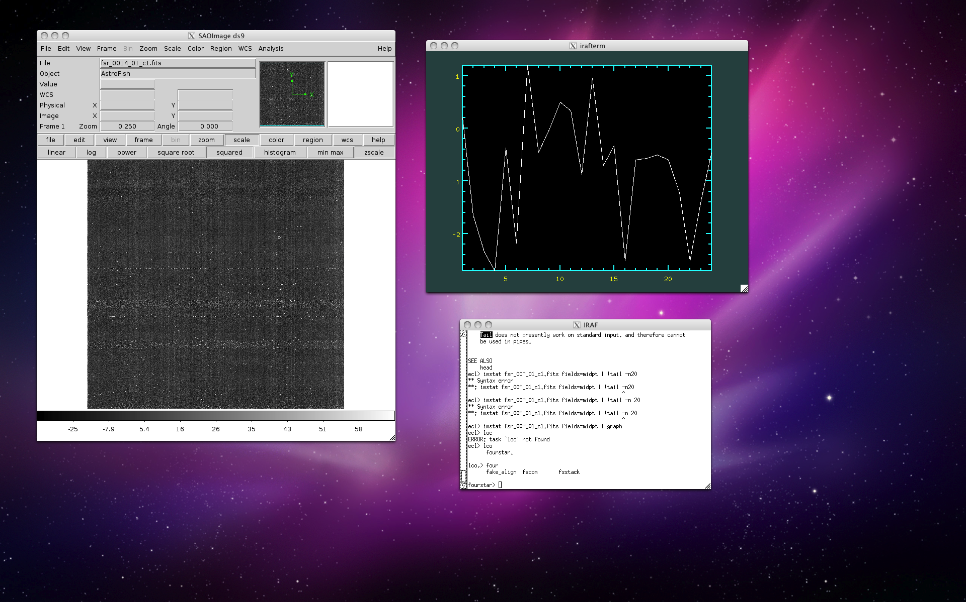

Target List
You do not need to load a target list into the FourStar interface, you can simply tell the telescope operator where to go or provide them with a list. But sometimes it is nice to have a list.
- A target list may be created prior to arriving. All that is needed is a simple text file containing the following columns (separated by a pipe | ): Object name, RA, DEC, EPOCH, comment (optional). The coordinates should be sexigesmal and the filename extension should be “.objects”. An example target list with the filename: strange.objects
something | 10:00:00 | -56:00:00 | 2000 |
wicked | 12:55:55 | 44:44:44 | 2010 | this way comes

To load the file upon arrival, it is best to transfer the file you created to the FourStar Computer one of these recommended ways:
- Place the file on a USB drive and insert the drive into the FourStar USB hub in the Control Room. Copy the file from your USB drive to the FourStar Desktop.
- If you brought a laptop and are connected to the network you can scp the file to the FourStar computer. Note: The control room computers ignore incoming ssh requests thus you may only ssh/scp from the FourStar computer.

With the file now locally available you can select it from the FourStar File menu: Open ObjectList… (or ⌘O).
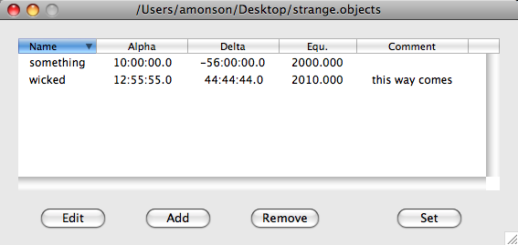

- A target list may also be created / appended / or edited in the FourStar software using the Objects palette.

Moving to an object in the Target list
- Select an entry in the object list and click “Set”. The Telescope-Control and SkyMap palettes will center on the objects coordinates and the airmass tool will update showing the current airmass and projected airmass for the selected object.

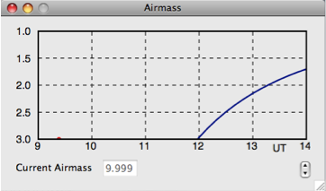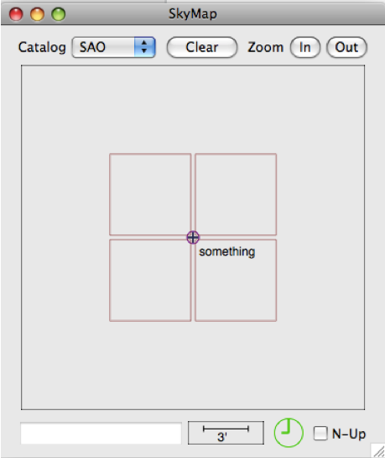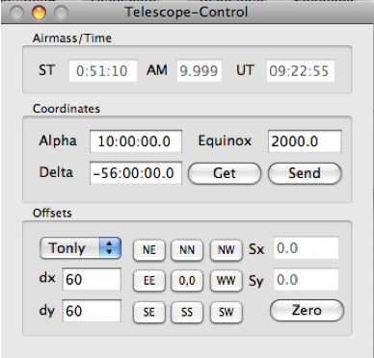

- If the field / airmass look correct then click the “Send” button to send the coordinates to the telescope operator and they will slew the telescope.

Placing the Target in the Right Spot
The telescope coordinates are centered on the gap between all four FourStar detectors. Thus, if your object is a point or compac source or you may want to offset to one of the other arrays. If you are observing an extended object and plan on dithering to cover the gap then this should not be a problem.

We currently recommend chip 1 or 2 for placing targets that only require one array. In the following example we chose chip 2. Once an object has been acquired by the telscope inform the Telescope operator that you will be applying an offset. Set the dx and dy offsets to 170 each and select Tonly. Verify the orientation by clicking the Get button and viewing the current telescope position/orientation in the SkyMap tool. If North is up then you want to click the NE button to move the telescope NE and place the object on chip 2.

Using ALADIN to plan your observations
We recommend using the ALADIN sky atlas tool to assist in planning observations. The tool can be accessed via the web or downloaded and used locally; the website is: http://aladin.u-strasbg.fr/

In the example below ALADIN has been installed on a local machine. Apparently, runnig ALADIN locally requires a bit of RAM (~1GB) so the web version may work better if you have less than 1GB of RAM on your computer.

- In the main ALADIN window, type the coordinates or name of the object you wish to observe.
- Load the FourStar.fov file to overlay the FourStar footprint on the sky.
- Rotate the field of view to the desired position angle.
- If your target declination is less than -29:02:00 (the observatory’s latitude) then the default roll angle will be 0° (North up, East left).
- If your target declination is greater than -29:02:00 then the default roll angle will be 180° (South up, West left).
- Adjust the position of the FourStar fov until a suitable guide star is found the “sweet spot” of the guider field and a suitable Shack-Hartmann star is found in the Probe-2 region.
- Record the position of the FourStar footprint by either reading the cursor value near the center of the fov or by “right-clicking” the fov layer on the right of the screen

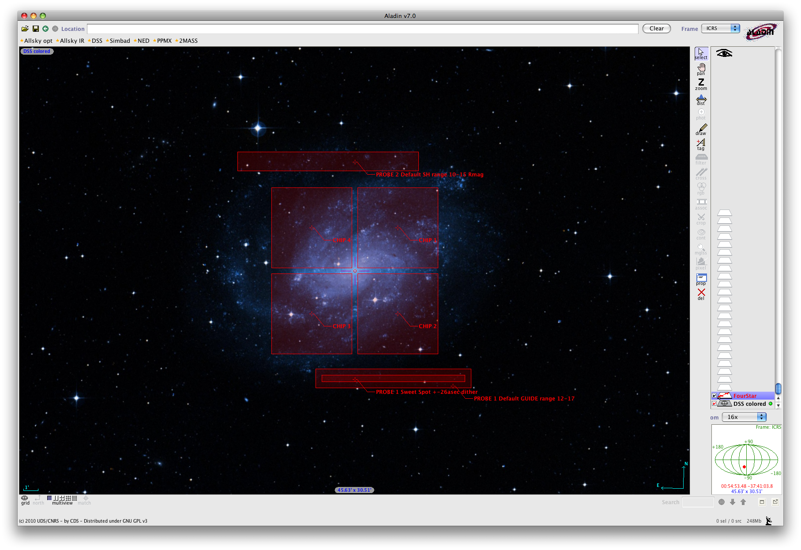

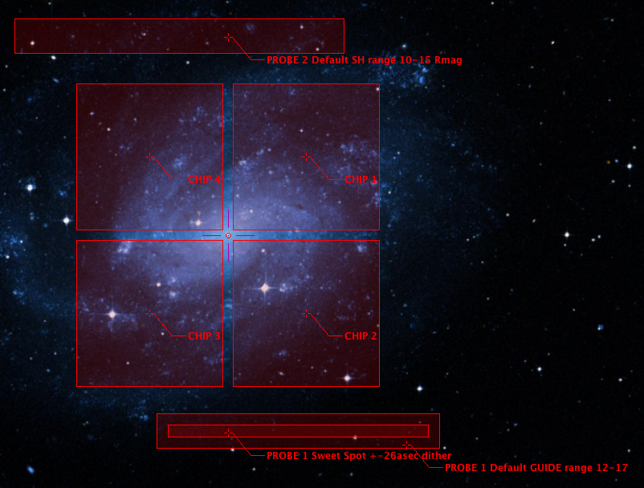

Taking an Image

Fourstar package in IRAF
Some simple quick-look scripts have been created in the lco.fourstar package. To access these scripts in IRAF, first load the lco package by typing “lco” and then “fourstar”. These scripts are for quick-look purposes only and should not be used to create data products. Remember to change to the directory containing the current data.

FSCOM
This script subtracts (default) one image from another using the imarith function and then (optional) mosaics the 4 images together to create a quick-look image for the field. This is useful for focus or quick image identification.
Examples:
cl>fscom 5 4 1 1
subtract fsr_0004_01_c?.fits from fsr_0005_01_c?.fits, creates a mosaic image called 0005_0004.fits and launches an imexam session for that mosaic image.
cl>fscom 5 5 1 2 op=“/”
divide fsr_0005_01_c?.fits by fsr_0005_02_c?.fits.

FSMOS
This script uses the IRAF task xdimsum to co-add multiple (dithered) images together to create a background subtracted image of one or all arrays. The background is subtracted from each image and then those images are combined together using telescope offsets found in the header or, optionally using cross-correlation (takes longer). This is useful for creating quick-look images.
Examples:
cl>fsmos 1 10 1 5 2
combine the runs 1 through 10 including the loops 1-5 for chip 2.
cl>fsmos “” “” 1 5 2 filen=“names.txt”
combine the run numbers included in the file “names.txt”, useful for a set of non-contiguous run numbers. The format for the text file should be one run number per line.

Recommended Strategies and Procedures
If using the Shack-Hartmann sensor allow at least one minute at each location for the system to complete a Shack-Hartmann cycle. For standard stars this is not necessary.

Table 3-1 provides some typical values for exposure information.
Table 3-1 Suggested parameter values for FourStar.
Filter | Focus offset (P2 default) | Focus offset (P1) | Gain | Mode | Sky Lo (DN/s) | Sky Ave (DN/s) | Sky Hi (DN/s) | Zero Point | Bright Limit (vegamag)
J | -18.5 | -16.0 | FullWell | CDS | 100 | 125 | 150
H | -18.5 | -16.0 | FullWell | CDS | 150 | 200 | 250 |  | 11.3
Ks | -21.0 | -18.5 | FullWell | CDS | 300 | 450 | 600
Hl | -19.5 | -17.0 | FullWell | CDS | 70 | 95 | 120
Hs | -18.7 | -16.2 | FullWell | CDS | 70 | 95 | 120
J1 | -19.5 | -17.0 | FullWell | CDS | 30 | 40 | 50
J2 | -19.5 | -17.0 | FullWell | CDS | 30 | 40 | 50
J3 | -19.5 | -17.0 | FullWell | CDS | 30 | 40 | 50

Flat Fields
Twilight flats are recommended to correct pixel-to-pixel variations in sensitivity. Generally one should start evening Twilight flats at the reddest wavelength and progress blueward and in the morning start at the blue and work toward the red.

In the evening, just before sunset, the telescope operator should have the dome and louvers open (the louvers are the vents on the side of the dome). It is always a good idea to confirm that the mirror covers are open, the flat field screen is removed, all lamps/lights are off. Just after the sun sets one can start testing the sky in the Ks filter with 1.456s exposure times.

Dark Frames
Dark Frames can be taken by selecting “Dark” from the FilterCombo menu. This crosses two filters that mutually block each other. If no darks are taken then the pipeline will use the most recent dark frames stored in library. It is recommended to take a series of Darks during the day of science observations. If exposure times are not known beforehand then darks can be taken at the end of a run; in this case, a python program mkdark.py exists that will create a macro called mkdark based on the exposure information that exists within a certain raw data directory. To run the program open a terminal on the Control-Room-Mac and change directories to the Raw Data path
[]# cd ~/Data
[]# mkdark.py 2011_09_30 9
This script will take approximately 112.0 min to run.

Now in the FourStar GUI type mkdark in the macro box and click execute. The script will automatically move to the dark filter, set the obstype to dark and vary the relevant exposure times, loop numbers, gains, and modes based on the sequences of exposures found in the 2011_09_30 data path. The number of darks to take is set by the trailing 9 in this case.

Bad Pixel Masks
Badpixel / hotpixel frames can be contructed using the ratio flat fields at different exposure times. If no badpixel masks are created the pipeline will use the most recent masks stored in the library. The linearity maps can also be used to classify bad pixels by sigma clipping spurious values.

Dome Flats
Dome Flat Fields are not generally recommended although they can be taken to construct bad pixel masks and used for flat fielding if twilight flats are not available.

From a terminal on burro or llama type the command ffs to open the dome screen GUI. Click on the screen in button to move the screen over the secondary mirror. The lamps on the secondary are too bright to use with FourStar so the auxiliary lamp located in the dome must be used. The power supply is accessible in the dome; ask the telescope operator for assistance locating it. The lamp is not very stable and some structure can actually be seen in the Hl filter from the lamp diffuser. Some exposure time and lamp settings are shown in Table 3-2. When you are finished make sure to remove the dome flat screen by clicking the screen out button.

Filter | Gain | Mode | Lamp (V) | Extime (s) | ~Flux (DN)
J | FullWell | CDS | 1.25 | 11.644 | 18,000
J | FullWell | CDS | 1.50 | 2.911 | 20,000
H | FullWell | CDS | 1.25 | 2.911 | 17,000
H | FullWell | CDS | 1.50 | 1.456 | SAT
Ks | FullWell | CDS | 1.25 | 2.911 | 25,000
Hs | FullWell | CDS | 1.25 | 8.733 | 27,000
Hs | FullWell | CDS | 1.50 | 2.911 | 27,000
Hl | FullWell | CDS | 1.25 | 8.733 | 31,000
Hl | FullWell | CDS | 1.50 | 2.911 | 30,000
J1 | FullWell | CDS | 1.25 | 90.24 | 18,000
J1 | FullWell | CDS | 1.50 | 5.824 | 7,500
J1 | FullWell | CDS | 1.50 | 14.56 | 16,000
J1 | FullWell | CDS | 1.80 | 5.824 | 24,000
J1 | FullWell | CDS | 2.00 | 5.824 | 40,000
J2 | FullWell | CDS | 1.25 | 32.02 | 17,000
J2 | FullWell | CDS | 1.50 | 5.824 | 16,000
J3 | FullWell | CDS | 1.25 | 20.38 | 23,000
J3 | FullWell | CDS | 1.50 | 5.824 | 26,000
Table 3-2 Lamp settings and exposure times for Dome Flats.

Twilight Flat Fields are preferred to remove pixel to pixel variations as the illumination more closely mimics the science observations. The most recent are stored in the library.
DUSK | Ks | Hl | Hs | H | J3 | J2 | J1 | J
Gain | FullWell | FullWell | FullWell | FullWell | FullWell | FullWell | FullWell | FullWell
Mode | CDS | CDS | CDS | CDS | CDS | CDS | CDS | CDS
Exptime (s) | 18 | 18 | 12 | 10 | 10 | 20 | 20 | 20
Loop/Dither | 1/5 | 1/5 | 1/5 | 3/5 | 3/5 | 1/5 | 3/5 | 5/5
Flux (cnt/s) | 30,000 | 30,000 | 30,000 | 30,000 | 30,000 | 30,000 | 30,000 | 30,000
DAWN | J | J1 | J2 | J3 | H | Hs | Hl | Ks
Gain | FullWell | FullWell | FullWell | FullWell | FullWell | FullWell | FullWell | FullWell
Mode | CDS | CDS | CDS | CDS | CDS | CDS | CDS | CDS
Exptime (s) | 20 | 20 | 20 | 10 | 10 | 12 | 18 | 18
Loop/Dither | 5/5 | 3/5 | 1/5 | 3/5 | 3/5 | 1/5 | 1/5 | 1/5
Flux (cnt/s) | 30,000 | 30,000 | 30,000 | 30,000 | 30,000 | 30,000 | 30,000 | 30,000

Data Transfer
We recommend plugging an external USB drive to the FourStar USB hub in the Control Room. The disk should appear on the Desktop of the Control-Room-Mac screensharing window. The recommended procedure is to rsync the data periodically throughout the night from a terminal on the Control-Room-Mac.
All data:
fourstar@Control-Room-Mac> rsync –av –-modify-window=2 ~/Data/2011_09_07 /Volumes/USER_DRIVE
The raw data:
fourstar@Control-Room-Mac> rsync –av –-modify-window=2 ~/Data/2011_09_07/fsr* /Volumes/USER_DRIVE/2011_09_07

- The –a option is necessary to prevent overwriting the data on subsequent repeats of the command, -t would also work, but –a preserves all file links if they exist.
- The –v option simply sets the verbosity and allows the user to view the files being copied.
- The --modify-window=2 option only replaces files if the local copy is more that 2 seconds newer than the remote copy. The default setting is zero and re-writes the data if the remote disk is FAT32 since the time stamp on FAT32 is only accurate to ±2s.

- exposure times for
- deep pictures / filter
- standard stars / filter
- Things done automatically to frames
- linearization
- dark subtraction
- distortion correction

- data processing
- user interface
- quicklook reduction
- final (mountain) reduction
- reduced data storage
- raw data storage

- utilities
- exposure time calculator
- standard stars

Focus Corrections

Instrument Specialist's Cookbook
Under normal circumstances FourStar should be in a state ready to use. That is, the FourStar software should always be running on the remote computer (Control-Room-Mac). It is this software that is responsible for reporting the instrument status even when not observing.

Starting the System

Powering Up FourStar
This section describes how to restart the FourStar sytem for the first time or in the event of a power failure or maintenance.

At the FourStar Equipment Room Rack
- Verify that the Firewall, KVM switch, 3 Netgear switches, Fiber switch, monitor and RAID chassis are powered on.
- Verify that the Control-Room-Mac is on. This runs the FourStar software.
- Verify that the Data-Red-1,2,3 computers are on. At least one of these must be on to access the RAID and run the pipeline reduction software.

On the Nasmyth Platform
- Ensure that Fourstar is attached to the telescope and free to rotate with no obstructions. This includes: inspecting the cart rollers to make sure they are clean and making good contact with the Fourstar load ring and double checking that no cables are loose or in danger of snagging.
- Check that the glycol coolant lines are connected and that there are no visible signs of leaking. Without proper coolant flow the racks will overheat and shut off automatically by use of thermal cutoff switches.
- Check that the 2 fiber-optic leads are plugged into Rack 2 at locations P27 & P6.
- Check that the main power is securely plugged into the main power bus on FourStar.
- If not already on, turn the electronics racks on by closing the red toggle switch covers. The covers are there to prevent accidental turn-offs.
- Check Rack 1 by opening the side panel: The motor controller and temperature controller should be on. If not already on, turn on the two Jade card power supplies as well as the two windows computers. Close the rack cover. Refer to Figure 4.1.
- Check Rack 2 by opening the side panel: The process controller, temperature controller and NetGear switch should be on. If not already on, turn on the two windows computers and the Ion-Pump. Within a minute, the Ion pump should show 2-3 green LED’s. If the scale shows more than this then refer to 6.6.1 for procedures to replace it. Close the rack cover. Refer to Figure 4.1.

RACK 1 | RACK 2
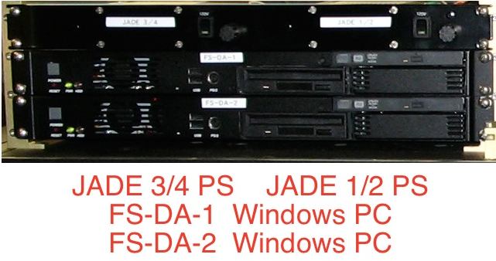 | 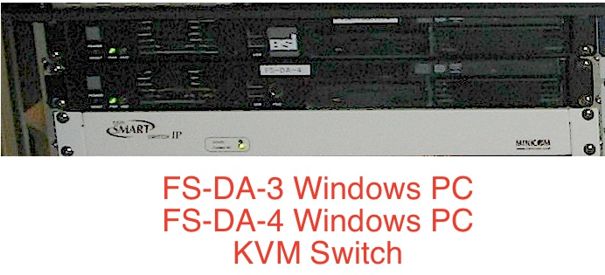
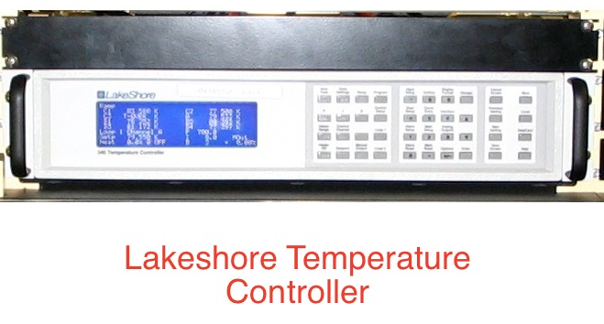 | 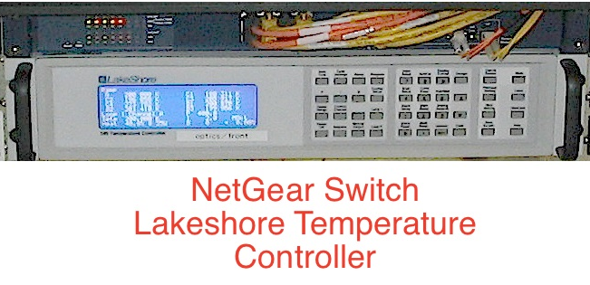
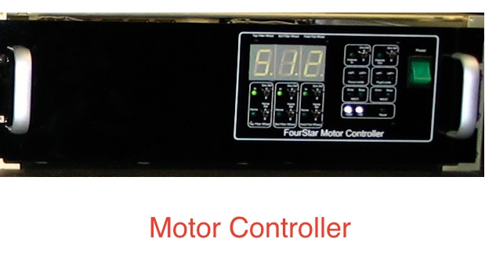 | 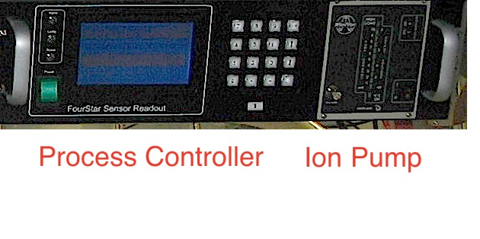

Figure 4.1 The FourStar Electronics Racks.

Interfacing with FourStar
From the Control Room, log onto both of the Mac-mini’s (burro and llama) in the Control Room using the “fourstar” or “obs” account. Although any account can be used, the fourstar user account currently has command aliases ready to use and is recommended.
- One of these (burro or llama) should be used as the VNC client to interact with the FourStar instrument.
- The other should be used for accessing IRAF and the FourStar pipeline via the web along with other web browsing activities.

Control Room, Connecting through VNC
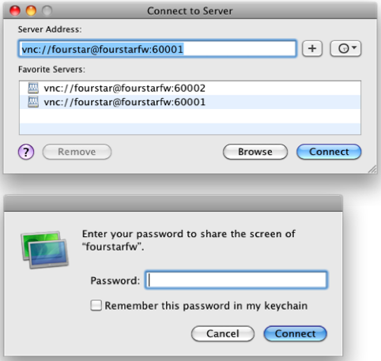
From the control room start a screen sharing session from one of the Mac Mini’s from the fourstar account (burro or llama). On the mac mini from the Finder application under the Go menu, click Connect to Server (or ⌘K). Enter or select the Server Address:
vnc://fourstar@fourstarfw:60001
as shown in Figure 4.2, and click Connect. (Note: the Nasmyth Mac is port 60002). Enter the password in the pop-up dialog box. In most cases the Fourstar software should already be running on the remote screen, if so, quit the FourStar application; we will turn it back on again shortly. The remote desktop of the Control-Room-Mac should appear as shown in Figure 4.3.
Figure 4.2 Connect to Server dialog box.

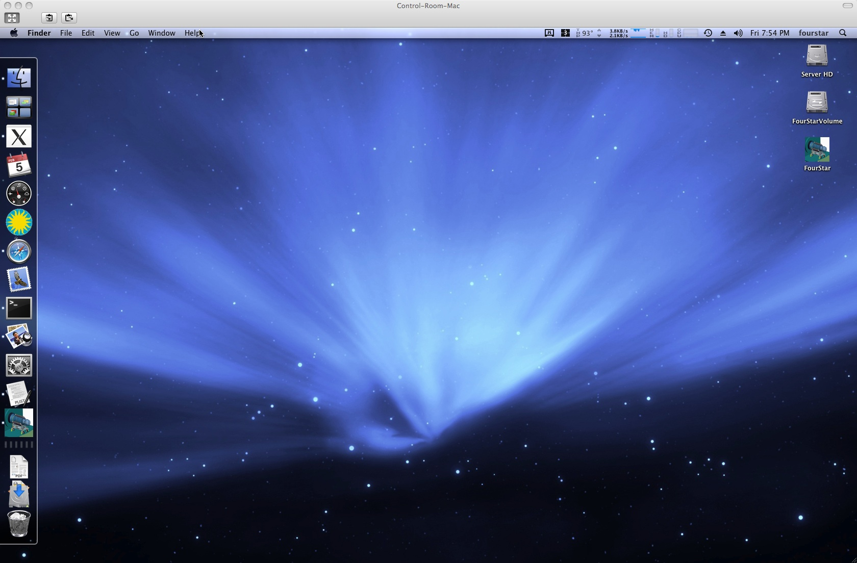
Figure 4.3 The Control-Room-Mac remote deskop.

Starting the FourStar Software
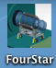
Double-click the “FourStar” icon on the remote desktop; the most recent version is the one with no date stamp on the end. The FourStar - Setup box will appear; see Figure 4.4. Use the individual pulldown menus to select the various control modes as shown in Figure 4.4. Check the boxes for the systems to be used. For normal operation all boxes should be checked, except for TempControl-3 which is used only for warming up the shroud dewar. Now switch to the IP-Numbers panel and check that all are correct according to the figure. The observers name may be entered at this time for inclusion in the fits data header. This may be changed at any time by selecting “Setup” from the “FOURSTAR” pulldown menu; see 6.1.1.1.

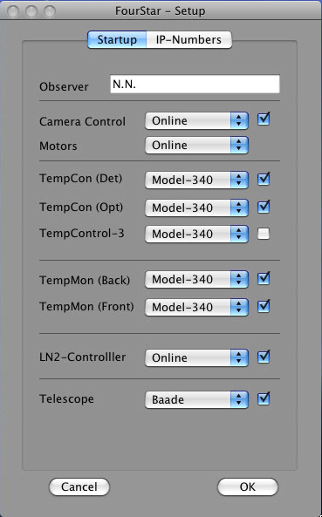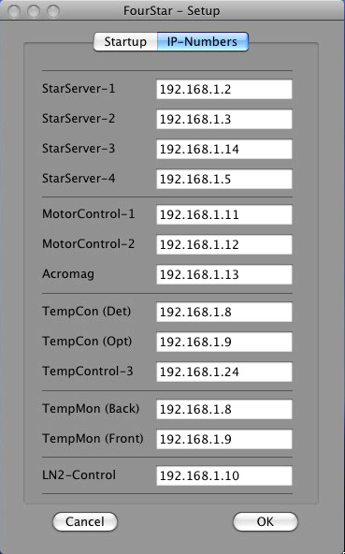
Figure 4.4 The Fourstar Setup tabs; Startup and IP-Numbers. The checkmarks indicate which modules to enable upon startup.

Once you click OK the various control and monitoring GUI’s (that you have checked) will appear. Wait at least one minute before trying to take an exposure, while the arrays are being configured.

Organizing FourStar Windows.
There are a number of important displays that must be regularly monitored to determine instrument health and there is limited desktop space available. To help with this the Mac utility “Spaces” is helpful for dividing intrument maintenance GUI’s and observing GUI’s. The spaces environment can be viewed by clicking the spaces application on the remote desktop located along the left edge. The “Spaces” environment currently has two virtual desktops available and in this example the Fourstar Camera control and telescope control are dragged to the first (left) desktop; see Figure 4.5.

Press the F8 key, then press the F9 key to view all windows and spaces. Drag the FourStar-Control and Telescope-Control windows to the other Desktop.
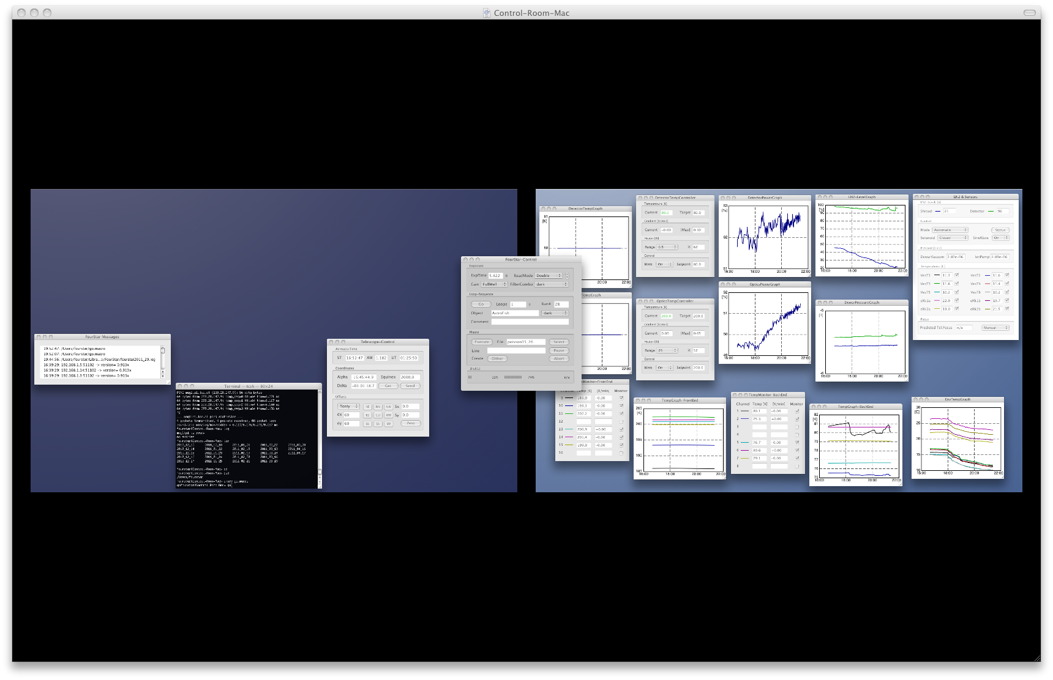
Figure 4.5 The Spaces environment showing the two virtual desktops.

- Click on the FourStar-Control window to make it active and under the Camera menu, click Show Qltool to open the Fourstar image display tool and magnifier.
- Under the Telescope menu, click on Show SkyMap, Show Airmass and Show Object List to show those windows. You should now see something like in Figure 4.6.
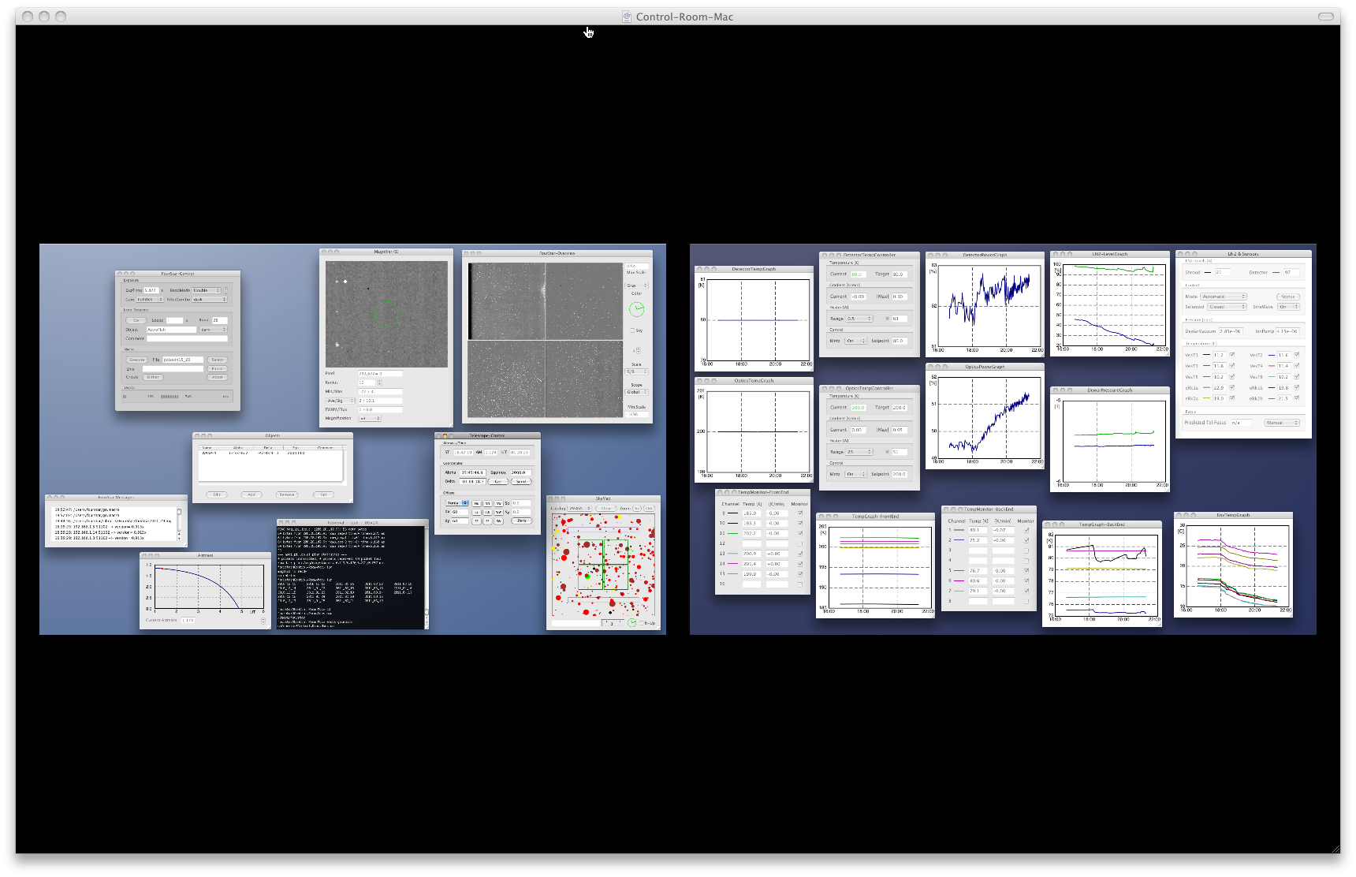
Figure 4.6 The Spaces environment showing the Fourstar control windows and graphs divided into two workspaces.

Summary of FourStar’s Critical Systems
- The Detector Temp controller should be set at a Target of 80.0 and a Range of 0.5 W. If the Range is off and you are preparing for run these values will need to be set at this time. The Detector Temperature graph should be flat at 80.0K and the Power graph should be stable and in the range 20-40%. If you just turned the heater on it will talke approximately one hour to equilibrate.
- The Optics Temp controller should be set at a Target of 200.0 and a range of 25 W. The optics Temperature graph should be flat at 200K and the Power gragh should have a diurnal oscillation with the range 20-60%.
- The Liquid Nitrogen graphs should be in the range 15-100% and have a nice-looking sawtooth pattern.
- The Pressure graphs should be flat between 2-4 x10⁻⁶ Torr.
- The FrontEnd and BackEnd temperature graphs should look flat and stable. The Shroud Dewar Temperature sensor will display a sawtooth pattern.

Web Monitoring
While the FourStar software is running the data are logged. The logs are available graphically on the web at:
http://obs.carnegiescience.edu/instrumentation/FourStar/status.html
This is a useful way to see the last 12 hours of FourStar’s critical systems. An email alert is issued to those on the list (contact Christoph), if any one of a number of critical events occurs, i.e.
- The Auto-Fill system has been open for more than 40 minutes. This indicates the LN2 supply tank has run out and needs to be changed.
- The Pressure is too high. This indicates the ion pump may need to be changed or there is a leak.
- Some Temperature is out of expected range and should be checked.

Observing Run Preparation
From burro or llama, whichever is running the screen sharing session to the Control-Room-Mac, click on any Fourstar window to bring that application to the foreground.

Set Data Path
Select the path(s) where your data is to be saved. From the Fourstar command bar select File—SetDataPath or ⌘D and enter the path(s) in DataPath1 and DataPath2. Note: clicking the ‘Default’ button will construct the preffered format for the current date. Click ‘Apply’. If the specified directory does not already exist a pop-up box will ask you to create it. If you do not specify a data path an error will come up each exposure warning that there is no data path; see Figure 4.7.
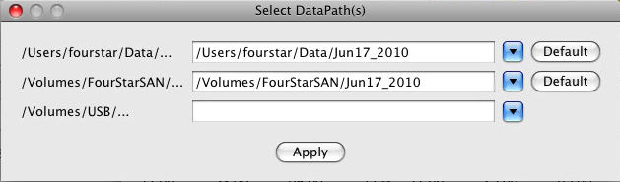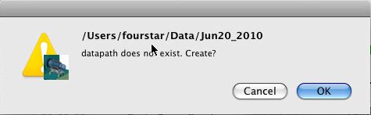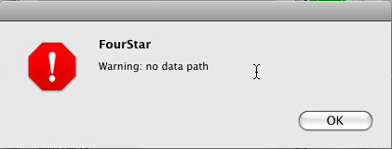
Figure 4.7 The ‘Select DataPath(s)’ dialog box along with the pop-up boxes for creating a directory and warning for no pata path.
The data is simultaneously written to up to three locations:
- DataPath1 is on the Control-Room-Mac internal hard drive (1TB) which is where the untouched raw data will be temporarily stored. /Users/fourstar/Data/date is the preferred format.
- The second path, DataPath2, is on the FourStar RAID chassis (12TB) where the raw data will be pipeline processed for the observer. /Volumes/FourStarSAN/date is the preferred format.
- The third path, DataPath3, is available to observers who wish to connect a personal USB storage device to the USB hub in the Control Room. Note: We do not recommend connecting a USB device during observations as it slow and can create a bottleneck when taking a fast cadence of exposures. It is possible to get the raw data later by copying from the internal disk. The average transfer speed is ~25GB/hr using the USB fiber hub.

The pipeline data will be available for the observer to copy at the end of the run at TBD.
If an observer brings a USB storage device, it should be Mac compatible or else be able to be formatted on site (which will result in a loss of whatever is on that device); see 6.2.5. We recommend Fat32 since that can be read universally on Macs, Linux and Windows.

Start IRAF/DS9
It is recommended to ssh to the FourStar Control-Room-Mac from “burro” or “llama”. This can be done from a terminal using the command “4star” which is aliased as ssh fourstar@fourstarfw -p 60000 . This requires entering the fourstar observer password (consult with telescope personnel). Once connected through ssh, IRAF and ds9 can be launched using the command “goiraf” which is aliased as xgiraf; /Users/fourstar/bin/ds9 . “xgiraf” is aliased (‘xgterm –ls –sb –title ‘IRAF’ –e ‘cd /Users/fourstar/iraf; exec cl’’) such that an xgterm will open and start the IRAF cl.

Observing Run Preparation Checklist
ON THE PLATFORM
Rack 1: Check that the Motor Controller and Lakeshore Controller are running.
Rack 1: Check that the 2 Windows PC’s are running.
A green LED should be visible to the left of each PC’s power button.
Rack 1: Check that both the JADE power supplies are on (1/2 and 3/4).
Green LED’s should be visible.

Rack 2: Check that the Process Controller, Ion Pump and Lakeshore Controller are running. The Ion Pump should show 2-3 green LED’s.
Rack 2: Check that the 2 Windows PC’s are running.
A green LED should be visible to the left of each PC’s power button.

Cart Rollers: Check that cart rollers are clean and making good contact with the load ring.
Cables: Check that all cables are secure to FourStar and won’t catch on anything when rotating.
Glycol: Check that the glycol is not leaking.
Front Window: Remove a cover from the conical adapter and inspect the front window. Also check that there is air-flow into the guider cavity from the white nylon tube.

IN THE CONTROL ROOM
llama or burro: Open screen sharing session to Control-Room-Mac. From the Finder menu select Go Connect to Server (⌘K), then vnc://fourstar@fourstarfw:60001
FourStar software: Quit the FourStar software and re-start it by clicking the Fourstar.app icon on the desktop. Arrange the GUI’s by moving the FourStar-Control and Telescope-Control to the other Spaces Desktop (F8 key and F9 key).
Check (or set) the Detector-Temp-Controller is set to 80K at 0.5W.
FilterCombo: Check the filter wheel functionality by moving to a few different filters.
Telescope-Control: From the Telescope menu, open the GUI’s: Show SkyMap, Show Airmass and Show ObjectList. The telescope position should be updating.
FourStar-Control: From the Camera menu, select: Show Qltool. Also, select Set DataPath (⌘D) and select the directory to store the data. Set run number to 1; from the Camera menu, select Change Run Number.
Take a set of read noise data (Gain=FullWell, ReadMode=Double, FilterCombo=Dark, exptime=1.456, loop=20). From a terminal, cd to the data directory and type rnoise.sh 1 20 the read noise should look reasonable (i.e. ~ 9, 8, 8, 7 ADU).
llama or burro: Log in as fourstar. From a terminal type the command: 4star to open an ssh connection to the Control-Room-Mac. In the remote terminal type the command: goiraf to start an instance of IRAF and DS9.

Observing Run Completion Checklist
At the end of an observing run it may be necessary to turn off some items to keep from overheating or wearing out. In general, this is a good idea if FourStar is not planned on being used for more than a week.

ON THE PLATFORM
Rack 1: Turn off both of the Windows PC’s. Hold down the gray power buttons for 2-3 seconds, the machines should properly shut down in ~20 seconds.
Rack 1: Turn off both the JADE power supplies (1/2 and 3/4).

Rack 2: Turn off both of the Windows PC’s. Hold down the gray power buttons for 2-3 seconds, the machines should properly shut down in ~20 seconds.

Cart Rollers: Check that cart rollers are clean and making good contact with the load ring.
Cables: Check that all cables are secure to FourStar and won’t catch on anything when rotating.
Glycol: Check that the glycol is not leaking.

IN THE CONTROL ROOM
llama or burro: Open screen sharing session to Control-Room-Mac. From the Finder menu select Go Connect to Server (⌘K), then vnc://fourstar@fourstarfw:60001
In the Detector-Temp-Controller window, set Heater to Off.
Close the screen-sharing window. Leave the FourStar software running; it monitors the instrument
Log off burro and/or llama.

Routine FourStar Maintainence

Window Inspection/start of every observing run
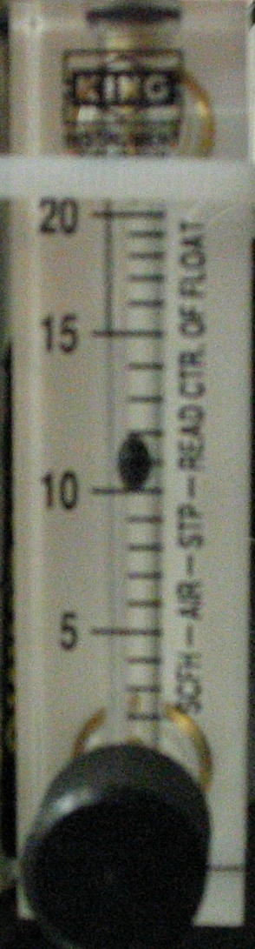
The entrance window must be kept free of dust and ice (due to condensation and subsequent freezing). In order to inspect the window, remove one of the six covers on the conical adapter. Insert the inspection mirror and look at the window. If dust has accumulated, use the camel's hair brush to remove it. Use extreme care. (Each item is located in the Instrument Cart Drawer.)

The system has been designed so that the window should have a supply of dry air blowing over it at all times. Make sure that this is indeed the case by checking the Flowmeter; see Figure 4.8. If ice has accumulated it will do so at the center of the window first. In this case the airflow has probably been interrupted. Observations must be suspended until the ice has had a chance to melt and evaporate.
Figure 4.8 Flowmeter

Autofill system inspection/start of every observing run
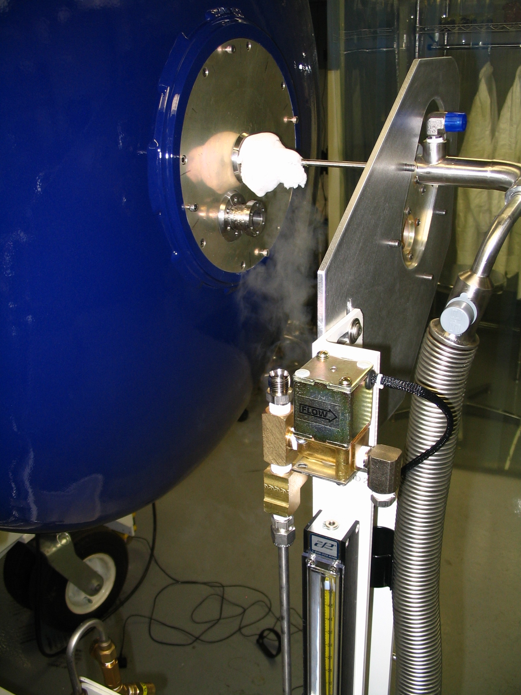
The autofill system has a stinger that is inserted into the fill port at the center of the back end of the instrument. Ice will form on and around this port, and it should be removed periodically; see Figure 4.9. Carefully and gently knock it off with a wrench or hammer. A catching container below the fill ports is useful to prevent puddles from forming.

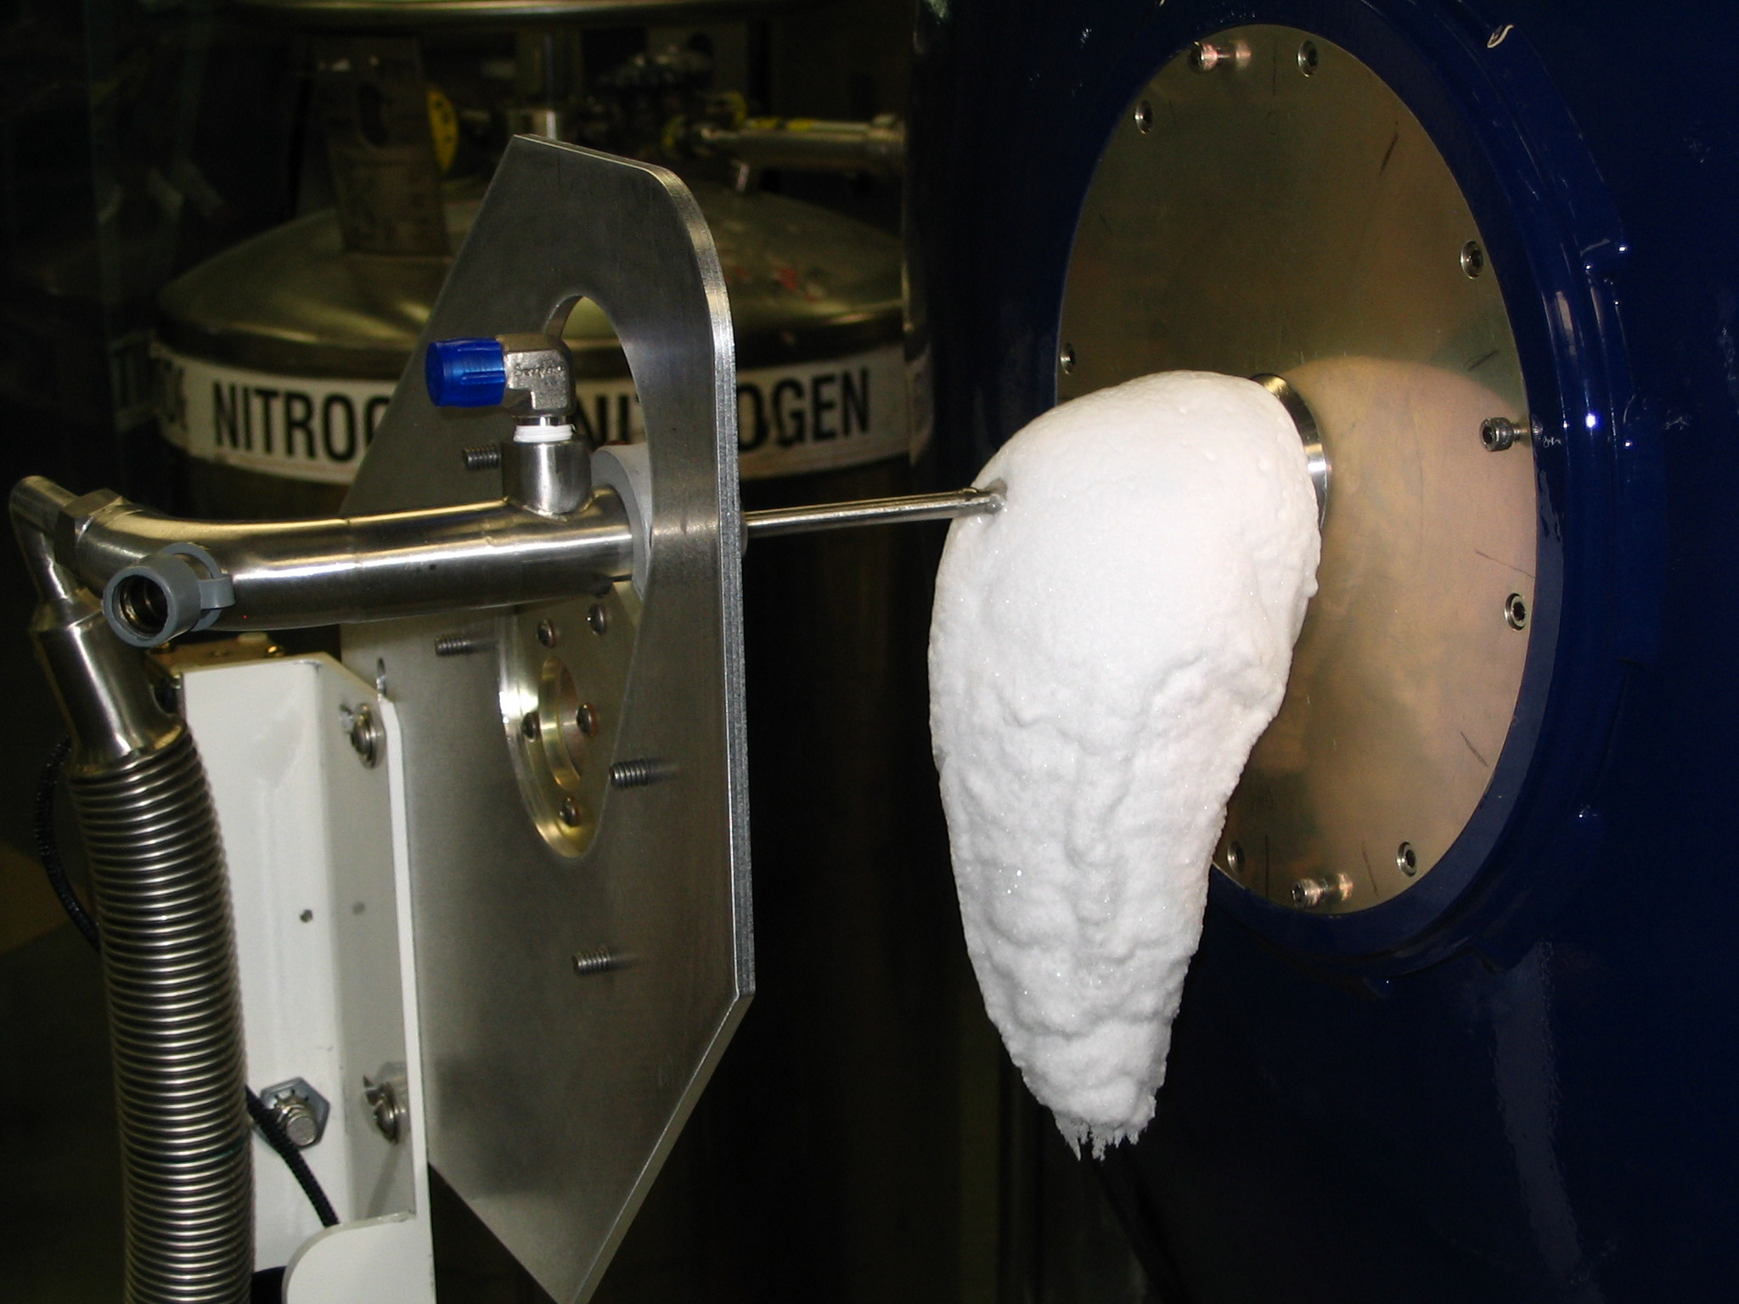

Figure 4.9 The autofill system with shroud dewar stinger in place. Note the ice build up near the fill tube.

Manual dewar filling/twice a week
For your safety, Use gloves located on the instrument cart to handle the hose.
The off-center fill port is used to fill the detector dewar.
- First rotate the instrument so that the port lines up with the hole in the plate (Rotation angle = tbd).
- Remove the long stinger from its holster on the autofill system. A micro-switch should then lock out all telescope motion, thereby ensuring that the instrument cannot rotate while the filling is proceeding.
- Insert the stinger all the way in and then back it out an inch.
- Close the valve on the LN2 supply tank then disconnect the autofill hose at the cart and connect it to the detector stinger using the wrench in the instrument cart. Note: there is some pressure in the hose so some hissing when the hose is disconnected is normal.
- Open the LN2 valve to commence filling. Liquid nitrogen will start to dribble out when the tank is full. Then close the LN2 valve.
- Disconnect the fill hose from the stinger and reconnect it to the cart autofill line.
- Remove the stinger from the dewar and place it back in its holster ensuring that the micro-switch is engaged.
DO NOT BREAK THE MICROSWITCH OR STINGER

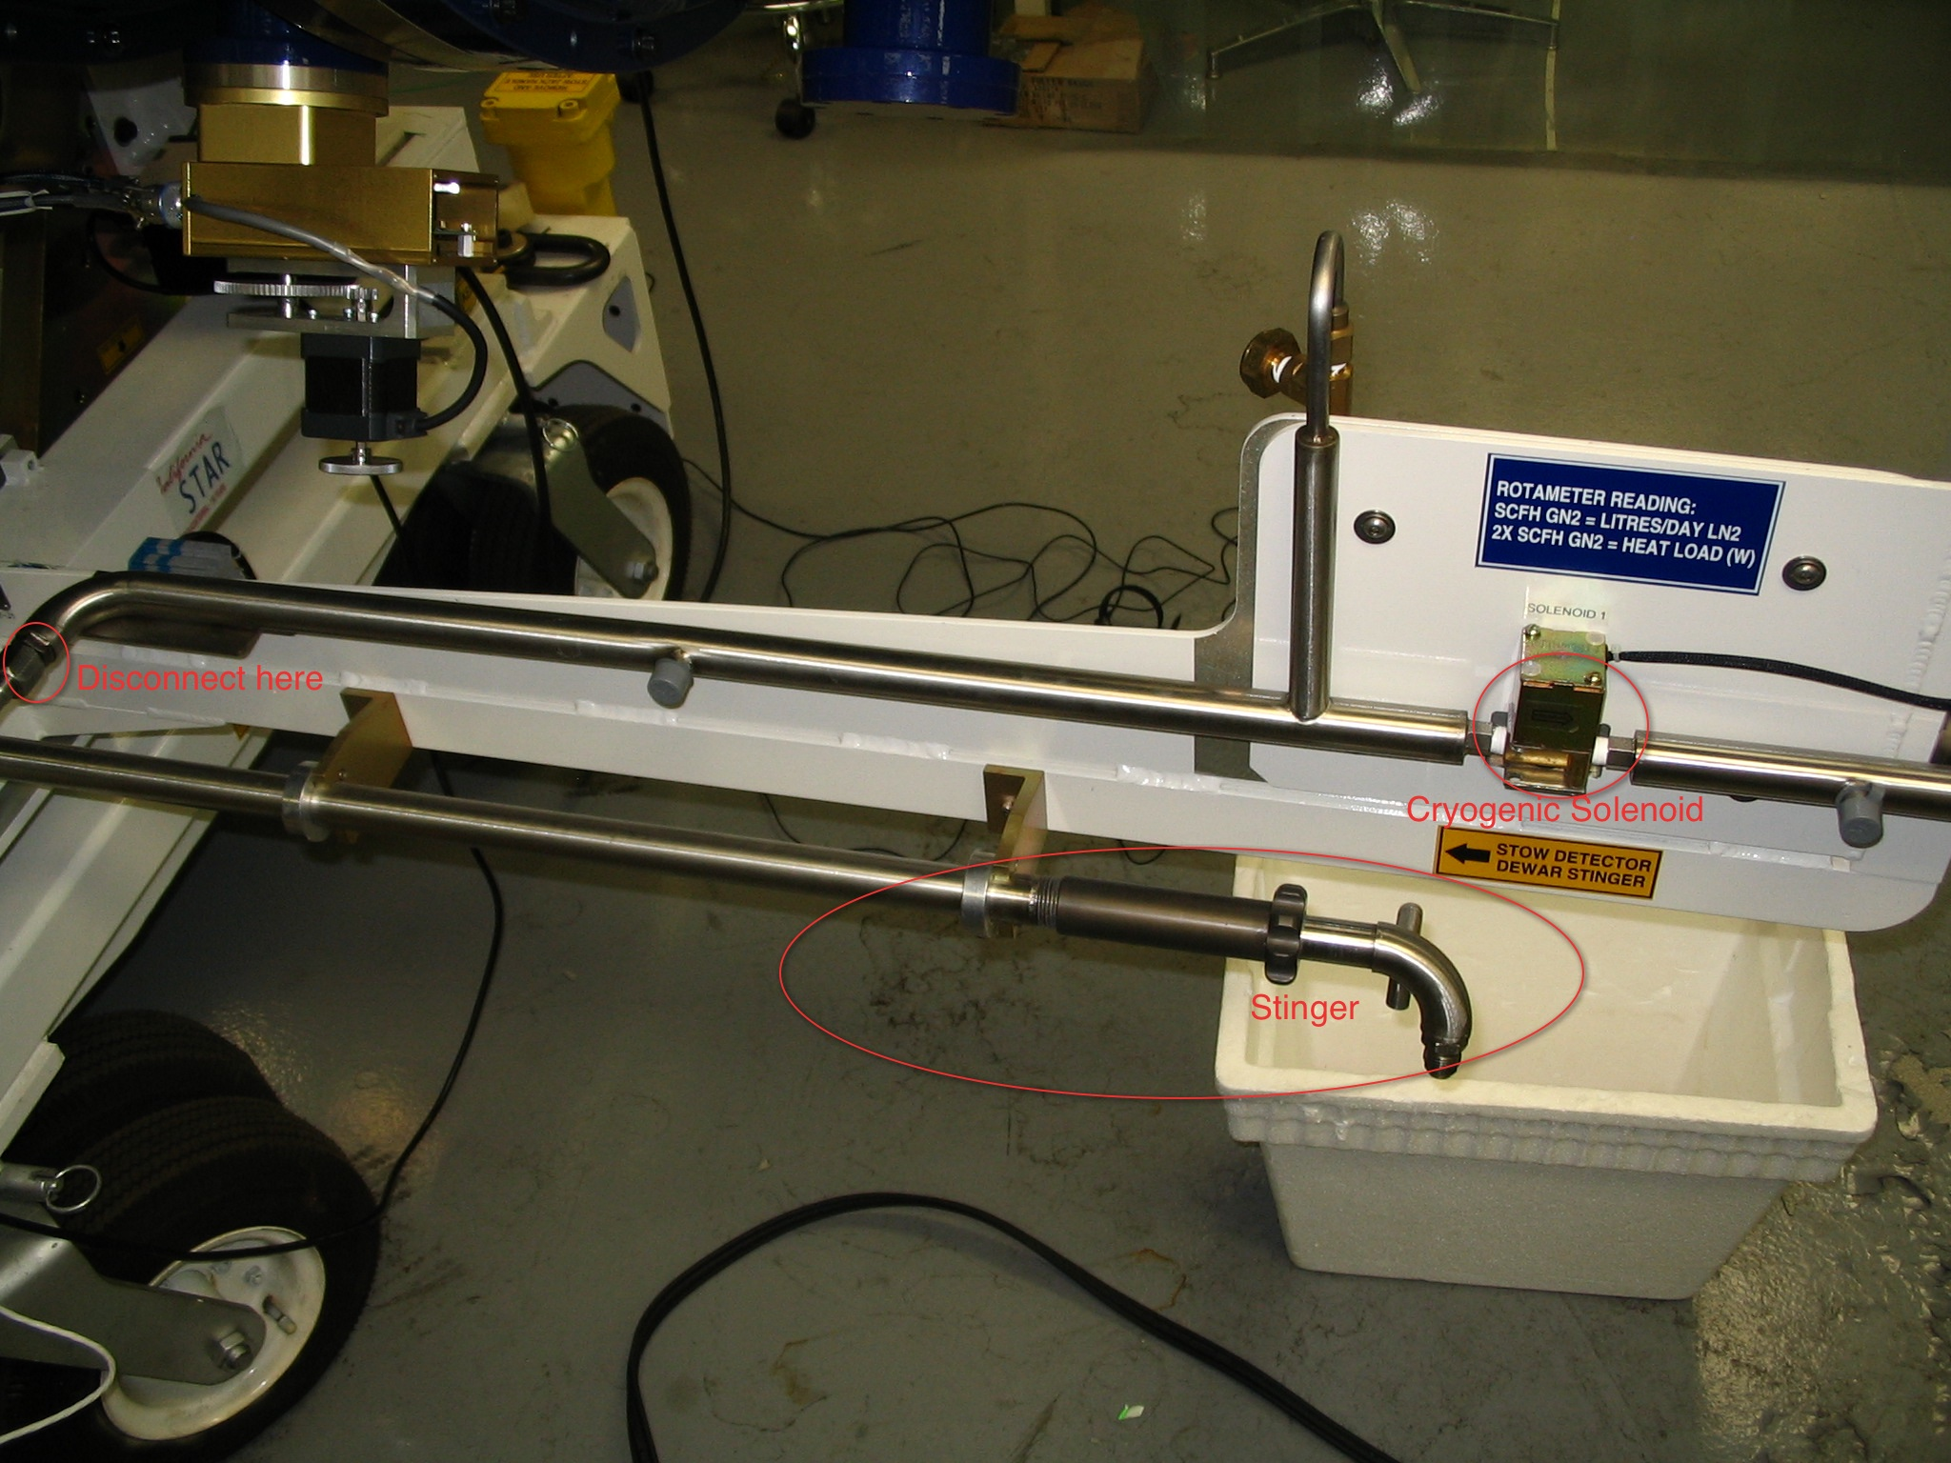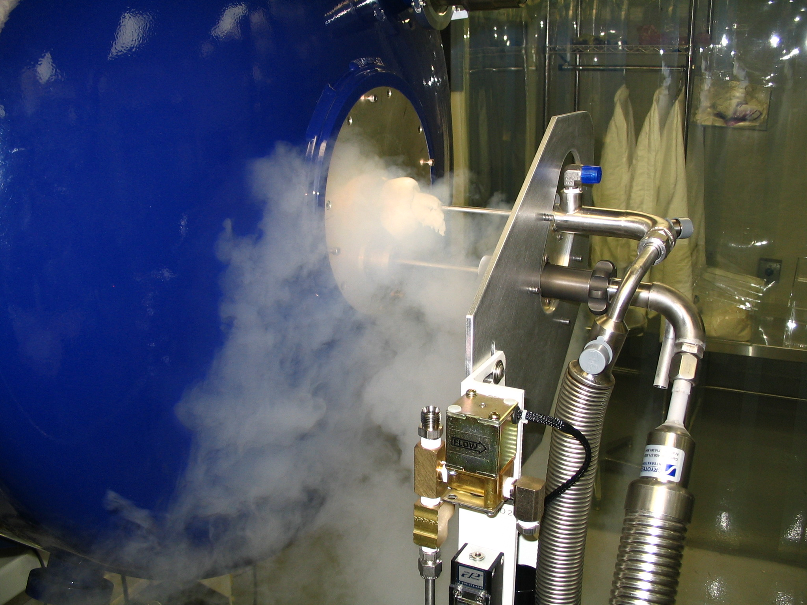
Figure 4.10 left: The detector Dewar stinger in its holster on Cart 1. Right: The stinger inserted into the detector dewar

Measure Read Noise
In order to check that the FourStar arrays and network communication is working it is a good idea to take a set of read noise measurements. The preferred method is measuring the variance of a number of short exposure dark frames.
- To find the read noise set the exposure time to 1.456 s (or 1 s; the software will set to the nearest possible exptime), set ReadMode to “Double”, set Gain to “FullWell”, set FilterCombo to “dark” and set Loops to “20” (This is a recommended value). Click “Go” to take 20 CDS reads.
- Open an xterm (if not already open) by clicking on the icon on the Dock. Under the Applications menu select “xterm” or type ⌘N. In the xterm window “cd” to the data directory where the 20 images were saved (i.e. DataPath1). Type rnoise.sh run num, where run is the run number of the sequence and num is the number of loops, in this case 20. The algorithm computes the variance of the central 1001 x 1001 pixels and returns the read noise (in ADU) for arrays 1-2-3-4, respectively; see Figure 4.11. To find the read-noise in electrons multiply the values obtained by the gain found in Table 2-1. If the read noise is higher than 20 ADU as reported by the ‘rnoise.sh’ script refer to Troubleshooting 5.1.5.

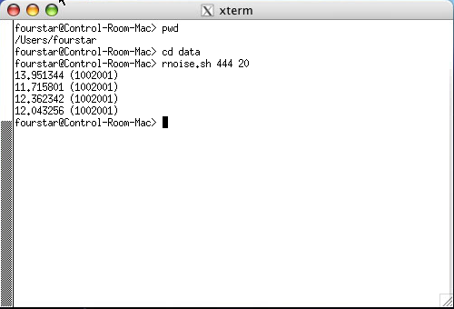
Figure 4.11 Xterm showing how to measure read noise.

Reduction Pipeline
The philosopy of the on-line data reduction system is to provide the observer with both quick-look data as a sequence (macro) of exposures is being executed, as well as a final data product that will be of sufficiently high quality that no further processing (e.g., at a home institution) will be necessary. In order for this goal to be realized, certain types of frames must be taken and saved in the data reduction library. Standard methods for obtaining and storing these frames follow:

Darks: For each combination of exposure time and gain setting used, or to be used, set the Loops counter to 25 (ExpTime < 30 sec), 15 (ExpTime 30 - 120 sec), or 10 (ExpTime = 120 - 240 sec). Set the Run# to the desired number and press Go. The resulting frames will be processed and stored automatically.

Hot/dead pixels: Turn on the flatfield lamp to a setting of XXXX, FilterCombo to "H", Gain = "LoNoise", Loops counter = 25, and Exptime = 15 sec. Press Go. The hot/dead pixel masks will be generated and stored automatically.

Domeflats: Follow the same procedure as for the hot/dead pixel masks, filter-by-filter. The following table gives the appropriate lamp settings and exposure times for each filter:

TABLE TO BE DONE

Twiflats: In general it will not be possible to obtain twiflats for more than two or three filters during a single twiflat session. The best order is Ks, H, J, i.e., from longer to shorter wavelengths as the sky emission fades. Set the ExpTime to 10 sec, Loops = 1, Gain = LoNoise, and take test exposures until the sky reaches a safe level, i.e., 20,000 ADU. Switch to Loops = 15 and Go. As soon as the loop finishes, change filters and repeat the procedure.

It should be noted that the twiflat exposures are used within the data reduction process only to generate pixel-by-pixel flats. The large-scale flatfield patterns are measured using the next step.

Starfield flats

TO BE DONE
- Record keeping
- On-sky performance
- backgrounds, image quality, throughput, efficiency
- Tel focus versus thermistor values
- how to report problems, nightly reports.

- Telescope interface
- vessel thermistor values and autofocus

Shutting down the System
In the event of an impending lightning storm or other urgent event that would lead to powering down the instrument here are the steps to shut down.

Shutting down on the Nasmyth Platform
- Rack 2: Turn off the Ion Pump (Vacion Controller) if it is on.
- Rack 2: Turn off the LN2 Process Controller.
- Rack 2: Turn off the Windows PC’s by holding the power button for 2 seconds. This will cause a proper shut down.
- Rack 1: Turn off the Windows PC’s by holding the power button for 2 seconds.
- Rack 1: Turn off both of the JADE power supplies (1/2 and 3/4).
- Rack 1: Turn off the Motor Controller.
- Check that the Nasmyth Mac on the FourStar cart is unplugged. Note: a green light is visible when there is power to the Mac, this does not mean the Mac is running, it is safe to unplug. If the light on the power button is on then the Mac is running. It can be powered off quickly by holding the power button until it powers off, then unplug it.

DECISION POINT: At this point most of the power consumption has been mitigated and FourStar is still quicky recoverable. Only proceed if there is danger of damage or if there is no need for a quick recovery. WARNING: Proceeding with the next step will result in the heaters being disabled and the detector and optics temperatures will drift low. It will take about as much time to recover as time that was lost in the outage, i.e. if the optics heater is off for 2 hours, it will take about 2 hours to re-equilibrate.
- Turn off power to Racks 1 & 2 by opening the red toggle switch cover and toggling the switch toward the cover. These switches are on the rear of the racks.
- Unplug the main power cord from the main power bus to minimize EMF.
With power off to the Autofill system the shroud dewar will have to be filled manually.

Shutting down the FourStar Computer System
This should be done from the Equipment room.
- Turn the rack monitor on by sweeping your finger across the power button (lower right corner).
- Access the Control-Room-Mac by pressing ‘1’ on the KVM switch.
- Close the FourStar software and any other applications that are running.
- Power off the Control-Room-Mac from the  pull down menu.
- Access the Data-Red-1 Mac by pressing ‘2’ on the KVM switch.
- Turn off the RAID chassis by accessing the RAID webpage; see next page. It will take approximately 2 minutes to shut down. Then turn off the power to the RAID by toggling the two switches on the rear of the chassis. Do not turn the power off until the shut-off command has been issued from the Webpage.
- Turn off the Brocade Fibre Channel Switch on the rear of the chassis (2 toggle switches).
- Power off the three Data-Red Macs from the  pull down menu. Access them from the KVM switch.
- Power off the KVM switch and CISCO Firewall. The switch is on the rear of each chassis.
- Unplug the Electronics Rack. The three Netgear switches will power off at this point.
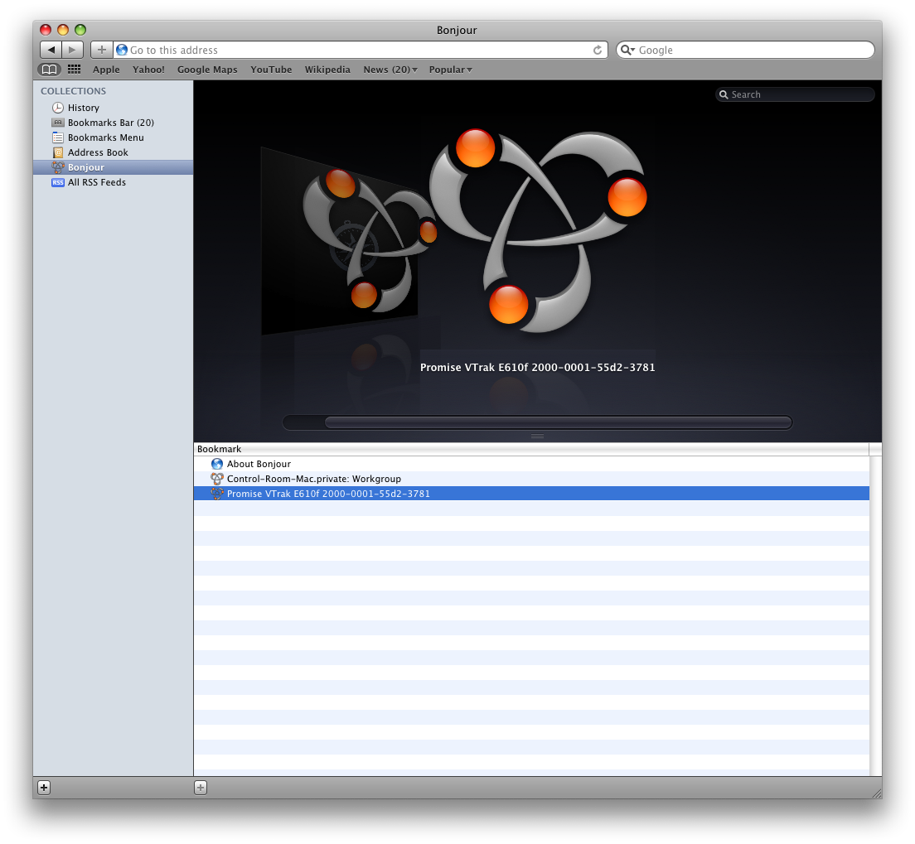
To access the RAID drives open the Safari webrowser and in the bookmarks menu select: Bonjour. The Promise VTrak Raid Chassis should appear on the bottom of the list as shown to the right. Double click it to open the login screen.

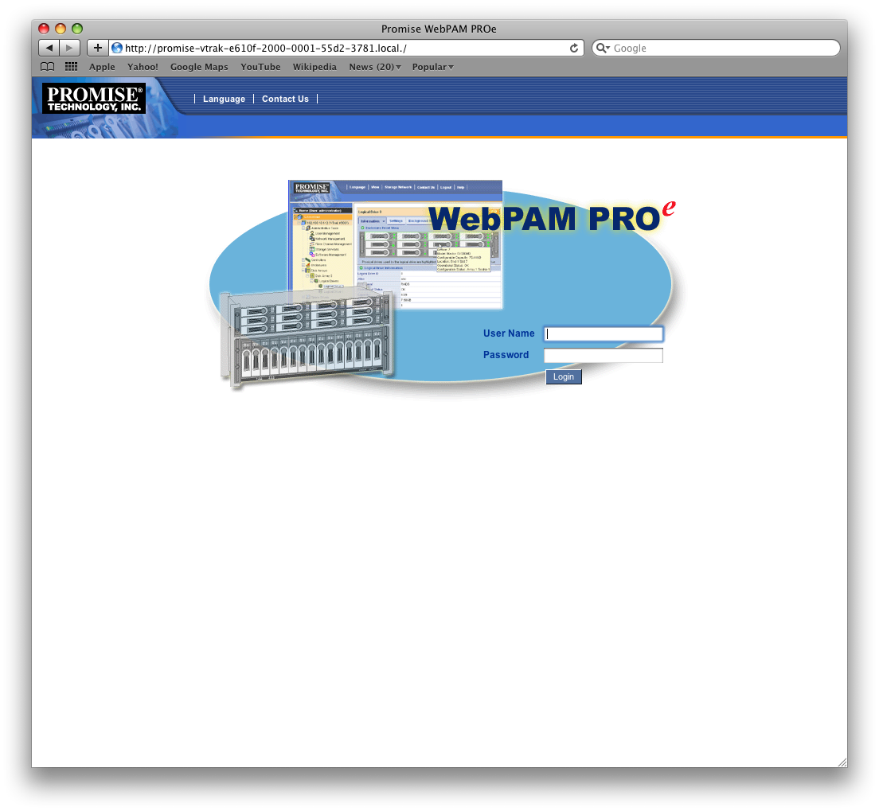
The RAID login screen appers as to the right. Enter the posted User Name and password. A pop-up window will appear warning about verifying the identity of the webpage; click Continue

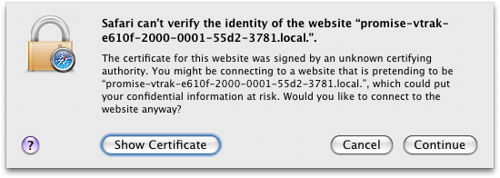

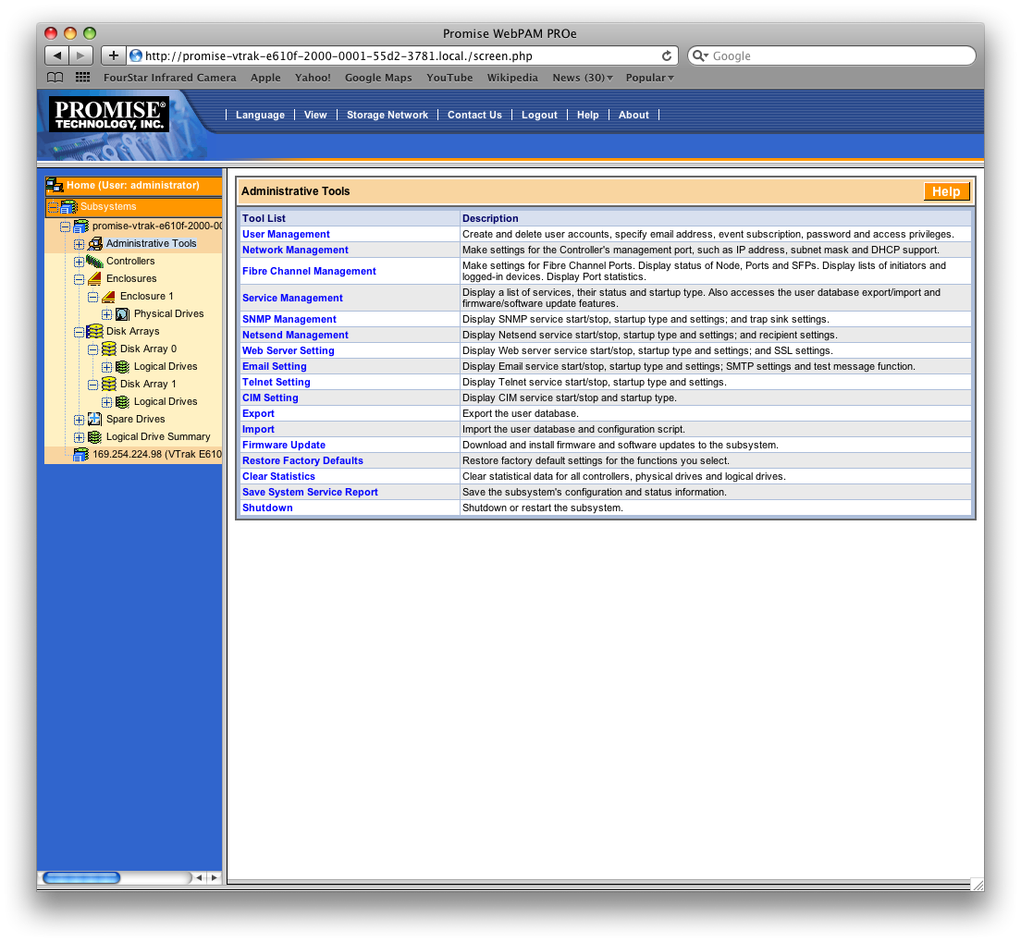
The RAID webpage will be displayed. Click on the Administrative Tools located on the left side menu. A list of Administrative Tools should appear as shown to the right. Select Shutdown at the bottom of the list.

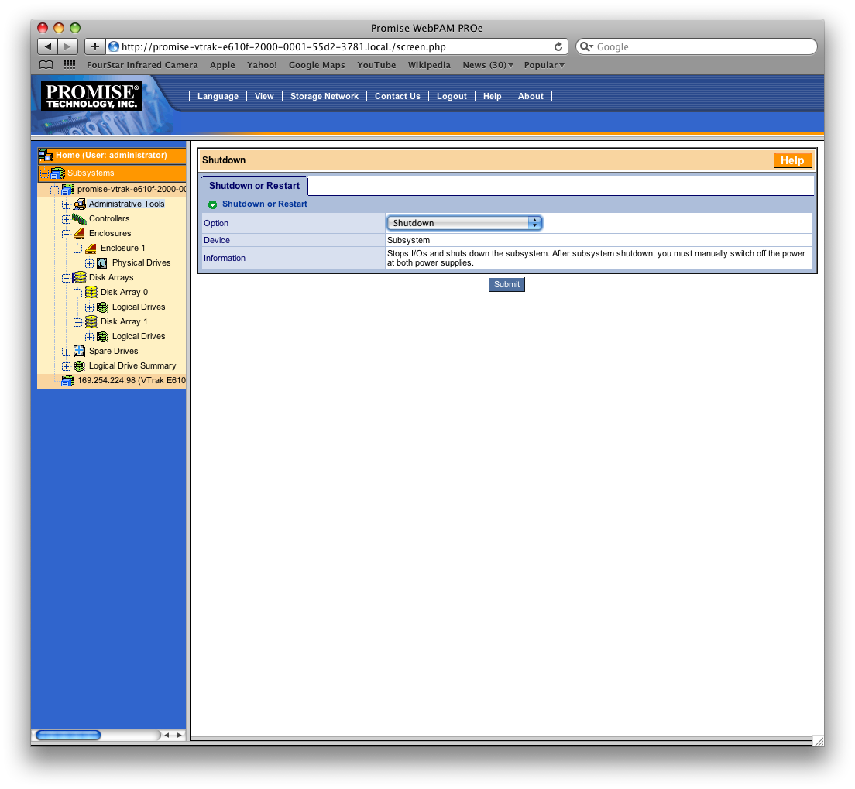
The Shutdown webpage will appear as to the right. Select Shutdown from the Option list and click Submit. Another Pop- Up will ask you to confirm the shutdown.

There is no confirmation that the RAID has properly shutdown. Wait ~2 minutes before physically powering down the RAID by toggling the two power supplied on the rear of the chassis.

FourStar Shutdown Checklist

SHUTDOWN: ON THE PLATFORM
Rack 2: Turn off Ion Pump (Vacion pump).
Rack 2: Turn off LN2 Process Controller.
Rack 2: Turn off 2 Windows PC’s (hold down square gray button for 2 seconds).
Rack 1: Turn off Motor Controller.
Rack 1: Turn off 2 Windows PC’s (hold down square gray button for 2 seconds).
Rack 1: Turn off 2 JADE power supplies (2 toggle switches in DIN slot above the PC’s).
Turn off and unplug the Nasmyth Mac located on the FourStar Cart (it should normally be off).
Unplug the Fiber to Ethernet Converter in the Junction Box (it should normally be unplugged).

OPTIONAL: ON THE PLATFORM, ONLY IN THE EVENT OF A SERIOUS THREAT
Rack 1: Turn off Rack 1. The power switch is located on the side under a red switch guard.
Rack 2: Turn off Rack 2. The power switch is located on the side under a red switch guard.

SHUTDOWN: IN THE EQUIPMENT ROOM
Access the Control-Room-Mac by pressing “1” on the KVM switch.
Close the FourStar software and shut down the Computer.
Access Data-Red-1 by pressing “2” on the KVM switch.
Power down the RAID chassis as described in the previous pages.
Shut Down the three Data-Red computers by accessing them via 2-3-4 on the KVM switch.
Power down the Brocade Fibre Channel Switch (under the keyboard).
Power down the KVM switch and CISCO firewall.
Unplug the Rack.

TROUBLESHOOTING

FourStar Error Messages and Minor Problems
These items suggest what to do in case certain symptoms appear.

VNC Screen Sharing slows to a crawl
Reboot the firewall in the FourStar Data Rack (in the Electronics Room).

A FourStar message box appears with a motor warning
Restart the FourStar software. If the problem persists check that all connections are okay then cycle the power on the motor controller and restart the software again.

The motors do not appear to be responding
Restart the FourStar software. If the problem persists check that all connections are okay then cycle the power on the motor controller and restart the software again. If the problem persists verify the correct IP address in the FourStar Startup menu and try pinging those IP’s and see if they respond. If all else fails replace the Motor Controller with its spare; see 5.2.3, Loss of the Motor Controller Unit.

Pupil Position reads “?” on startup
The Pupil position encoder read “Open” or “Closed” only if the linear pot is within a specified range; see Sec 6.5.2. View the motor status by accessing the “Show Motors” menu; see 6.1.2.2. Jog the position until it is within the range specified.

Read noise is higher than expected
Restart the system:
- Close the FourStar software.
- Restart the four data acquistion PC’s.
- Power cycle the two 5V JADE power supplies.
- Restart the FourStar software and try measrung the noise again. Make sure the “Cold” setting is selected and that #1 is set as the Master JADE.

Camera Control GUI inaccessible after starting FourStar software
If the Camera Control GUI remains grayed out (inaccessible) after starting the FourStar software, then it is likely the USB JADE device was not recognized by the Windows PC. This can be (optionally) verified by remotely accessing the Windows PC’s (6.2.1.2). If there is a JADE communication problem an error will be visible like that shown in Figure 5.1.
To remedy this follow these steps:
- Close the FourStar software.
- Disconnect the troubled USB cable from the JADE box; see Figure 5.2 & Figure 5.3.
- Turn off the JADE power supply in Rack 1, and then turn it back on.
- Re-connect the USB cable into the JADE box.
- Start the FourStar software again and see if the problem persists.
If the problem persists after 2 iterations restart the Windows PC. Hold the power button down for ~3 seconds and then release. This will cause the Windows PC to shut down properly. Wait until it powers off and then turn it on again. Wait 1 minute before starting the FourStar software.

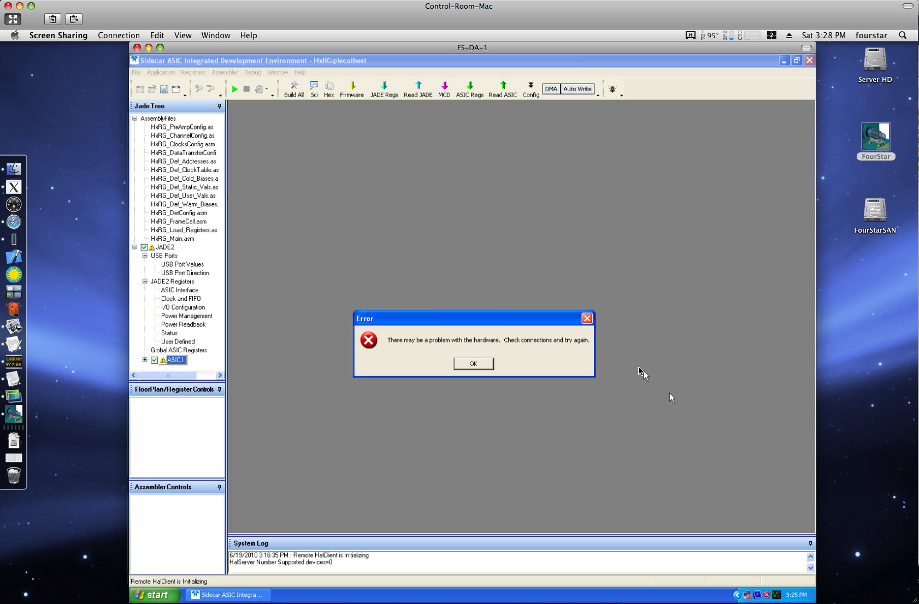
Figure 5.1 VNC screen sharing of a Windows PC showing a communication error with the JADE card.

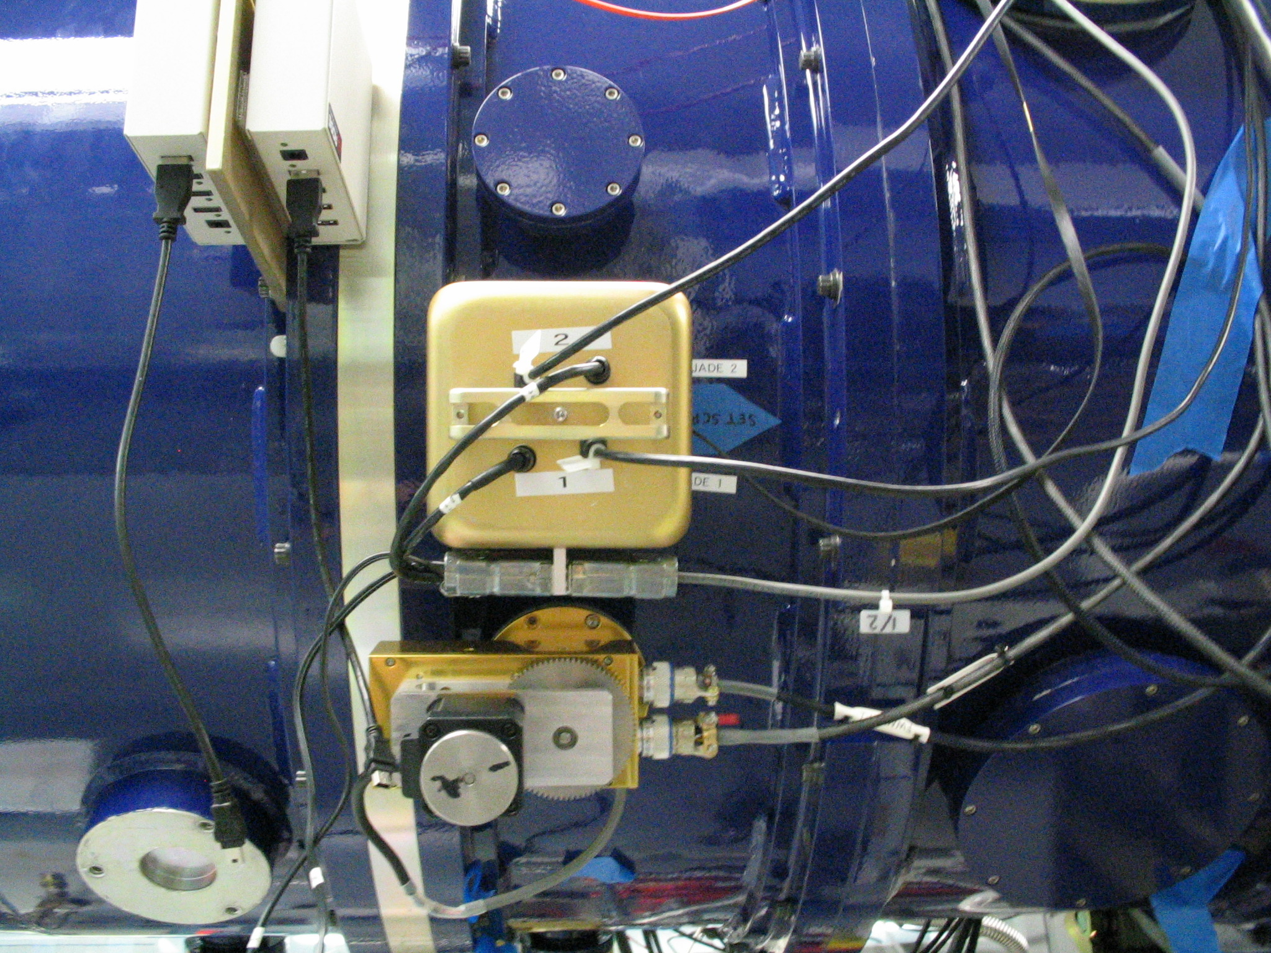
Figure 5.2 External JADE 1-2 box next to the top filter wheel motor. Each JADE card has a 5 volt power cord and USB connection.
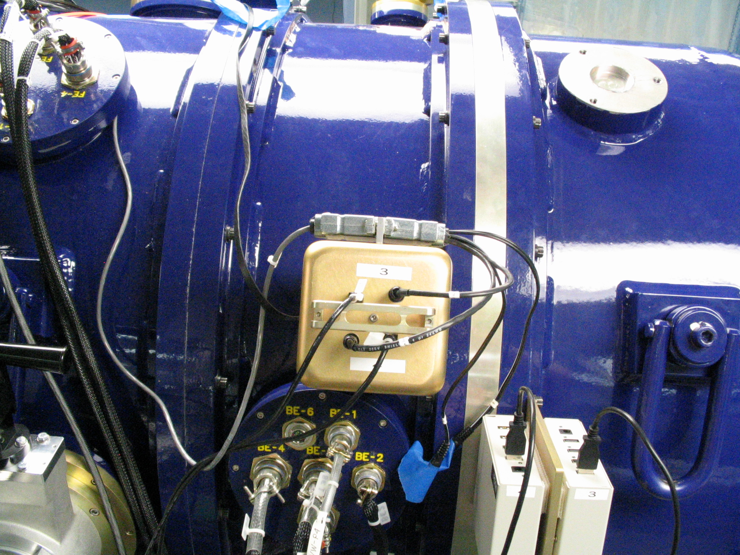
Figure 5.3 External JADE 3-4 box next to the back end (BE) connector bulkhead. Each JADE has a 5 volt power cord and USB connection.

Electronics Rack 1 & 2 Failures

General Considerations
If a system component of the FourStar data system is suspected of failing (for whatever reason) the first action should usually be to ascertain whether the device is responding to requests on the network. Remember, all instruments and computers composing the FourStar data system are at some level IP devices. One should look up the IP device of the problem system by referring to Table 6-1, open a terminal window on a computer residing within the FourStar data system network (for instance the Control Mac), and issue the command: ping 192.168.1.xxx
Failure to receive replies from ping requests indicates the device is unavailable due to:
- a failed network connection at the physical layer
- being powered down
- being in need of restarting
- being defective in some more serious aspect

A Data Acquisition PC fails (Rack 1 or 2)
This will cause the loss of one of the four imaging arrays until the problem is corrected. Also the read noise of the remaining detectors may increase. If the array #1 PC fails a new master will have to be designated in the FourStar Preferences window; see 6.1.1.2. Also, the malfunctioning array should be unselected from the “ChipSelect” option in the Preferences window to prevent commuication error messages from appearing.
- Temporary Solution (1-2 hours): Replace the lost Array Server with a spare Array Server; see 5.2.9. These spare computers are located in the FourStar spares cache and are labeled with their name and IP address on the front panel (e.g. FS-DA-BCKP, and 192.168.14). Once the spare is in place the FourStar software should be restarted with the appropriate new IP address set in the: Startup IP-Numbers tab.
- Long-Term Solution: A long-term solution to dealing with a failed Array Server is to repair it. This may involve actions such as replacing the power supply or processor board. Repairs might require rebuilding a failed hard disk from a cloned copy. Some of the more specialized spare parts are available in the FourStar spares cache. This repair operation is a task for technicians with experience in PC repair.

Caveats:
The efficacy of replacing an array server is very dependent on the current state of the disk on the spare server and how well it reflects the state of the disk on the system it is replacing. Generally speaking it is expected that by the time FourStar is commissioned, the spares will all be stable and have a disk which is an accurate image of Array Server #1, i.e. FS-DA-1. If this fact is in doubt then efforts should be made to achieve this goal. The safest way is to clone the disk of FS-DA-1 onto the backup Array Server as described in 6.2.7 Cloning an Array Server System.

When replacing an array server care should be taken that the correct PC gets replaced. It is the physical position of the PC that defines which array it corresponds to, not necessarily its label. Rack 1 contains the array servers for array #1 and #2, top and bottom, respectively. Rack 2 contains the array servers for array #3 and #4, top and bottom, respectively. See Figure 4.1 The FourStar Electronics Racks.

One should be careful to cable the replacement computer identically to the installed unit. There are two versions of the PICMG processor boards used on the Array Servers: The AxiomTech SBC81870 and the AxiomTech SBC81872. Both versions have two Ethernet interfaces. On the SBC81870, one Ethernet interface (LAN 1) has a maximum speed of 100 Mbps, and the other 1000 Mbps (LAN 2). It is crucial to the FourStar camera operation that when cabling a replacement Array Server in the electronics rack the 1000 Mbps Ethernet interface be selected. When viewed from the rear of the Array Server chassis, LAN 2 is the left most of the two RJ-45 Ethernet connectors. The SBC81872 based Array Servers also have two Ethernet interfaces implemented on RJ45 connectors CN18 and CN19. From the rear view, CN18 is to the right. Both of these are 1000 Mbps ports, although ordinarily only CNxx is enabled in Windows and this is the only Ethernet port that should be connected. Because of the critical nature of the selected Ethernet port it is important to verify any time an Array Server has been replaced that the correct port was selected and that it is operating at 1000 Mbps. This is done by booting Windows, opening the Control Panel (classic view) and selecting “Network Connections”. The Network Connections window should open and show the current Ethernet connections and their data transport speed. Right click one of the displayed connection icons to obtain further details (or look at the port status lights on the NetGear switch, green+green is 100Mbps and green+yellow is 1000Mbps). The spares have blue masking tape over the wrong port to discourage their use.

Loss of the Motor Controller Unit (Rack 1)
This disables remote operation of FourStar motors. If stuck in a filter combination that is useful observations can still continue. FourStar mechanisms can be moved by hand if necessary, although an instrument specialist is required to approve and conduct of this operation. There is no direct feedback about current filter configuration without the motors controller.
- Temporary Solution (1-2 hours): Replace with spare Motor Controller; see 5.2.9.
- Long-Term Solution: The long-term solution to this problem is to repair the failed motor controller. Complete documentation and a generous set of spare parts for this exist. Significant electronic expertise is required.

Loss of the Process Controller Unit (Rack 2)
This will prevent remote reading of the LN2 levels, vacuum, external and rack temperatures. A manual reading of the vacuum can be made using the spare MKS gauge. The LN2 levels will have to be monitored closely (the internal temperature sensors show telltale signs of warming up when LN2 is low) and filled manually.
- Temporary Solution (1-2 hours): Stop the control software and replace the Process Controller with the spare Process Controller; see 5.2.9.
- Long-Term Solution: The long term solution is to repair the failed Process Controller. A few spare parts and documentation exist for this. Electronics expertise is required.

Loss of the KVM Switch (Rack 2)
The loss of this unit (called the “Smart CAT5 Switch 16 IP”) will disable access to the FourStar Array Servers made through KVM connections on the Nasmyth platform (or in the lab), or through Safari via Ethernet. The Array Servers should still be accessible through VNC (see 6.2.1.2) when they are booted and running Windows XP. Thus, unless hardware problems are being encountered with the Array Servers, loss of this KVM switch should not immediately disable or affect operation of FourStar. This failure should still be addressed at a convenient time, and this is done so by replacing the KVM switch with its spare.
- Temporary Solution: Do nothing.
- Long-Term Solution: Replace with its spare (see 5.2.9) and a new and preferably identical KVM switch should be purchased (or the defective one repaired if possible).

Loss of a LakeShore 340 Temperature Controller (Rack 1 or 2)
The loss of either of these units will prohibit the temperature stabilization of either the detectors or the optics; which is undesireable. Note: The backlight for the displays on these units do not work when below ~20C, so if the display does not appear to work it may simply be too cold for the display. The unit should otherwise be functional.
- Temporary Solution (1-2 hours): One of the two available LakeShore spares should be substituted for the defective unit; see 5.2.9. All the LakeShore 340 (LS340) units should be effectively identical in hardware. Depending on which LS340 was replaced the appropriate settings need to be configured from the front panel of the LS340; see 6.7.
- Long-Term Solution: Unless something very elementary is wrong such as a blown fuse, field servicing of this unit is usually difficult and it is recommended that it be sent to LakeShore for repair.

Electronics Rack Overheats (Rack 1 or 2)
The temperatures of the various chassis within the two racks are supposed to be kept at safe levels (below 32 C) by the heat exchanger/fan system that is part of each rack. The temperatures are monitored by the control system as explained in 6.1.6. In addition, each rack has a thermal cutout switch that will cut the AC power to the rack if the temperature exceeds 40 C. Should this occur, the switch can be reset by removing the small access port cover and manually pushing the button; see Figure 5.4. However, this should not be done until and unless the cause of the overheating has been identified and fixed. There are two possibilities:
- Either one or both of the fans have quit working. The only way to check the fans is to remove the large cover. If a fan motor has failed, it must be replaced before resuming observations; see 5.2.9.
- The flow of glycol has been interrupted. In this case, the telescope cooling system must be investigated and returned to normal operation before resuming observations.

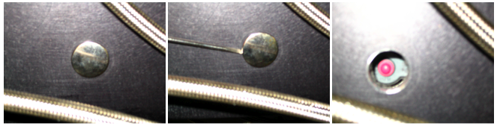
Figure 5.4 Thermal Switch access for Rack 2. A small flat-head screwdriver works well to remove the plug. The red button just needs to be pushed to reset the switch.

Other Items (Rack 1 or 2)
There are several miscellaneous support items such as power supplies, Ethernet-to-Serial converters, and other passive components in the FourStar electronic racks. Acsertaining faults for these items may be time consuming and/or difficult. In most cases spares exist for these components.

How to swap out an Item in an Electronics Rack
This is a procedure for how to replace an item in case of failure to any one of the following electronics units: Windows PC, Motor Controller, Process Controller, JADE Power Supply, Lakeshore Temperature Controller, NetGear switch, KVM switch or the Heat exchanger or Fan. Note: The spare Process Controller contains the spare Varian-VacIon Controller. If the Varian-Vacion Controller fails simply replace the entire Process Controller unit.
- Remove FourStar from the telescope; see 6.3.5-How to Remove FourStar from the Instrument De-rotator.
- Rotate the instrument (by hand) for easy access to the desired rack.
- Remove glycol heat sink from the cover of the rack that needs to be opened. There are fifteen #8-32 socket head cap screws. Fold the heat sink out of the way and tie it down (cable ties in FourStar Cart drawer).
- Gently remove the rack cover by removing the eight stainless steel (silver colored, not black) button head screws and place it out of the way on the platform.
- Disconnect the cables from the back of the unit to be replaced.
- Remove the unit and mount the spare. Note: the Motor and Process Controllers are mounted on rails with locking catches on the sides that need to be pressed in while removing / inserting.
- Re-connect the cables to the unit in the correct place (they are labeled).
- Before closing up the rack, check that the spare is working by:
- Connect the platform power cable to the main power bus on FourStar.
- Power on both racks, turn on the JADE power supplies (rack 1) and start the Windows PC’s.
- Start up the Nasmyth-Mac and start the FourStar software. Verify that the instrument status is being read properly and that image acquisition is working properly.
- Once everything is working properly close the FourStar software and shut down the Nasmyth-Mac.
- Shut down the Windows PC’s (by holding the power button for 3 sec) and turn off the JADE power supplies.
- Turn off power to the racks and disconnect the platform power cable from the main power bus on FourStar
- Replace the rack cover and heat sink.
- Re-attach FourStar to the telescope; see 6.3.4.

Control Room or Equipment Room Failures

General Considerations
If a system component of the FourStar data system is suspected of failing (for whatever reason) the first action should usually be to ascertain whether the device is responding to requests on the network. Remember, all instruments and computers composing the FourStar data system are at some level IP devices. One should look up the IP device of the problem system by referring to Table 6-1, open a terminal window on a computer residing within the FourStar data system network (for instance the Control Mac), and issue the command: ping 192.168.1.xxx
Failure to ping requests indicates the device is unavailable due to:
- a failed network connection at the physical layer
- being powered down
- being in need of restarting
- being defective in some more serious aspect

The Mac Mini in the control room fails (Control Room)
The FourStar software will still be running and can be accessed by VNC from a different computer.

The Control-Room-Mac fails (Equipment Room)
- Temporary solution (Fast): Observations can resume by powering on the Nasmyth-Mac on the platform and running the FourStar software from there; see 4.1.2.1. As with the Control Mac, the Nasmyth Mac is a client of the Xsan2 cluster and most other functions should appear identical to the Control Mac from the users point-of-view. The control room speakers will not render audio cues when using the Nasmyth Mac. To archive user data, portable USB disks will need to be directly connected to the Nasmyth Mac on the Nasmyth platform. The Nasmyth Mac has a front panel USB connector to facilitate this.
- Mid-Term Solution: Requires at least 1 hour when it will not interfere with observing. Swap the Nasmyth-Mac with the Control-Room-Mac.
- Long-Term Solution: The long-term recover scenario for the Control Mac is to repair it. If a failed system disk is the suspected problem, a mirror image spare is available to replace this. A spare system board, spare memory, and a spare power supply are also available. If work on the computer chassis needs to be performed, the computer should be removed and taken to a static free workbench for servicing. If the computer is capable of booting, hardware diagnostics are available on the Apple system install disks found in a plastic portable file storage box marked “FourStar Boxed Software”.

A Data-Red-Mac’s fails (Equipment Room)
- Temporary solution (Fast): Observations can resume by doing nothing.
  - Why: The other Data-Red-Macs will process the data albeit slower. Data-Red-1 is the Primary MetaData Controller of the FourStar Xsan2 cluster. Data-Red-2 and Data-Red-3 are standby MetaData Controllers. If Data-Red-1 fails, then Data-Red-2 immediately and automatically assumes the role of a MetaData Controller and the Xsan2 cluster continues to operate. If Both Data-Red-1 and Data-Red-2 fail, Data-Red-3 immediately and automatically assumes the role of Primary MetaData Controller and the Xsan2 cluster continues to operate. The loss of any one of the data reduction Macs results in the loss of eight processing cores (of 24 available normally). The online data reduction pipeline can operate, if necessary, with as few as eight cores.
  - However: If the computer hosting the FourStar Master Control Program (MCP) of the pipeline fails, the pipeline must be stopped and reconfigured to recognize the changed hardware environment, and then restarted. The FourStar Instrument Specialist or Scientist would ordinarily be called upon to perform this activity.
- Long-Term Solution: See Long-Term Solution of: The Control-Room-Mac fails-5.3.3.

Loss of an Individual RAID Drive Disk Drive Unit (Equipment Room)
- Temporary Solution: Do nothing. The system will recover automatically in real-time using RAID-5 capability. No data will be lost, data acquisition may continue, and the pipeline should continue to operate with very little impact on performance.
- Long-Term Solution: Eventually the failed drive unit should be replaced with one of the hot spares active in the RAID chassis. The failed drive should be removed and a spare hard drive from the FourStar spares cache should be installed in the Promise chassis. This will automatically build itself into a new hot spare. Consult the Promise Raid manual found on the FourStar Web site for more details.

Loss of a Promise RAID Drive Controller (Equipment Room)
- Temporary Solution: Do nothing. There are two redundant drive controllers on the Promise chassis and failover will be automatic. Some degradation in RAID performance may be noticed, but otherwise the data system should perform normally.
- Long-Term Solution: Replace the Promise controller with the spare Promise controller from the FourStar spares cache. This should be hot-swappable.

Loss of a Promise RAID Drive Power Supply (Equipment Room)
- Temporary Solution: Do nothing. There are two redundant power supplies. There is no impact on the data system.
- Long-Term Solution: Replace the failed power supply from a spare found in the FourStar spares cache. This should be hot swappable.

Loss of the Brocade Fibre Channel Switch (Equipment Room)
This will cause the RAID volume to go offline and the pipeline will be disabled. It is still possible to operate FourStar and acquire data. The data will be stored to the Control Mac internal drive (and possibly to user USB 2.0 portable disks, if configured that way by the observer).
- Solution: Remove the failed Brocade switch from the Server Data Server rack and replace it with the spare Brocade switch. Note that the spare unit only has 24 of the 32 Fibre Channel ports activated (1-24). However this is more than enough since only 21 ports are used, but one must take care to avoid connecting to inactive ports 25-32. The FourStar Macs will all probably need to be rebooted after replacing the Brocade switch, preferably starting with Data-Red-1, the Primary Metadata Controller. The two Brocade switches use the same type of power supply and these are easily swappable as need be.

Loss of a Netgear GS716T Ethernet Switch (Equipment Room)
Four of these switches are in use. Two of them form the main data communications 1000 Mbps fiber backbone, while the other two are used to implement necessary switching for the networks that form the pipeline Xsan2 cluster. If either of the backbone switches fail, the FourStar data system will essentially be disabled until it is replaced. If the switch in the camera electronics rack were operational, but not the one at the other end of the backbone in the FourStar Cluster Rack, in theory the camera could still be operated with the Nasmyth Mac, although a monitor, keyboard, and mouse would be needed to access this computer. If either of the Ethernet switches supporting the Xsan2 cluster were lost, the reduction pipeline would fail, but the camera would remain operational and data could be logged to the internal drive on the Control Mac and to user supplied USB drives. Note that when a GS716T is replaced, it may also be necessary to replace (or retain from the replaced switch) the small form factor (SFF) 1000BaseFX adapter accessory found on most of these switches that support fiber connectivity.
- Solution: Replace malfunctioning unit with a spare.

Appropriate Response to FourStar Email Alerts
If an email alert is sent out then some aspect of FourStar is not behaving as expected.

FourStar WARNING: Optics-Heater-Power low (XX W)

FourStar WARNING: Shroud-Dewar temperature high (XX K)

FourStar WARNING: last shroud dewar fill more than XX hours ago

FourStar WARNING: LN2-solenoid open for XX minutes

FourStar WARNING: LN2-solenoid closed for XX hours

FourStar WARNING: Dewar pressure high (XX Torr)

FourStar WARNING: LN2-Level(Shroud) is at XX%
- Immediate Action: Check shroud dewar fill level
- Follow-Up Action: Contact FourStar personnel.

FourStar WARNING: Detector-Heater-Power low (XX W)

FourStar WARNING: LN2-Level(Detector) is at XX%
- Immediate Action: Check detector dewar fill level
- Follow-Up Action: Contact FourStar personnel.

FourStar WARNING: LN2-Processor Alarm/Error
- Immediate Action: Cycle the power on the LN2 processor and restart the FourStar software.
- Follow-Up Action: Contact FourStar personnel.

FourStar WARNING: E-rack temperature is XX [C]
- Immediate Action: Turn off items in Electronics Racks to prevent further overheating. Check the glycol lines and heat exchangers.
- Follow-Up Action: Contact FourStar personnel.

APPENDIX

FourStar Software Interface

FourStar Setup Descriptions
All of the Online/Simulator options should be set to ‘Online’. Refer to 6.2.6 for Simulator mode network diagnostics.
- Observer: The Name of the observer as it will appear in the fits image headers.
- Camera Control: By checking the Camera Control box, the Camera Control GUI (module) will be available on startup. In Online mode the control computer will talk to the StarServer (Windows PC) pointed to in the IP-Numbers table and that StarServer will communicate with the JADE/ASIC/SCA (Sensor Chip Assembly) hardware to provide the actual data.
- Motors: The motors are considered part of the Camera Control and should remain online.
- Temperature Control (Detector): By checking this box the detector temperature control is displayed. This should be set to Model-340 with the appropriate IP address set in the IP-Numbers tab.
- Temperature Control (Optics): By checking this box the optics temperature is displayed. This should be set to Model-340 with the appropriate IP address set in the IP-Numbers tab.
- Temperature Monitor (Back): By checking this box the back end temperatures are displayed. This should be set to Model-340 with the appropriate IP address set in the IP-Numbers tab.
- Temperature Monitor (Front): By checking this box the front-end temperatures are displayed. This should be set to Model-340 with the appropriate IP address set in the IP-Numbers tab.
- LN2-Controller: By checking this box the LN2 levels, automatic fill, pressure gauge, ion pump status and instrument external temperatures are displayed. This should be set to Online.
- Telescope: By checking this box the telescope control interface will be available. This should be set to “Baade”.

When the software is started the JADE/ASIC configuration code will be uploaded to each array with array-specific parameters. By default, the master JADE/ASIC pair will upload first which should take ~30s followed by the remaining JADE/ASIC pairs which will take approximately another 30s. Note: The FourStar Control GUI exposure contols will be inaccessible during the upload phase. The status can be monitored by remote viewing the Windows PC’s (6.2.1.2) or by the Show H2RG option on the FourStar-Control GUI (6.1.2.3). Wait at least one minute before trying to take an exposure.

If the camera control GUI remains inaccessible it may be that the USB JADE device was not properly recognized by the Windows PC; see 5.1.6.

Observer Fits Header Keyword
If the observer wants the fits header keyword ‘Observer’ to be something other than the default, then under the FourStar pull down menu select Startup. Edit the Observer field and click OK. Don’t alter the other fields. See Figure 6.1 for details.

Figure 6.1 Updating the Observer header keyword from the FourStar-Setup tab
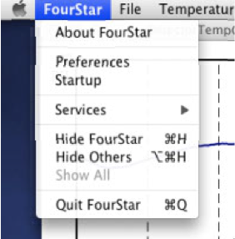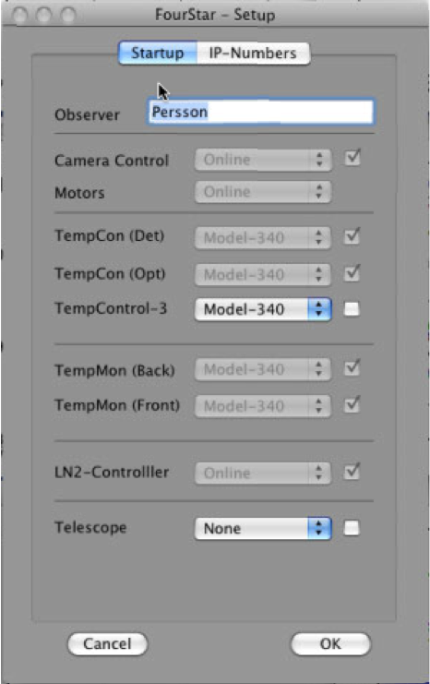

Change the FourStar Startup Preferences
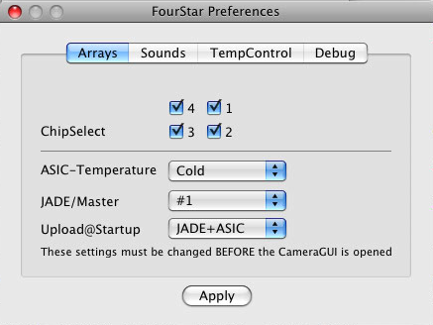
The default values should normally suffice. The only reasons to change these settings, is for engineering in the clean room, or if an alternate temperature control sensor needs to be used. From the FourStar menu select Preferences. On the Arrays tab select the options as shown.
- ChipSelect: Select which chips to display in the Qltool.
- ASIC-Temperature: Cold/Warm, uploads relevant ASIC code. Warm is for engineering mode in the cleanroom only. Use Cold while on the telscope.
- JADE/Master: Select which JADE card to use as the master clock generator. This is determined in hardware by the sync-cable; #1 is the default.
- Upload@Startup: JADE+ASIC is the default. When selected the master JADE is brought online first (~30 sec) and then 2-3-4 are brought online (~30 sec). If ‘None’ is selected then no code is uploaded to the JADE or ASIC. This option can save time if the software was accidentally closed and was restarted in which case as long as the code was previously uploaded to the JADE and ASIC they will still be operational.

Use an Alternate Control Temperature Sensor
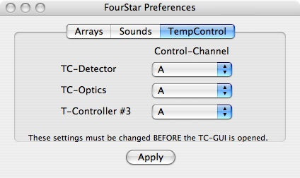
The controllers use by default the temperature sensor coming into channel A of each controller. If a control temperature reading becomes unrealistic or flakey it can cause the controller to react by supplying too much or too little heat to the system. It is possible to change which sensor is used to monitor the detector and optics. In the Fourstar menu under Preferences change the Channel used by that controller to a different one nearby that is working correctly. The backups for TC-Detector should be D2 and for TC-Optics D2 (Both D2).

FourStar Control GUI Description
The four boxes within the FourStar-Control GUI contain the following:
Exposure: Defines the exposure details.
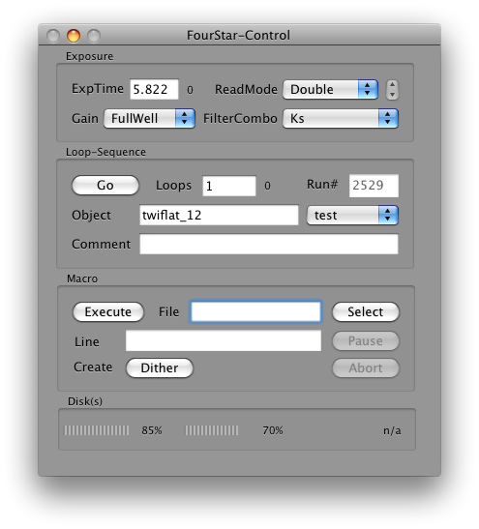
- ExpTime: The exposure time (in seconds) per frame. The minimum increment is 1.456s. You may enter any exposure time and the software will adjust the exposure time to the nearest available value.
- ReadMode:
  - Double: Correlated Double Sample (CDS) Read; use for high background.
  - Fowler N: Fowler sample read N times, where N is controlled with the up/down arrows; use for low background.
- Gain:
  - FullWell: Higher dynamic range; use for high background.
  - LoNoise: Low noise setting; use for low background.
- FilterCombo: Select desired filter. The software will prevent taking exposures while moving the filter wheels. It should take less than 30s to reach any filter combination.
Loop-Sequence: Start taking images.
- Go button: Start exposure sequence—Does not execute a macro.
- Loops: The number of identical exposures.
- Run#: Identifies the next exposure or loop of exposures.
- Object: The name of the object being observed.
- Object type: (Pull down menu) writes object type flag to image header.
Macro: Take images with a defined dither/mosaic/filter pattern; see 6.15-FourStar Macros
- Execute: Starts current macro indicated by “File.”
- Select: Select a macro from a location.
- Abort: Aborts current macro; lose current exposure.
- Pause: Pauses current macro but finishes current exposure loop. A dialog box will open prompting to resume when ready.
- Line: Displays current line of macro being executed.
- Create: Dither: Select pre-defined dither pattern; see 6.15.1-Using default macros.
Disk(s): Displays current disk usage for each data path currently being accessed. A warning will appear when the disk limit is being reached (how much?)

Quicklook and Magnifier Display
Displays data as read out from the ASIC’s, reference pixel subtracted (see 6.8-Reference Pixel Subtraction), otherwise non-processed. Access from the Camera menu: Show Qltool.

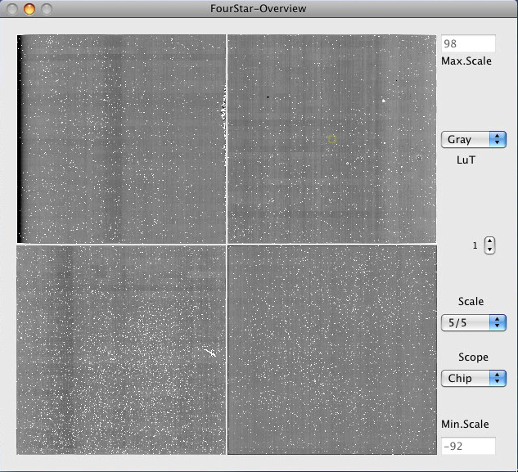
- LuT: Change display color scheme.
- Scale (z1 and z2 in IRAF speak), options; Full: display the full range of pixel values, 3/3:, 5/5:, 5/10:, Man: Manual scaling controlled by Min.Scale and Max.Scale
- Scope: Scales arrays on a chip by chip basis or a global basis. The chip mode helps if there are offsets on each chip, useful in engineering modes.
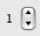
- scroll through loop number in the currently displayed run.

Magnifier: Displays region of interest as outlined in the FourStar-Overview window. You can move to a region by dragging the square region of interest or by clicking anywhere in the Overview display window.

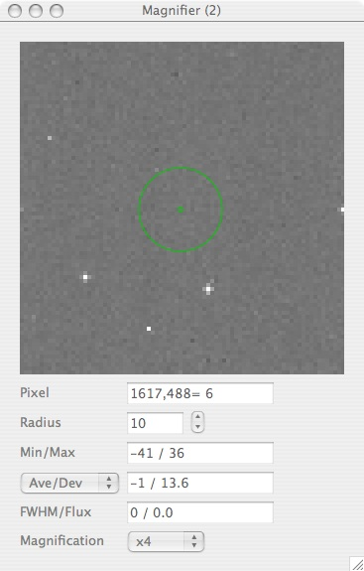
- Pixel: Displays current pixel location and value. You can scroll the current position by using the arrow keys (by holding either the CTL or OPTION key you can scroll by 10 pixels, holding both you can scroll by 100 pixels).
- Radius: Set the radius of the aperture for statistics.
- Min/Max: Displays the minimum and maximum value within the display aperture.
- Ave/Dev: Displays the average and standard deviation of pixel values within the aperture. Various sigma-clipping algorithms are available from the drop down menu.
- FWHM/Flux: Press SPACEBAR to measure the FWHM (in Pixels) and Flux (in ADU’s) of the source in the aperture; centroiding is done on the brightest object within the aperture.
- Magnification: Control the magnifier window size.

Show Motors
From the Camera pull down menu select ‘Show Motors.’ A dialog box will prompt for a password (consult the FourStar password list). Once the password is entered hit ‘OK’ and then select ‘Show Motors’ again. If the password was accepted, a hidden panel will emerge from the FourStar-Control GUI that will allow moving the FourStar motors individually; see Figure 6.2.
- If any line is grayed out then that motor is in motion.
- The Counter box displays the current number of pulses the motor controller has issued since activated (DR mode only).
- The Pulses box displays the number of desired pulses to apply to the motor. Clicking the circles below the - and + symbols specifies directionality.
- Under the Port column are flags designating whether a position is in a detent position ‘D’, the home position ‘DH’ (since the home is also a detent and they are independent switches) or not in a detent BLANK. Clicking Port returns the immediate status of the positions.
- The top, bottom and field-flattener wheel are normally operated in the Encoder = ‘Ok’ mode; which means everything is working OK, i.e. the encoder and switches are working in harmony. As a fallback, the encoder = ‘DR’ (Dead Reckoning) mode is available in which the counter position and known offsets are used to move to the desired filter position, determined by the Port flag.
- The Home button will move that item to its designated Home position, which are the open positions for the filter wheels and the FakeStar lens for the field-flattener wheel.
- The Pupil position is either open or closed as determined by the readout of a linear pot inside FourStar. The values for closed should be 26000±20 and 41000±20 for open. A limit-switch prevents the iris from moving too far in either direction designated by a F(o) and F(c) under the Port column.
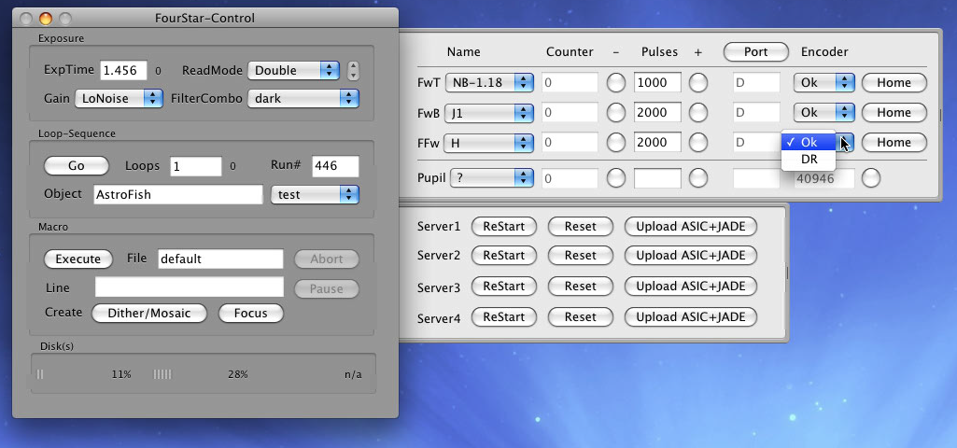
Figure 6.2 The Motors and H2RG panels shown coming from the Control GUI.
If the FilterCombo dialog bog box return a value of ‘undef’ (un-defined). This probably means:
- A selected filter combination did not reach its intended configuration. If this happens it may be necessary to move an individual wheel a small amount. If a ‘?’ appears under ‘Name’ then it is possible that:
- The wheel did not quite make it to the detent position and manually applying pulses in either direction will get it there.
- The position switch that triggers when in a detent has failed and must be switched to its backup by going out to the platform and toggling the respective switch on the FourStar motor controller located in Rack 1.
- The external encoder in the motor gearbox has become loose and is out of phase thus even though the filter wheel is in a detent, the encoder is not in the proper orientation. To fix this rotate the aluminum disk in the gear box until the motor controller displays a valid encoder position. This is best accomplished in the home position since the home detent is unambiguous.

- Network Communication has been disrupted. Close the FourStar software, cycle the power on the motor controller and start the FourStar software again.

Show H2RG
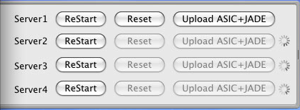
Figure 6.3 The Master JADE-ASIC code has been uploaded and the others are still in the process of uploading.
From the Camera pull down menu select ‘Show H2RG.’ A dialog box will prompt for a password (consult the FourStar password list). Once the password is entered hit ‘OK’ and then select ‘Show H2RG’ again. If the password was accepted, a hidden panel will emerge from the FourStar-Control GUI that will show the state of the four PC Servers that facilitate communication to the arrays, see Figure 6.3. When the FourStar software is initiated the master JADE code is uploaded first (~30 s). Once completed the remaining Servers will upload the code to their JADE/ASIC (another 30 s). During this time the status of the upload can be monitored from the FourStar software from this GUI or alternatively using a remote connection to the Windows PC running the VNC server software, see 6.2.1.2.

Telescope-Control
Allows user to view current telescope position, apply small dithers and submit new coordinates for slew to the night assistant. Access from the Fourstar Telescope menu: Show SkyMap; appears as in Figure 6.4 (slewing is NOT possible from this GUI). This tool is useful to verify star patterns and observed dither patterns as well as offsetting the telescope by small amounts (i.e., guide rates not slew rates).

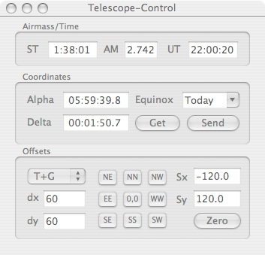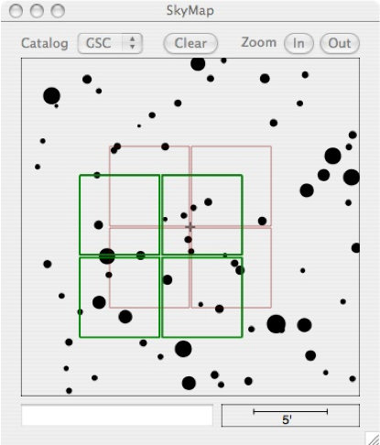
Figure 6.4 The Telescope-Control GUI and SkyMap Viewer. The red footprint shows the current position and the green footprint(s) show previous positions.
Airmass/Time: Displays the Sidereal and Universal Time and the airmass at the coordinates displayed.
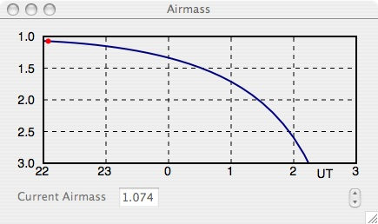
Coordinates: User can enter coordinates or offsets and view virtual targets/sources in the SkyMap window.
- Get: Get the current telescope position and move SkyMap display to that location.
- Send: Send displayed coordinates to the night assistant for slewing.
Offsets: Send offsets to telescope and/or guider.
- T+G: Telescope plus Guider option. This will offset the Telescope and continue guiding.
- Tonly: Move telescope only. No guiding or Shack-Hartmann.
- dx: Set the E-W step size (arc-seconds).
- dy: Set the N-S step size (arc-seconds).
- NE,NN,NW, … etc: Apply offsets in chosen direction. 0,0 will apply the negative offsets in Sx /Sy to return to the starting position.
- Sx / Sy : Displays the cumulative offsets applied since a slew.
- Zero: Set the diaplayed cumlative offsets to zero.
Airmass display: Show the projected airmass for the current position. Access from the Fourstar Telescope menu: Show Airmass.

Temperature Monitors
There are 16 temperatures that are monitored inside Fourstar and are displayed in the TempMonitor-FrontEnd windows, Figure 6.5 and TempMonitor BackEnd window, Figure 6.6. A description of the location of a sensor is displayed when you move the mouse over the Channel number (see Figure 6.6) and the locations are shown in Figure 6.7 . Ignore channels 3 & 12. Number 3 is broken; 12 is not used and 8 & 16 are spares.

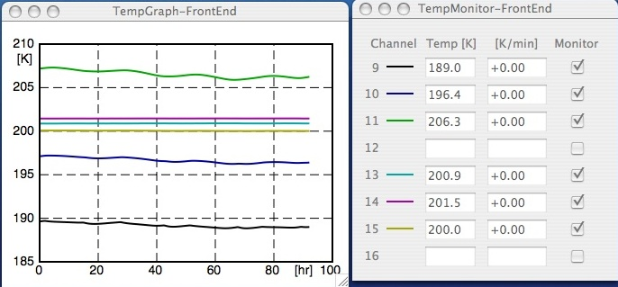
Figure 6.5 The Front End temperature monitoring windows.
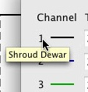
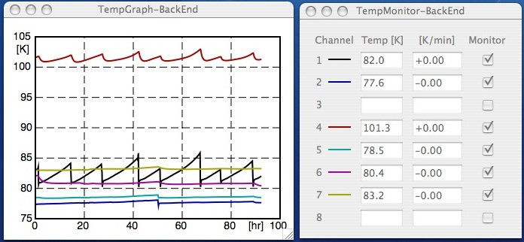
Figure 6.6 The Back End temperataure monitoring windows.

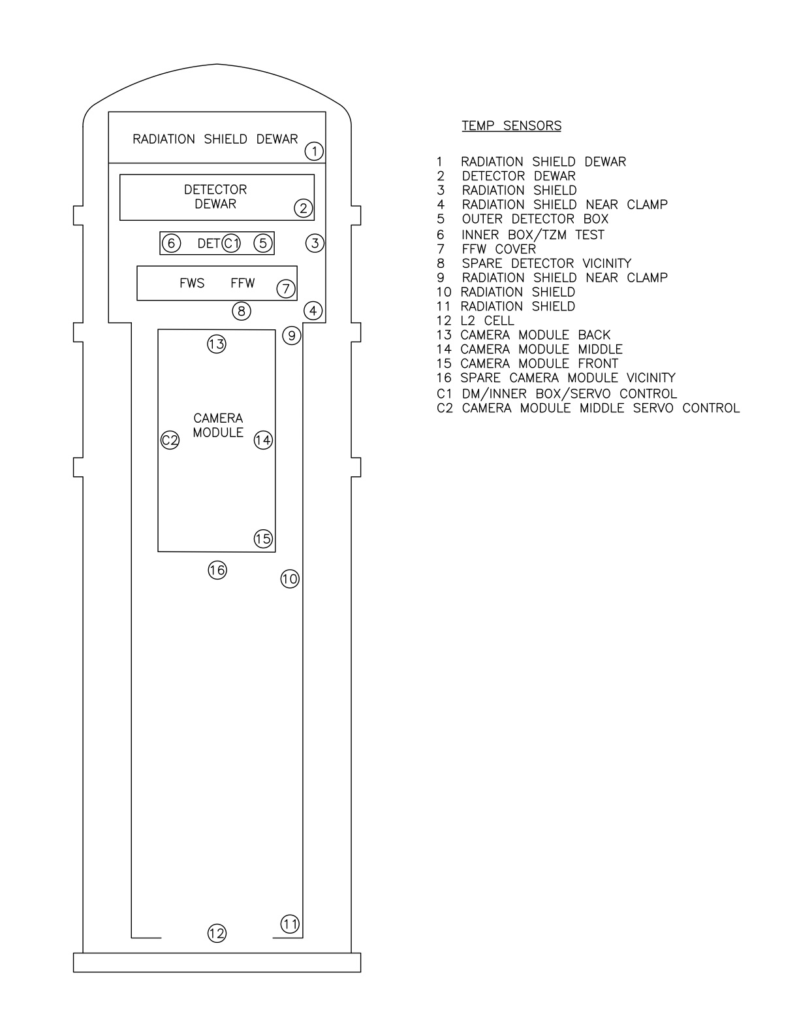
Figure 6.7 The locations of the Fourstar internal temperature sensors.

Temperature Controllers
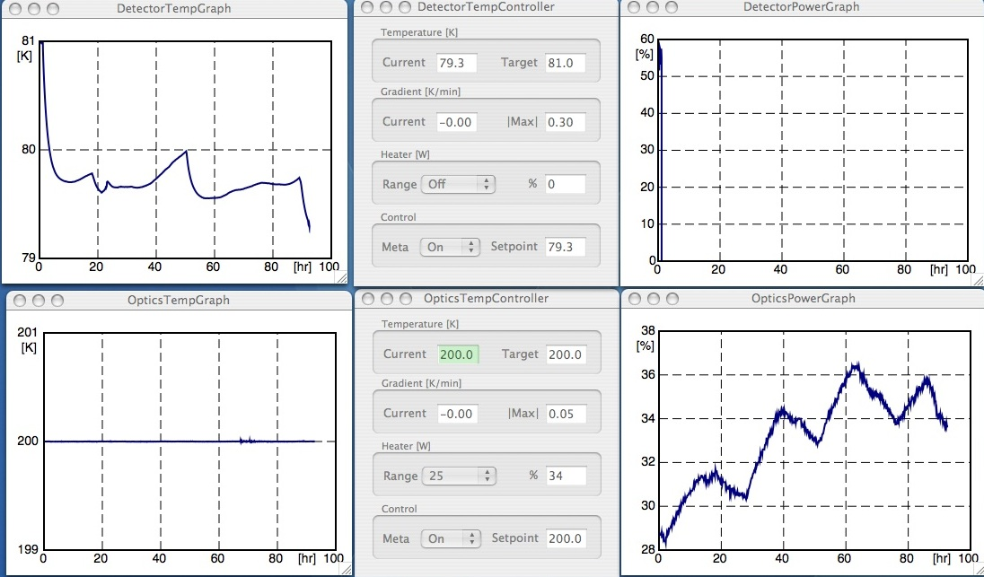
Figure 6.8 The Detector and Optics temperature controllers along with TempGraph’s and PowerGraph’s.

Two critical temperatures must be maintained to a high degree of accuracy and precision: the detector temperature and the optics temperature. The detector must be maintained at a constant level especially during any particular observing run since the dark count is dependent on the temperature (approx 0.1e-/s / degree TBD). The camera optics also must be maintained at a constant level (±1 degrees) since the index of refraction of the glass is functionally dependent on its temperature. To keep the temperature stable power resistors provide heat to allow for regulated temperature control at the detector and camera optics. The resistors are capable of dissipating heat into the system and should be set to the proper levels. The GUI’s should appear as shown in Figure 6.8.

In the event that network communication is interrupted, the software crashes etc, the temperature controllers will continue to operate at their last known settings provided there is power to the instrument. Once communications are restored the last settings will be recovered.

Temperature [K]:
- Current: Displays the current temperature reading from that location.
- Target: User defined target setpoint for operation. For the Detector the Target should be 80.0 and for the Optics the Target should be 200.0.
Gradient [K/min]:
- Current: The current rate at which the temperature is rising or falling.
- |Max|: The user defined maximum rate, rising or falling (absolute value), that is allowed. This should be set to 0.30 for the detector and 0.05 for the optics.
Heater[W]:
- Range: To change a value the GUI must be unlocked from the Temperature menu. The Detector should be set to 0.5 (0.5 Watts) and the Optics should be set to 25 (25 Watts). Off: No heat enters the system and the area will get as cold as it can, but provides no means of regulation. This setting should never be used during normal operation.
- %: Displays what percentage of the amout of power selected in ‘Range’ that is required to keep the ‘Current’ temperature at the ‘Target’ temperature. This should be in the 10-90% range.
Control:
- Meta: Should remain on. The meta (middle) controller sends the value in ‘Setpoint’ to the temperature controller. If a new Target temperature is input then the meta-controller sends new setpoints to the temperature controller at incremental amounts. This acts as a safety net against warming or cooling too quickly. The temperature controllers themselves are also hard programmed not to exceed more than 1K/min (see the RAMP command for the Lakeshore 340).
- Setpoint: The value actually sent to the temperature controller.

LN2 & Sensors
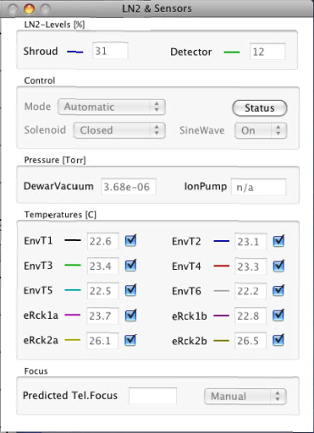
Look at the LN2 & Sensors GUI. It contains information about important instrument subsystems:
LN2-Levels [%]: The current Shroud and Detector dewar levels are shown. The dewars must never be allowed to run out. The autofill system should keep the Shroud dewar filled, but the Detector dewar must be filled manually about every four days of operation.
Control: This panel controls the LN2 autofill system. To change settings it must be unlocked from the LN2+Sensors menu – ‘Unlock GUI’.
- Mode: pulldown menu to control the system.
  - Pass-through means that the solenoid valve that allows/stops the flow of LN2 into the shroud dewar can be operated manually from the ‘Solenoid’ pulldown menu on the panel.
  - Automatic means the solenoid valve will open and close according to the preset fill level parameters.
  - DeadReckoning fills the shroud dewar at defined intervals for a defined amount of time; this mode is not used.
- Solenoid: in Passthrough mode, allows user to manually open or close the fill valve, otherwise it displays the current state of the valve.
- SineWave: The LN2 fill sensors require an AC input to correctly read a capacitance; this setting must remain ‘On’.
- Status: (Button) get the immediate fill status (report to the log)
Pressure[Torr]: The vessel pressure is displayed. With the ion pump running it should read a value around 9e-06. The numerical reading and/or the graph should be inspected twice a day. There are two measured values: one (DewarVacuum) from the Pfieffer guage and the other (IonPump) from the ion pump. These two values will not necessarily agree, but they should be within a factor of 2.
Temperatures(C): There are 6 temperature sensors on the outside of the vessel; these are used to compute the telescope focus offset needed to keep the instrument in focus. They should always read within a few degrees of the ambient temperature in the dome. There are also 4 temperature sensors within the two electronics racks on the vessel; they are there to protect the racks from overheating. They should read values that are approximately 10 C above the ambient temperature in the dome.
Focus: The Predicted telescope focus value is shown. To automatically focus the telescope use the Manual/Automatic button.

Software / Computer How To’s
This section describes how access some of the FourStars features that are otherwise not used for normal operations. These features can be useful tools for diagnosing problems or just for fun.

Accessing the Array Servers Remotely
The Array Servers are physically located in 19” racks mounted on the FourStar dewar and as such rotate with the instrument on the Nasmyth platform. The StarServer application (used for array communication) and other applications start autonomously on boot-up. Normally there is no need to access the keyboard or monitor of these computers directly. However on occasion it may be necessary to diagnose a problem or to perform system maintenance. There are three ways to access the Array Servers remotely:
- Via the KVM breakout on the racks with a monitor, mouse, and keyboard located on the Nasmyth platform.
- LAN access from a FourStar Mac using VNC.
- LAN access on a Mac over the KVM Web interface using a Web browser.

KVM Access on the Nasmyth Platform
This is the most direct and foolproof method to access the Array Servers. One advantage of this method is that full access to the Array Servers is obtained, regardless of whether or not Windows has been booted. For instance, one can monitor the full power-on boot process, modify BIOS settings, and so forth. Connector’s J24, J25, and J26 on instrument Rack #2 breakout the keyboard, monitor, and VGA connections of the KVM switch. When using the KVM breakout FourStar must be removed from the telescope. This is critical for safety and precludes the use of access this method during regular operations. The operation of the Minicom KVM switch is detailed fully in its manual, but the essentials are simple and will be described. The KVM switch should be powered on before the computers (this is usually the default when the rack is powered). The Minicom has been programmed with an onscreen menu to access the four Array Servers by name. To activate the onscreen menu push the SHIFT key in quick succession twice, i.e. SHIFT+SHIFT. Navigate the menu entries with arrow keys to select the desired Array Server to access and switch between computers by hitting the RETURN key once the desired computer name is highlighted. Further details on KVM commands are available using the pop-up help menu activated by the F1 key or in the on-line Minicom manual on the FourStar Web site.

VNC to Windows Computers 1-4
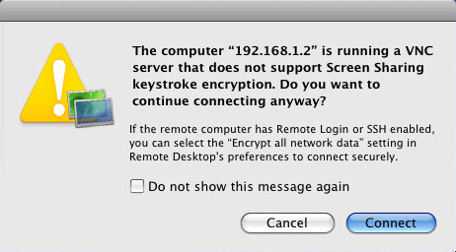
Each of the Windows PC’s is running a VNC server so it is possible to view each screen remotely from the Control-Room-Mac (or Nasmyth Mac). Once you have successfully started a screen sharing session to the Control-Room-Mac (refer to 4.1.2.1) start another VNC session from within that one. On the remote mac from the Finder application under the Go menu, connect to server, or ⌘K. Enter the server address vnc://192.168.1.2 and click Connect. (Note: All four Windows PC’s can be accessed). Enter the password on the pop-up dialog box and click Connect. A pop-up window will appear warning about keyboard encryption like that shown in Figure 6.9; click Connect to continue. The Windows PC screen should appear similar to that as shown in Figure 6.10.
Figure 6.9 VNC warning message.
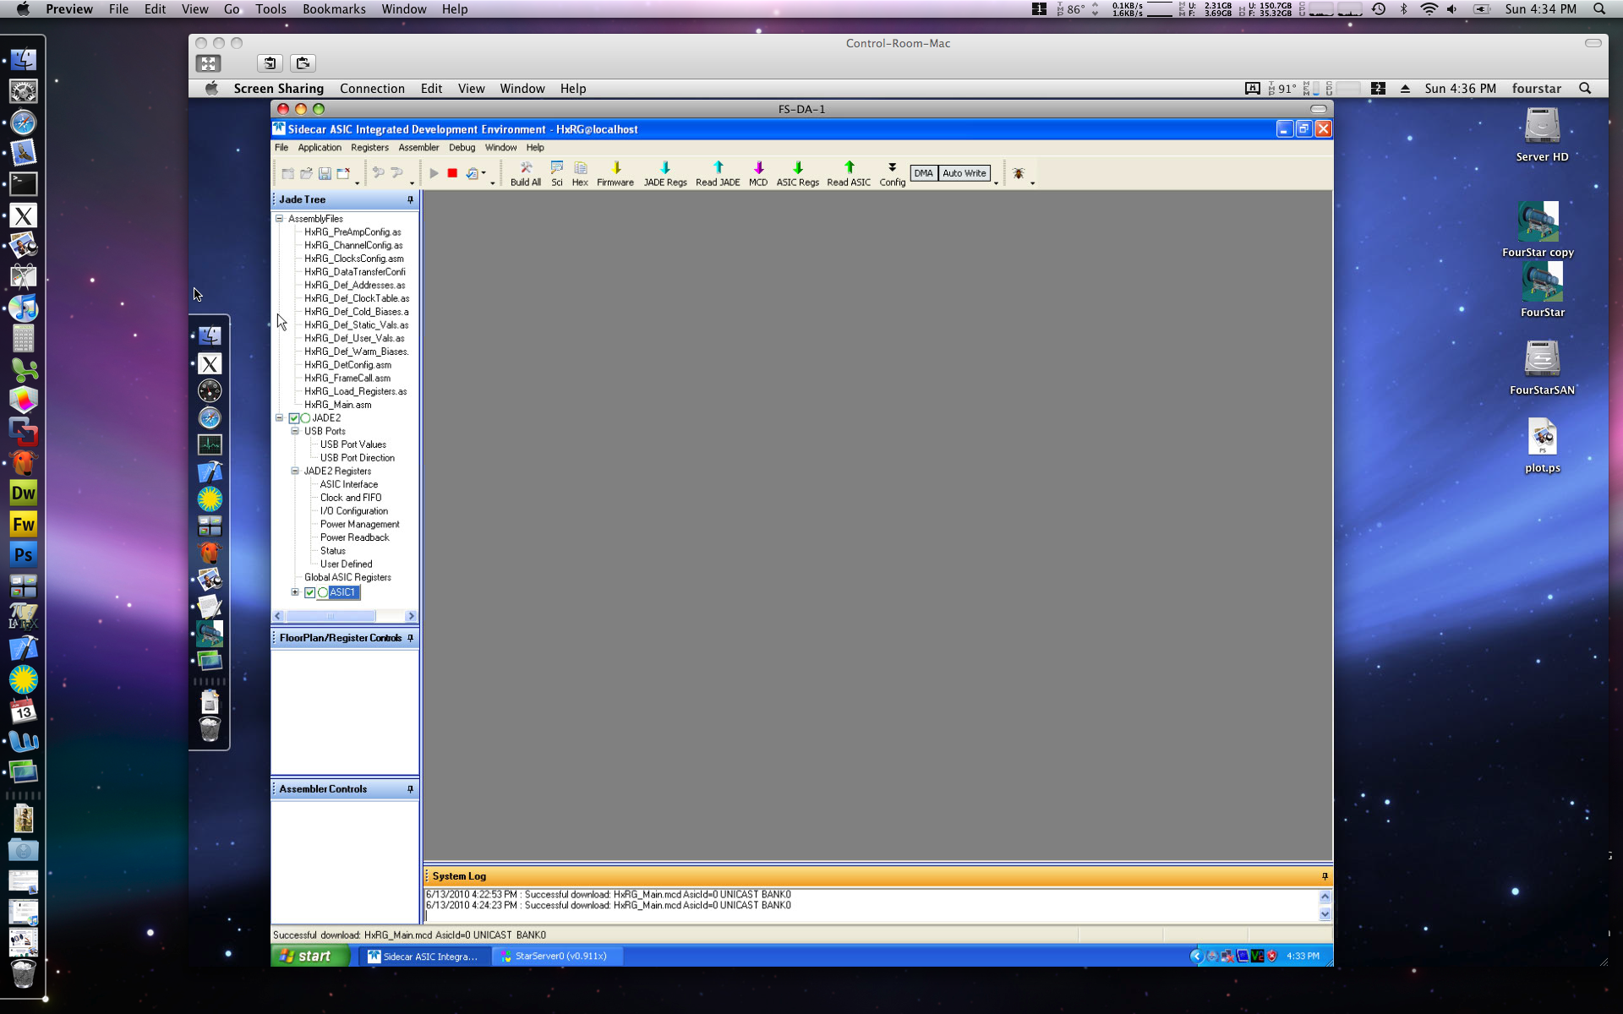
Figure 6.10 A Windows PC screen sharing session within the control computer screen sharing session within a control room computer Desktop.

LAN Access to the KVM Switch Using a Web Client
The KVM switch itself may be accessed using a Web browser (Safari recommended). This method allows one to monitor the video of the Array Servers from the Control Room at all times regardless of whether they have booted an operating system or not. To do this, enter as the URL: http://192.168.1.22 then follow the prompts to validate a certificate (if requested) and provide the system Super User password. The ability to control the mouse and keyboard of the Array Servers over a browser client is very imperfect, and it is recommended that it be relied on only to monitor screen activity. This technique is, however, the only way to monitor the complete state of the Array Servers, regardless of whether Windows has been booted or not, from the Baade Control Room.

View the array parameters, filter wheel contents and combinations
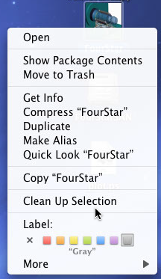
Right click on the FourStar icon; this will bring up a list of options. Select ‘Show Package Contents’. This will open the FourStar folder in a Finder Window; browse to Contents/Resources. Here there are multiple files that contain information loaded by the software on startup. ‘filters.txt’, for example contains the filter wheel options available to the user.

View the FourStar log using the Console Application
- In a Finder window browse to the ~/fourstar/Library/Logs/FourStar directory, double click on the latest log and console will open the log.

OR

- In Finder, open the Utilities Folder from the ‘Go’ menu; double-click ‘console’. Console Messages will display FourStar ‘status’ queries. FourStar logs can be viewed by using the navigation on the left.
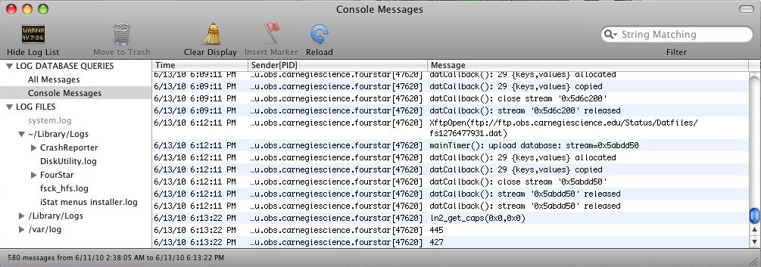

Booting and Rebooting the FourStar Computers
Computer shutdown, restarting, or rebooting operations will be a frequent operation during system administration and maintenance. With the Mac’s this is simple using the “Apple” menu in the upper left-hand-corner of the screen. Alternatively, keyboard command sequences are available for this (consult standard Apple or Mac documentation sources).

Before turning off the master power switch to the electronics racks on the FourStar dewar, it is important to make sure the Array Servers are powered down correctly. The easiest way to do this is to push their front panel power/reset buttons for approximately 2-3 seconds. This will initiate a correct Windows shutdown procedure, which takes about a minute. During the shutdown process, the red hard drive activity lights are unusually active. Rapid activity of the red hard drive activity light immediately following the front-panel initiation of a shutdown is a sign that the power/reset button was depressed for the appropriate length of time. The front panel green power light extinguishes when the computer has fully completed its shutdown.

If one needs to power up an Array Server turn on the rack power and simply depress the front panel power/reset button and it will boot.

All Array Server shutdown functions may also be performed in the standard way via the Windows Start button. For this, access to the Array Servers must be obtained via ARD or using KVM access methods discussed in 6.2.1.

Format an External USB Storage Device
So, you’ve brought an external USB drive and it needs to be formatted. Launch the “Disk Utility” application, which is in the Utilities Folder (From the Applications Folder Utilities Folder Disk Utility.app). Select the external drive that is to be formatted. Click on the Erase tab near the top. Under Volume Format select MS-DOS (FAT) if you want nearly universal readability. One pitfall of FAT32 is that the largest contiguous filesize is limited to 4GB. If you plan on tarring or zipping data that will be larger than this filesize, select a different format. Click the Erase button. A pop-up window will ask to verify the procedure. Click the Erase button in this window to start the process of erasing the disk. Once the process is complete, the drive will appear with the name it was given on the left side of the window; see Figure 6.11.
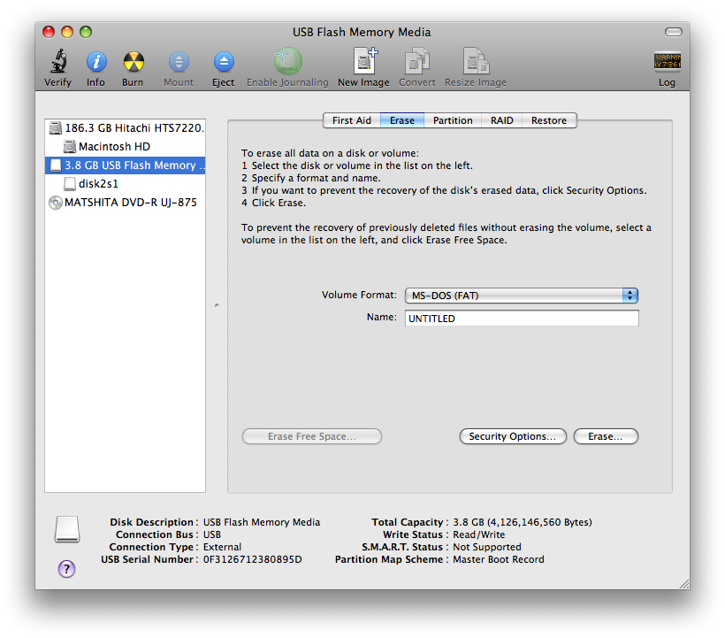
Figure 6.11 Formatting Hard Drive window.

Use the Camera Simulator Mode for Diagnostics
In Simulator mode the control computer will talk to the StarServer pointed to in the IP-numbers tab but the StarServers WILL NOT communicate with the JADE/ASIC/SCA hardware; i.e., the data will be simulated by the remote StarServer. This allows for testing the network communication to the instrument. By setting an IP address to localhost (or 127.0.0.1) that StarServer will be accessed on the local machine, i.e., the data will be simulated locally rather than on a remote computer. This provides a means to check the software without requiring network communications.

Cloning an Array Server System
This section describes the creation of a master clone disk of the Array Server. This disk can be used to rebuild a lost Array Server system after a disk crash. The other motivation to clone an Array Server hard drive is to maintain a fresh copy of the master Array Server image, which we define as Array Server FS-DA-1. The existence of such a fresh copy will expedite the recovery of a system that has failed due to a disk crash. The ability to replicate a master disk also facilitates system administration of the Array Servers and guarantees that all systems will be identically configured. Note that disk cloning is an operation that should only be performed by qualified and experienced personnel since unrecoverable damage can result if an error is made.

Two LaCie 160GB ruggedized USB portable drives are available to recover Array Server disks. There is nothing particularly special about these drives other than there physical robustness, and any USB drive of sufficient capacity can be used to accomplish this task. One of these drives should always contain an up-to-date image of FS-DA-1, while the other will be used as a scratch drive for cloning operations. The drives are labeled as such.

There are several ways to build a clone of an Array Server disk. This section describes one fairly efficient method, which is simple, has been tested, and does not rely on either the source or target system to be bootable. This technique makes use of the commercial package Acronis True Image Workstation (www.acronis.com).

To start this process one needs to locate the LaCie USB ruggedized hard drive labeled as a “Scratch Drive”, a USB cable, and the Acronis True Image Work Station Bootable Recovery Disk. The Acronis disk is normally kept in a file folder box in the FourStar spares storage area. If one is cloning an Array Server located in the FourStar electronics rack, KVM connections should be made as described in 6.2.1.1.

Step-by step cloning instructions are provided below:
Building the clone image
- Insert the Acronis CD in the source computer and connect the disk with a USB cable.
- Shut down the source computer with the front panel power button and restart it (this can be done via Windows as well with the Restart function).
- Boot from the Acronis disk.
- On the Acronis splash page select “Acronis True Image Work Station (Full Version)”.
- Select “Clone Disk”. Click “Next”. Select “Automatic Disk Clone Mode”.
- Highlight “Disk 1 IDE (0) Primary Master” as the source hard disk. Click “Next”.
- Highlight the “Disk 2 USB” disk as the destination disk. Click “Next”.
- On the next screen select “Delete Partitions on the Destination Hard Disk”. Click “Next”.
- Check the layout on the Hard Disk Drives Structure page and make sure it looks sensible, then click “Next”.
- On the next page click “Proceed”. Cloning of the source to the USB portable disk has now started and this takes about half an hour.
- When the disk cloning finishes, click the “OK” button.
- Disconnect the USB drive, remove the Acronis Boot Disk, then power-off/shutdown the source PC. This last step is important to avoid IP address conflicts (see below).

Restoring the clone image to an internal disk
- Plug the cloned USB drive in the target system and boot the target from the Acronis disk. It may be necessary to edit the PC BIOS to make the first boot device the CD-ROM. Watching the messages when rebooting and depressing the Delete key when prompted accesses the PC BIOS. The BIOS menus have help functions and are also described in detail in the AxionTech PICMG board manuals found on the FourStar Web site.
- On the Acronis splash screen, select “Acronis True Image Work Station (Full Version)”.
- Select “Clone Disk” on the Disk Clone Wizard screen. Click “Next”.
- On the Clone Mode screen, select “Automatic”, then click “Next”.
- On the Source Hard Disk screen, highlight “Disk 2 (USB)” and click “Next”.
- On the Destination Hard Disk screen, select “Disk 1 (IDE)” and click “Next”.
- On the Non-empty Destination Hard Disk screen, select “Delete partitions on the destination hard drive”.
- On the Hard Disk Drives Structure page click “Next”.
- On the next page click “Proceed”.
- After the cloning successfully finishes, remove the Acronis CD and reboot the target system.
- Log into the target system as the Administrator. The computer may request an additional reboot after it automatically adjusts some plug-and-play drivers. If so reboot again.
- Once the target PC reboots and is plug-and-play stable, one needs to set it to the correct IP address and computer name. Each Array Server is labeled on its front panel with its name and IP address.
- Log in with the administrative account and double-click the “Network Connections” icon found on the XP Control Panel. Double click the network connection servicing the Gigabit network interface, and then double-click the Internet Protocol (TCP/IP) entry. Modify the IP address as appropriate and make sure the other entries are correct (subnet mask, DNS servers, and gateway address).
- To set the target computer to the correct name, double-click the System icon on the XP Control Panel. On the Systems Properties page select the Computer Name tab. Click the “Change button” and enter the correct computer name. Click the OK button. If the name is changed the computer will request an immediate reboot. Initiate the reboot. When the reboot is complete the cloned system should be ready for use.

Hardware / Mechanical How To’s

Focusing across the array (FakeStar in the Lab)
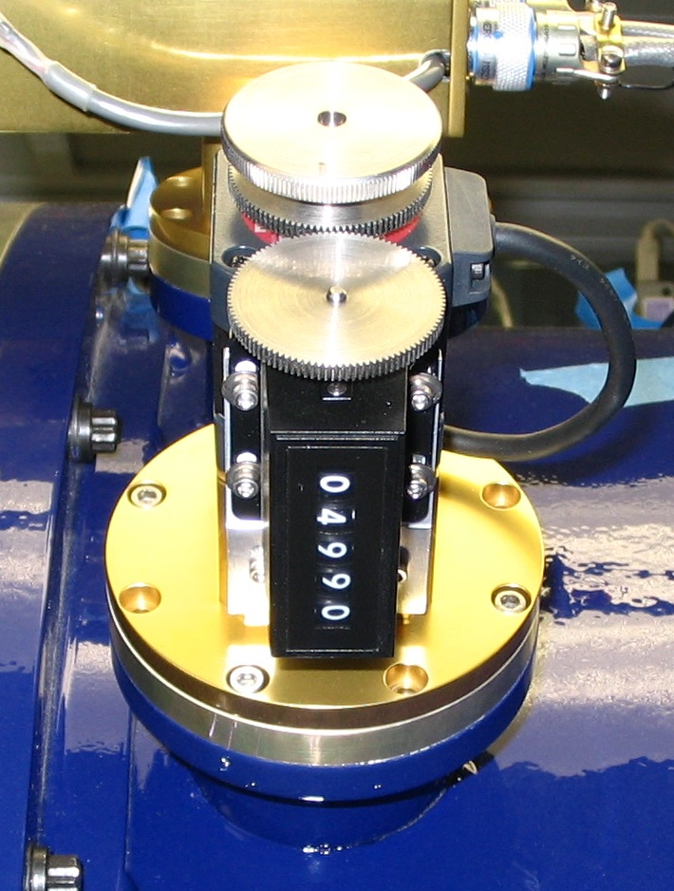
The four arrays are mounted individually and have been adjusted to be coplanar. The height of the focal plane can be adjusted manually by turning the motor shaft with the dial indicator. One rotation equals 10 indicator units and results in the focal plane moving 0.0025”. The Nominal focus has been set in the lab and should be 05400.

Note: The motor is NOT connected to the motor controller to discourage its use. Focus should be obtained by focusing the telescope—never touch the focus knob.

Thermal Cycling the Instrument
It is important that the cool-down or warm-up rates are not too high otherwise damage (from thermal shock and internal stresses) to the detector or optics may occur.

Cooling Down
Start by slowly filling the Shroud Dewar (central fill port). Continue topping it off as desired without letting it run out for the next 24 hours. Start slowly filling the inner dewar. Make sure the detector temperature controller is running and the gradient is set for 0.3K/min. This will require a heater setting of 50W. After ~8 hours (or about when 10% of 50W) the heater setting can be set to 5W. The Camera heater will not be required for cooldown as the natural cooldown rate is sufficiently slow. The Camera heater will be required after the ~4th day to prevent the camera from getting too cold (Target = 200.0K, Range = 25W).

Warming Up
In general it is okay to let the liquid nitrogen simply run out and let FourStar slowly warm up at a natural pace. This will take approximately seven days. If a more rapid warm-up is needed the heaters can be used to expedite the warm up to four days.
Easiest option:
  - Decouple FourStar from the instrument rotator (see 6.3.5).
  - Stop filling with LN2.
  - Wait 7 days.
Faster option: If authorized by FourStar personnel
- Connect the spare Lakeshore temperature controller to BE-6. BE-6 is located .... The cable that connects the spare LS340 is located with in the LCO cleanroom with the spare LS340.
- Check the spare Lakeshore heater settings, see 6.7.
- Connect Nasmyth Mac: TBD and start FourStar Software with TempControl-3.
- Change the setpoint parameters to 293K.
- Max rates of 0.08, 0.03 and 0.08 for the detector, optics, and back end, respectively work about right to converge at 293K at the same time in about 3-4 days.

Getting FourStar on the Nasmyth Platform
This section is included in case FourStar ever gets transported to the Cleanroom for maintenance and then gets returned to the telescope.
- Starting from the Cleanroom with FourStar on Cart 1. FourStar should not be under vacuum.
- The hoists should be oriented down and FourStar strapped securely to Cart 1, but not so tight as to overload the ball transfers. A shim should be placed near the front to axially support FourStar.
- Push FourStar onto the lift platform outside the Cleanroom and raise it to the truck bed.
- Carefully ease FourStar onto the truck. Use rubber squares under the jacks to provide friction with the truck bed. Turn the jacks until FourStar is supported by the jacks then strap FourStar to the truckbed using the four hoist points on Cart 1.
- Slowly drive FourStar to the lift platform next to the Clay Telescope.
- Once backed up to the lift platform secure FourStar by placing a come-along to the building and securing the end to Cart 1. This is a safety step since the truck is inclined downward.
- Un-strap FourStar and lower the jacks so Cart 1 is once again on its wheels. The wheels should be aligned for moving towards the lift platform and locked.
- Using the come-along ease FourStar onto the lift platform and lower it to ground level.
- Gently move FourStar to the Baade Scissor Lift. Un-strap FourStar from Cart 1 and orient the hoists upwards.
- Move FourStar onto the Scissor lift front end first. The Scissor lift will support both FourStar and Cart 1 when in the lower position, but not when in operation.
- Use the Dome Crane to maneuver the FourStar Load Spreader over the two hoist points at the very front and on Section 2 of FourStar. The long end of the Load Spreader affixes to the front. This end should be supported while the other gets attach to Section 2 to prevent the beam from damaging FourStar.
- Use the crane to ease FourStar off Cart 1.
- While slowly raising FourStar with the crane, raise the scissor lift keeping Cart 1 about 1-3 feet from FourStar. Keep an eye on clearances through the dome floor.
- Once the scissor lift has reached the Nasmyth platform push cart 1 onto the platform. Push the ball ends on the bottom of the jacks at the front end of Cart 1 into the Vee-blocks near the instrument rotator. The ball ends on the bottom of the jacks at the rear end of Cart 1 should fit into the Vee-blocks at the rear of the platform.
- Position FourStar onto Cart 1 using the crane.
- Raise Cart 1 on the jacks until the reference ball ends on the jacks just make contact with the flat reference on the stands mounted on the vee-blocks.
- Also, check for level across Cart 1. Especially along the axis between the two rear rollers.

How to Attach FourStar to the Instrument De-rotatator
When finished with maintenance FourStar should be re-attached to the telescope.
- LOCK OUT THE TELESCOPE MOTION.
- Release the 4 cart clamps (red-handles) and push the instrument forward until making contact.
- Install the 12 bolts at the Conical adapter / telescope guider interface.
- Re-engage the 4 clamps.
- Disengage front wheel support by pushing the red handle (the orange wheels should lower).
- Remove the front support plate. This is necessary to provide supply line clearance.
- (OPTIONAL) Disconnect the Platform air supply hose by accessing it through a porthole in the conical adapter.
- Connect the guider air supply hose.
- Connect the (2) labeled fiber optics cables to rack 2.
- Connect the 24V autofill solenoid cable; P14 on rack 2.
- Connect the Glycol lines at the quick-connect interface.
- Connect the main power cable to the main power bus on FourStar.
- REMOVE TELESCOPE LOCK OUT
- Power up FourStar; see Error! Reference source not found.-Error! Reference source not found..

How to Remove FourStar from the Instrument De-rotator
When doing maintenance on FourStar it should be decoupled from the telescope.
- LOCK OUT THE TELESCOPE MOTION.
- Power down FourStar; see 4.7.1-Shutting down on the Nasmyth Platform.
- Make sure the main power cable is disconnected.
- Disconnect the Glycol lines at the quick-connect interface.
- Disconnect the 24V autofill solenoid cable; P14 on rack 2.
- Disconnect the (2) labeled fiber optics cables from rack 2.
- Disconnect the guider air supply hose by accessing it through a porthole in the conical adapter.
- Connect the Platform air supply hose by feeding it through a porthole.
- Mount the front support plate.
- Engage front wheel support by removing the pin near the red handle and pulling the red handle; see (picture).
- Remove the 12 bolts from the Conical adapter / telescope guider interface.
- Release the 4 cart clamps (red-handles) and pull the instrument back 1 inch.
- Re-engage the 4 clamps.
- Dress all the supply lines that were removed to the guider wrap to prevent damage and make sure there are no interferences between the instrument rotator and FourStar.
- REMOVE TELESCOPE LOCK OUT

Pumping using the main Vaccum Port
Don’t. We will do it. The safety cover should always be over vacuum gate valve; see Figure 6.12.
Okay, in the rare event it becomes necessary here are the genergal procedures:
- Contact FourStar personnel to confirm the necessity of this act.
- Plug in the MKS vacuum gauge located under the FourStar cart to monitor the internal pressure.
- Rotate FourStar so that the main vacuum port is accessible (the home position).
- Lock the telescope/guider rotation to prevent instrument rotation during pumping or remove FourStar from the rotator to pump for longer periods; see 6.3.5-How to Remove FourStar from the Instrument De-rotator.
- Remove the safety cover over the main vacuum port using the thumb-screws. This cover is in place to prevent the gate valve from opening and to protect the O-ring surface from scratches.
- Maneuver the vacuum pump into place and using the bolts and Kwik-flange O-ring secure the pump to the main vacuum flange. Note: the screw, wrench and kwik-flange o-ring should all be located and kept with the vacuum pump cart.
- KEEP THE MAIN VALVE CLOSED! Plug in the Vacuum cart using the power trip accessory and start the turbo pump; see 6.3.7-Use the FourStar TurboPump Cart.
- Once the Turbo pump has reached a better vacuum than the MKS gauge then the Main Gate Valve can be opened.

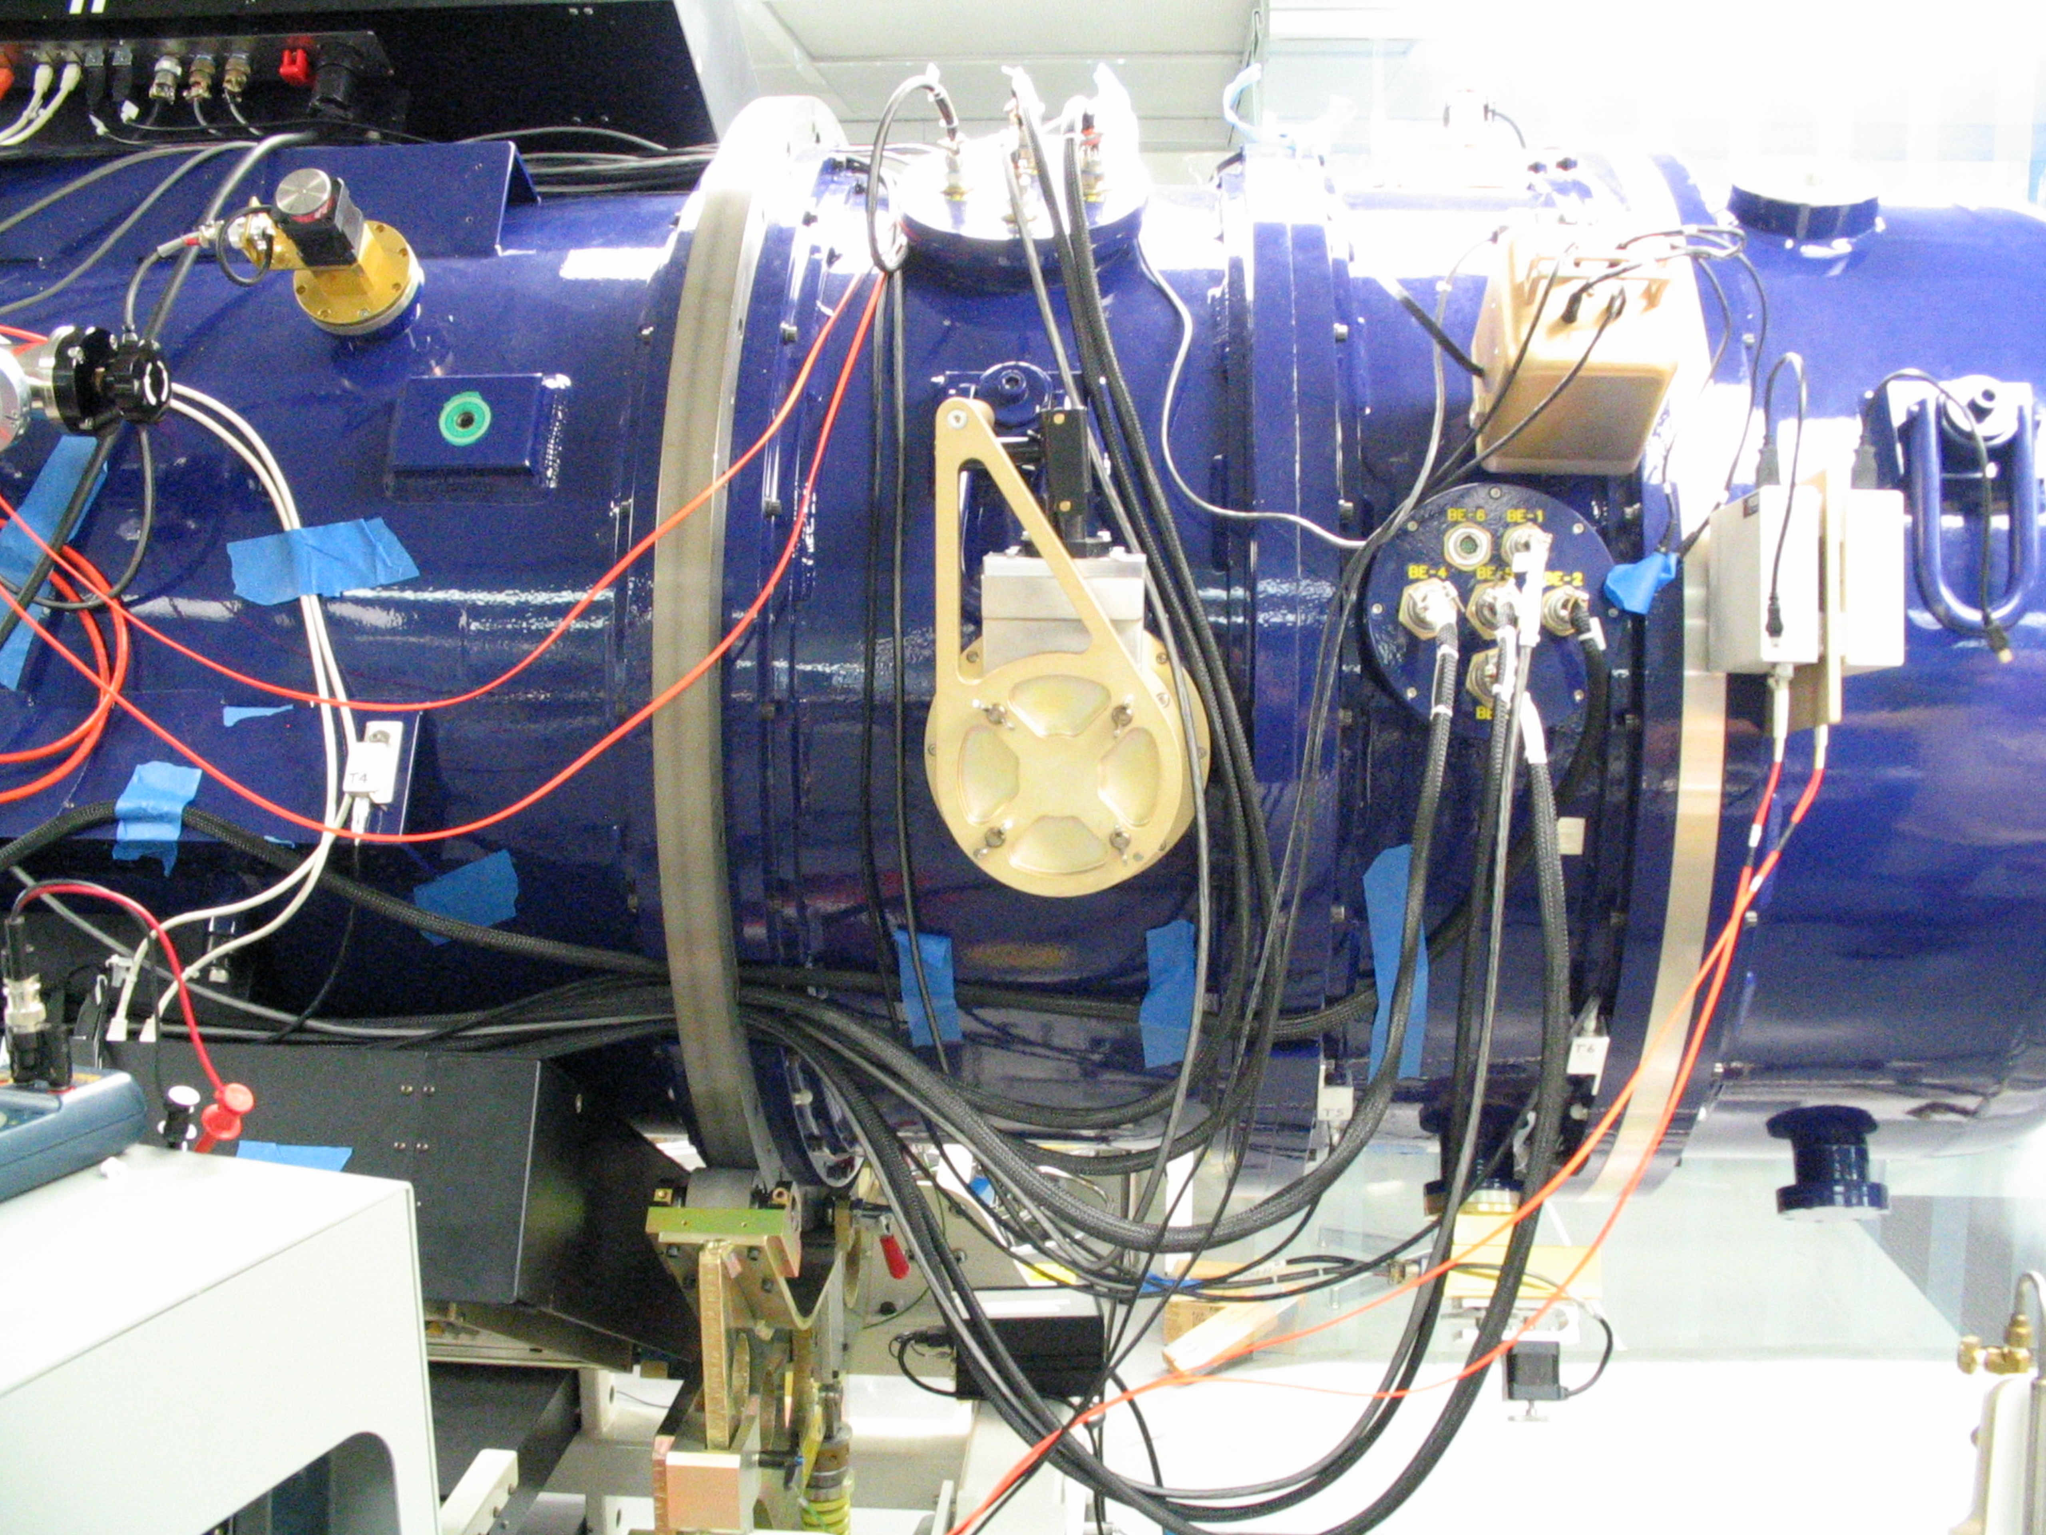
Figure 6.12 The main FourStar Vacuum port with the safety cover in place.

Use the FourStar TurboPump Cart

Main Control
The main control panel is shown in Figure 6.13. Press the Start/Stop button to start. The scroll pump with rough out the system until a fan speed of 58krmp is reached at which point the turbo pump will start operating. The rough vacuum is monitored with a termocouple gauge and is displayed on the front panel in the TC1 box. The high vacuum Ion Gauge (IG) display will show “OFF”. Once a high vacuum is reached (58Krpm) the EMIS button can be pressed and after a minute a high vacuum reading will be displayed. It is preferred to keep the use of this gauge to a minimum; turn it off by hitting the EMIS button again.
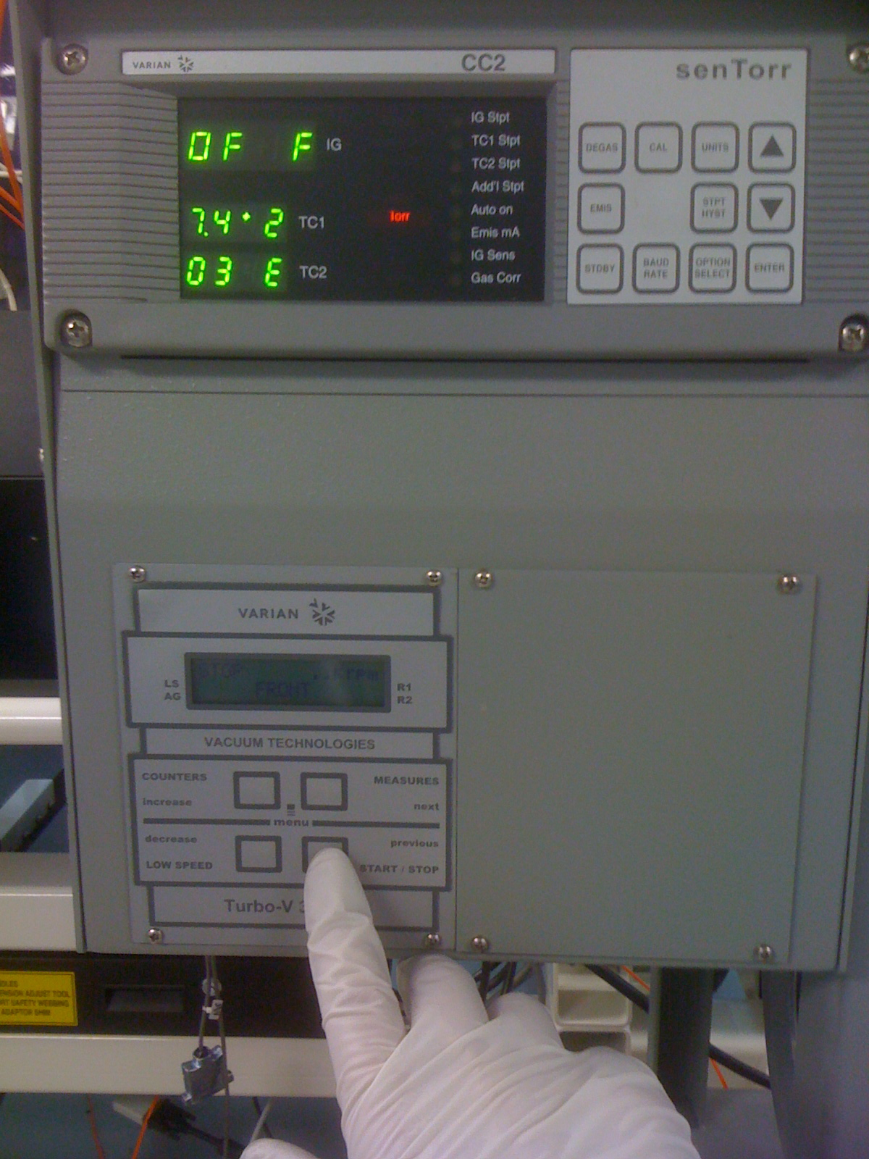
Figure 6.13 Turbo-pump control panel.

Power Trip Box
If power is lost to the pump while attached to the dewar a valve in the pump will close to prevent backfill into the dewar. This safety valve is normally closed and opens when the pump is powered. However, it takes a moment for the pump to reach a good vacuum, thus for a moment when power is restored there is some backflow which is bad. To prevent this, a trip box is used that does not restore power to the pump until it is reset. This allows closing the main Gate valve to the dewar before allowing power to return to the pump. The pump can then ‘pump on itself’ until a good vacuum is obtained and then the main Gate valve to the dewar can be opened.

Power was lost at some point. Close the dewar Gate Valve.  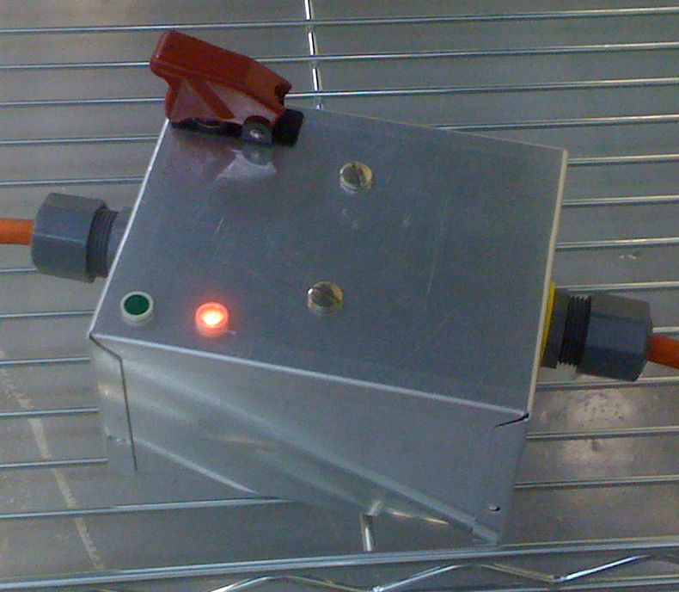 | CLOSE GATE VALVE! 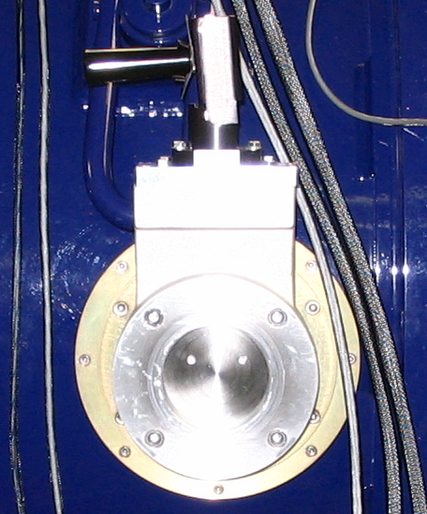 | Locate the restore button under the red switch guard. 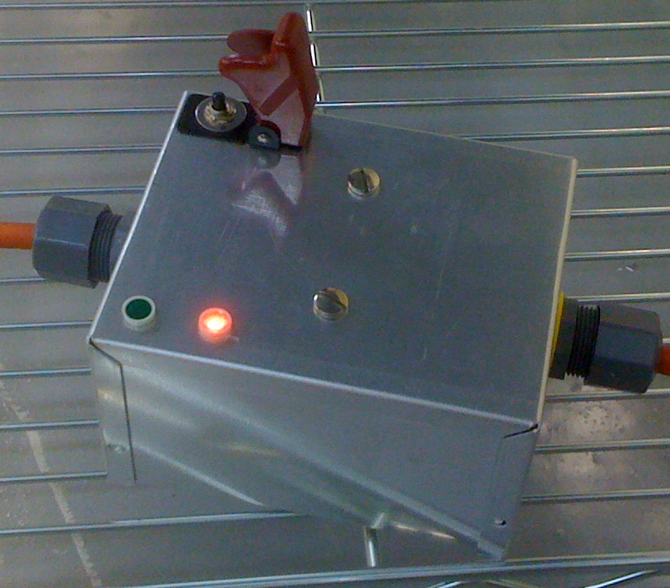
Press the restore button. 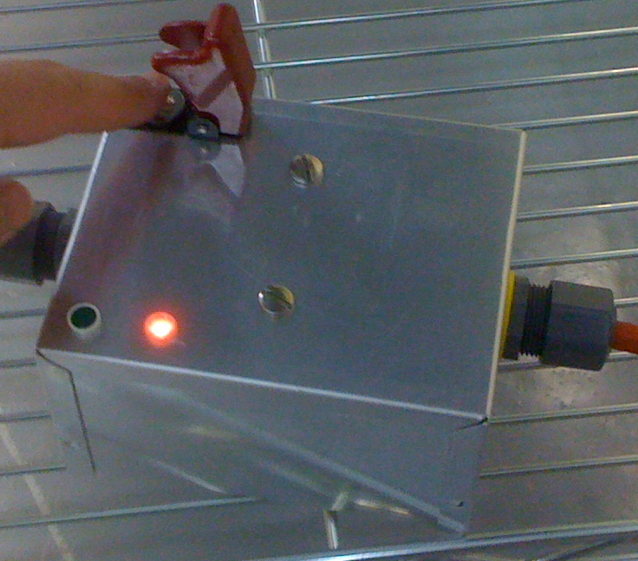 | The light should be green and the pump should start running. 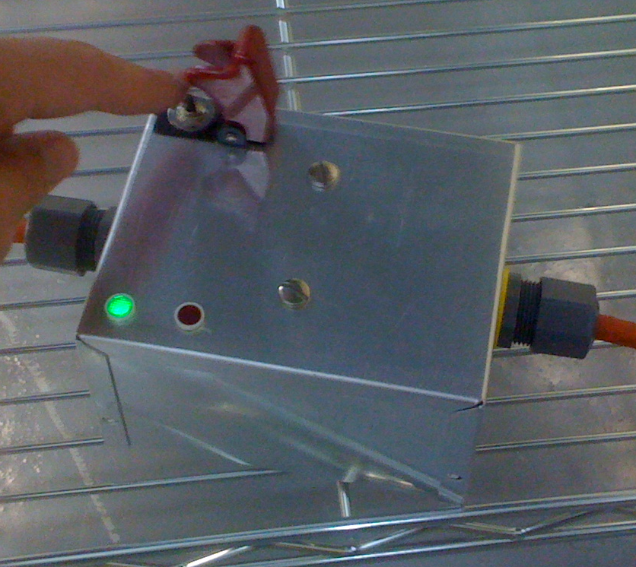 | Wait for the pump to reach good vacuum and open the Gate Valve.  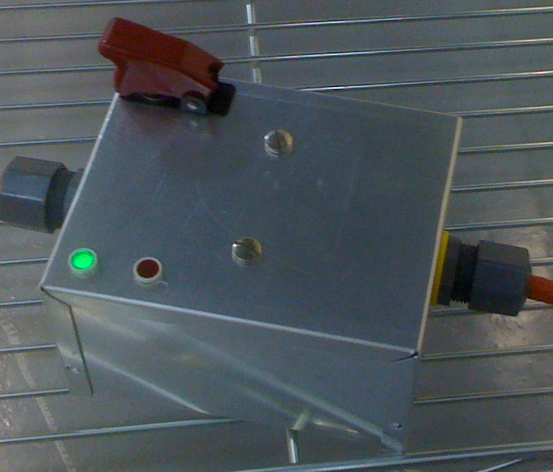

Synchronization Cable
The synchronization cable connects the JADE2 cards’ clock frequencies to a master clock. This eliminates beating frequencies between the clock signals. If the read noise is higher than expected then it may be the syncronization cable has failed and needs to be replaced. Array number one is especially vulnerable to this type of failure and leaves telltale signatures in the form of strong vertical banding in dark frames.

Network General Overview and Architecture

Introduction
The FourStar Data System is a distributed computer system consisting of nine computers and several Internet Protocol (IP) devices on a private computer network. The purpose of the data system two fold:
- To facilitate the control and monitoring of the FourStar Infrared Camera.
- To process FourStar data to a final reduced state online and automatically.

The architecture of this system was driven by the need to meet the above requirements and to do so in a fashion that provides reliability and system longevity. The purpose of this chapter is to provide a resource to familiarize support personnel and other interested persons with the hardware architecture of the system and to provide guidelines for performing basic maintenance tasks.
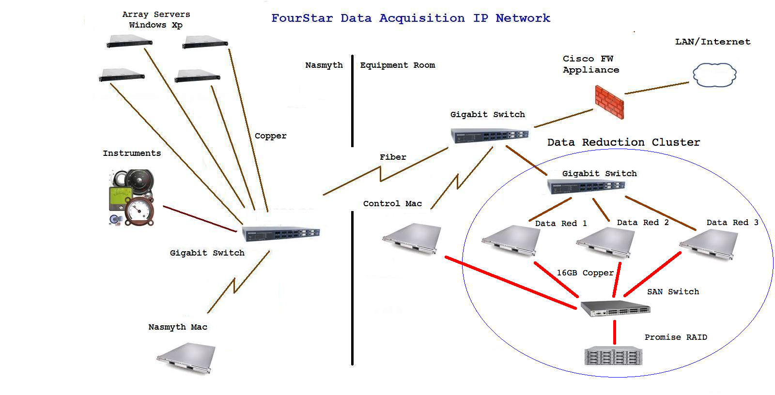
Figure 6.14 FourStar Data System
Figure 6.14 shows a schematic representation of the FourStar Data System. Note that this drawing is simplified in many details (which will be further below). The Data System is distributed into three locations: The FourStar dewar, the Nasmyth Platform, and the Equipment Room. When observing one usually accesses the FourStar Data System from the control room using Observatory provided Apple workstations and connecting through the Cisco Firewall Appliance. When operating FourStar in the laboratory, one uses the Nasmyth Mac directly with a directly attached keyboard, monitor, and mouse.
The Nasmyth Mac is attached to the instrument cart base. The Nasmyth Mac can also be used as a rapidly available computer to back up the Control Mac in the event of a failure of the Control Mac when observing.

An elementary understanding of the system can best be understood by considering the data flow for the acquisition of an image. The Control Mac runs a GUI from which the observer enters array readout parameters such as the exposure time, number of exposures, filter desired, etc. The observer then commands an integration sequence. The Array Servers running camera server software field requests from the GUI to readout the imaging arrays. The Array Servers are 1U chassis based Windows XP-based PC’s. Each of the four imaging arrays has a dedicated Array Server. The connection to the Teledyne imaging array JADE-2 readout electronics is by Universal Serial Bus 2.0 (USB 2.0), i.e. each imaging array is a seperate USB 2.0 device. Image data flows from each of the Array Servers over Gigabit cooper CAT 6E cable to a Gigabit Ethernet switch. The imaging data from all four arrays is then transported over Gigabit fiber Ethernet to another Gigabit switch in the equipment room to the Control Mac where they are manipulated in memory (for example FITS headers are added), and written to the shared Promise Raid drive. The image data (when aggregated after the first Gigabit switch) at all times move over either fiber Ethernet or trunked high-speed copper connections for maximum throughput. The Control Mac also keeps a pristine copy of the raw data on its local disk for security and convenience.

The Control Mac GUI also provides for extensive monitoring and control of the FourStar temperature, vacuum, and cryo environment. Once on the Promise RAID volume, the data reduction pipeline running on the FourStar Data Reduction Cluster reduces data from FourStar automatically.

Physical Distribution of Components
The computer system hardware is located in three physical locations: On the FourStar camera dewar (which rotates), on the base of FourStar Cart #1, and in the FourStar Server Rack located in the equipment room.

The FourStar electronic racks hold the four Array Servers, a Gigabit Fiber/Copper Ethernet Switch, and a KVM switch. Figure 4.1 displays a view of the electronic racks mounted on the FourStar dewar. Each of the two dewar electronics racks holds two Array Servers. In normal operation the Array Servers act as autonomous controllers not requiring user interaction. Access to these computers (when required) is through the KVM switch or Apple Remote Desktop (ARD). Each Array Server runs a copy of VNC Server. The KVM switch is also an IP device and may be accessed via a Java enabled Web browser. This technique has the benefit of allowing access to the Array Servers when they are not running Windows XP, such as during the boot process. See 6.2.1 for details.

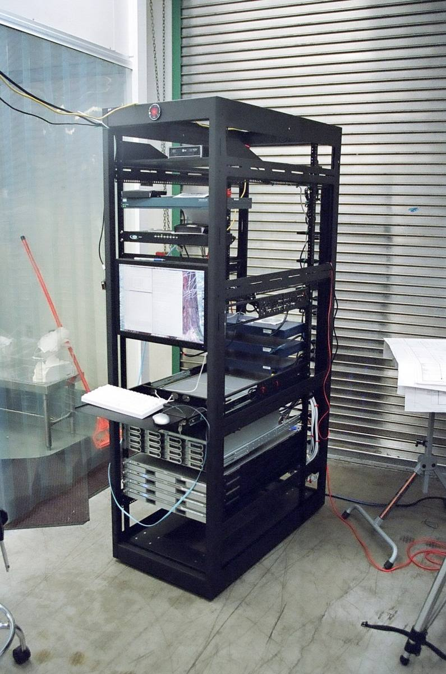
The base of FourStar Cart #1, which always moves with FourStar, holds the Nasmyth Mac, a 1U high Mac Xserve. The purpose of The Nasmyth Mac is to control FourStar when it is used in the laboratory or when the normal Control Mac is unavailable. A key function of the Nasmyth Mac is as a rapidly available backup control computer for FourStar at the telescope. Access to this Mac is either over Ethernet via ARD or directly by connecting a USB keyboard, USB mouse, and monitor. The video output on the Nasmyth Mac uses an Apple MiniDisplay Port connector, which is typically converted to the more standard Digital Video Interface (DVI) to feed commonly available commercial flat screen monitors. For convenience, the DVI cabling, a USB 2.0 extender cable, USB mouse, USB Apple keyboard, and Apple MiniDisplay Port to DVI adapter are normally kept in the accessory drawers of the FourStar Cart #1 for this purpose.

All the components shown on the right-hand portion of Figure 6.14 are contained in a rack called the FourStar Server Rack located in the Magellan Baade Equipment Room. A photo of this rack is shown in Figure 6.15. The FourStar Server rack deploys four Xserve Apple dual quad core servers. One of these is the “Control Room Mac” (although it is not physically in the Control Room), which is used to run all control and monitoring software for FourStar. The other three Xserve computers named “Data-Red-1”, “Data-Red-2”, and “Data-Red-3”, are used to run the online data reduction pipeline. This open frame rack also holds a RAID chassis, network switches, and a SAN switch. The top shelf of the rack holds a USB 2.0 fiber optic transceiver unit. From top to bottom are the Cisco Pix Firewall Appliance, the DVI KVM switch, the 20” flat screen monitor, the keyboard/mouse and tray, the Promise RAID chassis, the Control Mac, and the three data reduction Macs. Netgear Ethernet switches and the Brocade Fibre Channel switch can be seen mounted on the rear rails of the rack.
Figure 6.15 FourStar Data Server Rack.
To enable the implementation of a Storage Area Network and provide Ethernet support, the FourStar Data Server Rack also contains a Brocade 4100 Fibre Channel switch, three NetGear 716 Gigabit Fiber/Copper Ethernet switches, and a Cisco Pix 515E firewall appliance. The Xserve computers in the rack may be accessed from the front of the rack via a 20-inch flat screen monitor on the rack and a USB keyboard and mouse in a self-contained keyboard tray. The operator selects which computer in the rack to display by a push-button front panel selection switch on a DVI KVM switch.

System Network Topology
Three switched networks are supported by the FourStar Data system; Figure 6.16 details network topology located in the FourStar Server Rack.
- A primary Ethernet. This “In-Band Network” (see below) is a private Gigabit Ethernet linking all FourStar IP devices, computers and instruments. This network has restricted access to the Las Campanas LAN (and thus the Internet) through a hardware firewall. The purpose of this network is to facilitate high-speed data transfer from the Array Servers, general fast communication for graphics and data between all instruments and computers, and access to and from the Las Campanas LAN and Internet (in a controlled fashion).
- A switched Fibre Channel Network. This network supports cluster access to a high performance RAID volume. Note that this is not an Ethernet-based network. The cluster contains all the Xserve servers, a Fibre Channel switch, and a RAID chassis. To support cluster disk access, a Storage Area Network (SAN) is implemented on a physical Fibre Channel layer using Apple’s Xsan2 application software.
- A Metadata Network. This is a private Gigabit Ethernet network linking all the members of the Xsan2 SAN. This Metadata network is composed of all the Mac Xserve computers (no others). This fully private in that there is no routing to the Las Campanas LAN. The Metadata network is required by Xsan2 to communicate Metadata between SAN cluster members. Metadata is data which describes data and it is used by the SAN for managing file locking, space allocation, and data access authorization. Since this network contains only traffic related to the SAN and has not external routing, it is often referred to as an “Out-of-Band” network.
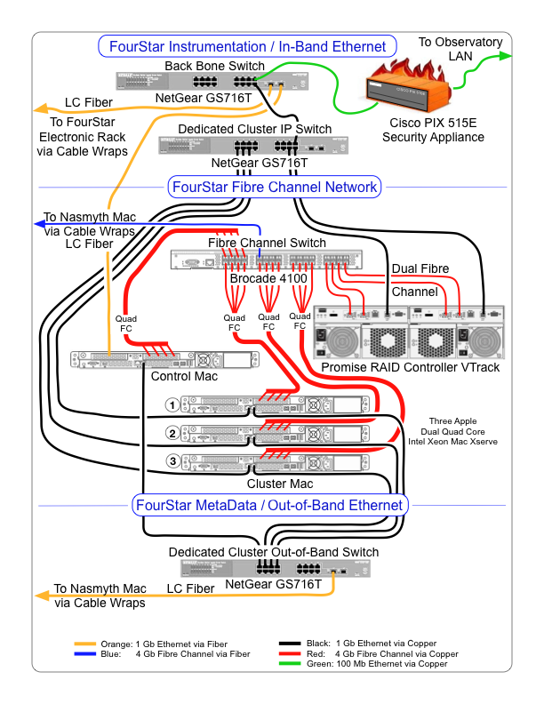
Figure 6.16 Schematic wiring diagram of the FourStar network within the electronics rack.
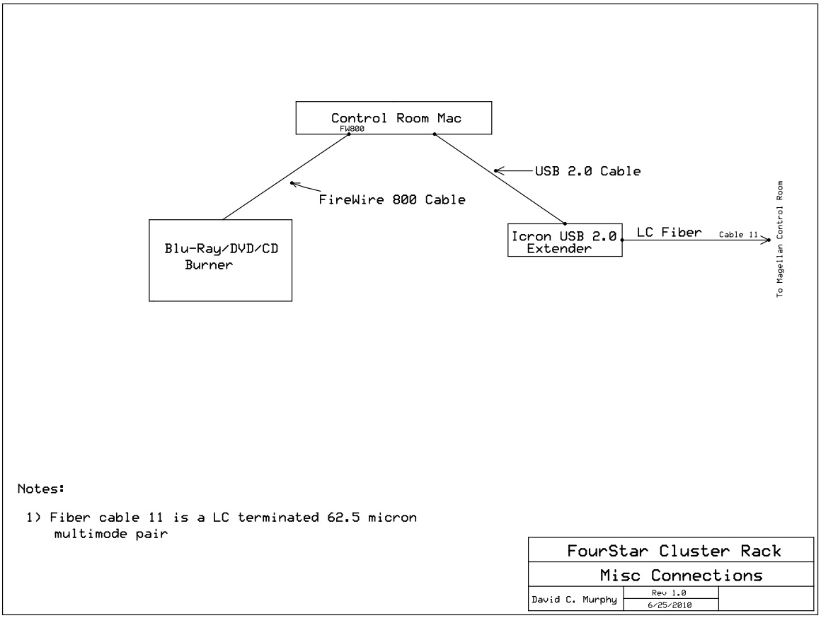
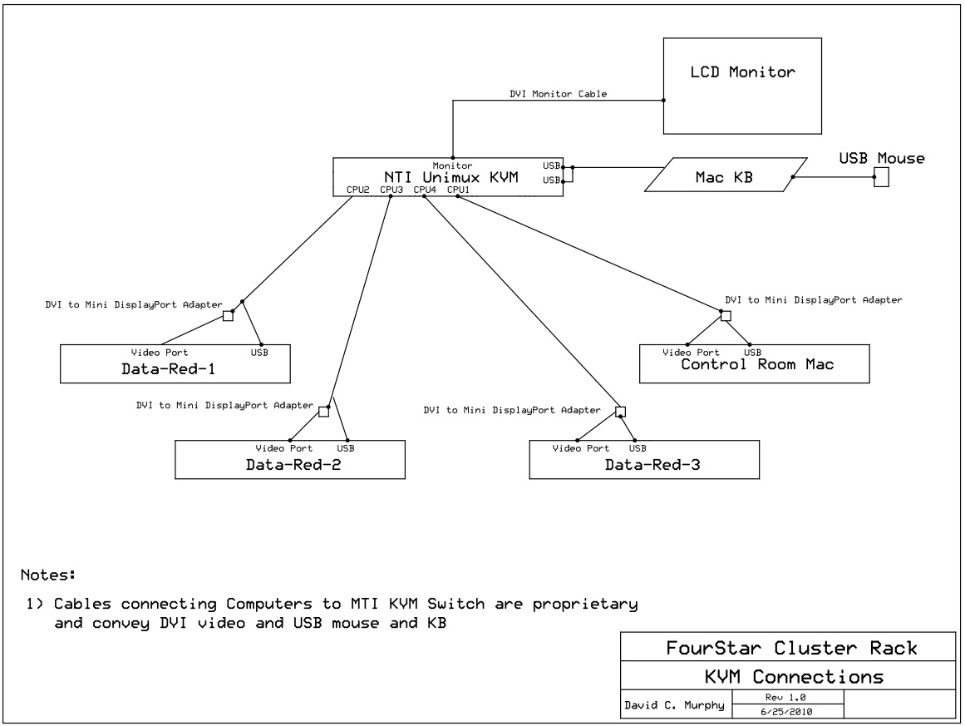

The primary Ethernet implements the 192.168.1.x/255.255.255.0 (Class C) IP space. The IP address for all devices and computers on this network are static. Domain Name System (DNS) services are not used. Apple Directory Services are also explicitly avoided. Table 6-1 details the IP address assignments for the primary Ethernet network. The subnet mask is 255.255.255.0.

Table 6-1 IP Addreses for the main FourStar Data System Network.
Computer | Address | Description
CISCO | 192.168.1.1 | CISCO Firewall Appliance
FS-DA-1 | 192.168.1.2 | Array Server 1
FS-DA-2 | 192.168.1.3 | Array Server 2
FS-DA-3 | 192.168.1.4 | Array Server 3
FS-DA-4 | 192.168.1.5 | Array Server 4
Nasmyth-Mac | 192.168.1.6 | Nasmyth Mac: Platform
Control-Room-Mac | 192.168.1.7 | Control Mac: Equipment Room
LakeShore 1 | 192.168.1.8 | LakeShore Unit #1 on Dewar
LakeShore 2 | 192.168.1.9 | LakeShore Unit #2 on Dewar
Process Controller | 192.168.1.10 | Process Controller on Dewar
Motor Controller | 192.168.1.11 | Mycom Unit for Motors 1-3 (wheels)
Motor Controller | 192.168.1.12 | Mycom Unit for Motor 4 (pupil)
AcroMag ADC | 192.168.1.13 | AcroMag ADC – Pupil Position
FS-DA-BCKP | 192.168.1.14 | Spare Array Server
FS-DA-BCKP-2 | 192.168.1.15 | Spare Array Server
Data-Red-1 | 192.168.1.16 | Data Reduction Computer 1
Data-Red-2 | 192.168.1.17 | Data Reduction Computer 2
Data-Red-3 | 192.168.1.18 | Data Reduction Computer 3
FS-DA-BCKP-3 | 192.168.1.19 | Spare Array Server
Minicom KVM | 192.168.1.22 | KVM HTTP Address
Lab LakeShore | 192.168.1.24 | Lab LakeShore Unit

The Metadata network uses the private IP space 10.1.1.x/255.255.255.0 (Class C). The IP address for all devices and computers on this network are static. There is no routing to any other network and no network name services such as DNS or Apple Open Directory are implemented. Table 6-2 details the IP address assignments for the Metadata network. The subnet mask is 255.255.255.0.
Table 6-2 IP Address assignments for the FourStar Data Metadata Network.
Computer | Address | Description
Data-Red-1 | 10.1.1.1 | Primary Metadata Controller
Data-Red-2 | 10.1.1.2 | Backup Metadata Controller
Data-Red-3 | 10.1.1.3 | Backup Metadata Controller
Control Room Mac | 10.1.1.4 | Xsan2 Client
Nasmyth Mac | 10.1.1.5 | Xsan2 Client

Communication from the primary Ethernet to the Campanas LAN (or Internet) is through a Cisco 515E firewall appliance using Network Address Translation for outgoing connections. A few very limited number of Port Address Translation (PAT) connections are defined for incoming connections. All outgoing connections are permitted. The Las Campanas DNS Servers are used to provide naming services for Internet or LCO LAN access on outgoing connections.

A detailed drawing showing the cable connections for FourStar Main LAN Ethernet devices found in the dewar electronic racks is given by the electronic drawings of Rack #1 and #2 found at this link:
http://obs.carnegiescience.edu/instrumentation/FourStar/ELECTRICAL/links.html

Telescope Fiber Optic Cabling
Communication between the major distributed elements of the computer system: The dewar electronic racks, the Nasmyth Mac, and the Fourstar Data Server Rack is by multimode fiber optic cable. This provides requisite speed and Galvanic isolation necessary for the hostile electrical environment encountered by distributed systems at the Baade telescope.

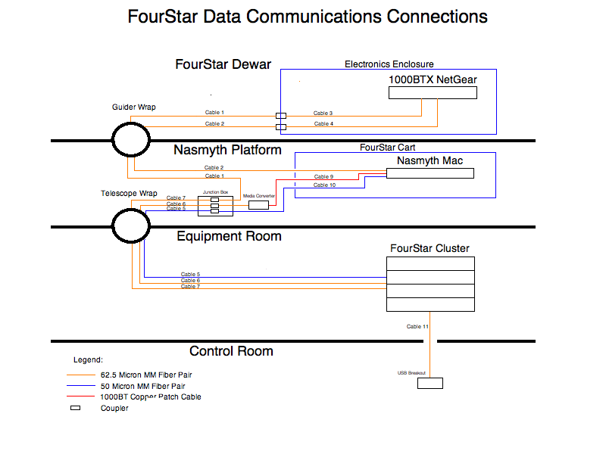

Figure 6.17 Data communications cabling scheme for FourStar.

Figure 6.17 details the external data communications cabling layout for FourStar. All cables are labeled on both ends with a number. An important maintenance consideration to note is that there is some redundancy in the cabling scheme in the event of a failed cable. A summary of the cable lengths and type is given in
Table 6-3.
Table 6-3 Data communications cables for FourStar.
Cable Number | Length | Type | Connectors
1 | 18 m | 62.5 micron multimode pair | LC
2 | 15 m | 62.5 micron multimode pair | LC
3 | (see electronic racks drawings)
4 | (see electronic racks drawings)
5 | 50 m | 50 micron multimode pair | LC
6 | 50 m | 62.5 micron multimode pair | LC
7 | 50 m | 62.5 micron multimode pair | LC
9 | 18 m | Certified Cat-6 Copper | RJ45
10 | 18 m | 50 micron multimode pair | LC
11 | 28 m | 62.5 micron multimode pair | LC

- Cable 1 and Cable 7 physically implement the primary Ethernet fiber backbone. These two are patched to each other with a junction box found on the Nasmyth platform. Cable 1 routes through the guider rotator cable wrap, and Cable 7 routes through the telescope cable wrap. These two cables form a 1000Base-SX Ethernet backbone between two Netgear switches, one in the electronics rack, and another in the Server Rack. The Control Mac connects directly to the Netgear Fiber switch in the Data Server Rack with a 1000Base-SX PCI interface (Small Tree) assuring physical data throughput needs.
- Cable 2 is routed through the guider cable wrap to connect the Nasmyth Mac directly to the Fiber Backbone.
- Cable 6 carries out-of-band metadata Ethernet from the FourStar Cluster Rack out-of-band Netgear switch (using one of its available 1000Base-SX ports), through the junction box, to a 1000Base-SX 1000Base-T media converter, and over Cable 9 (a Certified Cat-6 twisted pair) to the second copper Ethernet port on the Nasmyth Mac. This enables the Nasmyth Mac to participate as a client in the Xsan2 cluster.
- Cables 5 and 10, patched to each other through the Nasmyth junction box, connect the PCI Fibre Channel port on the Nasmyth Mac to the Brocade Fibre Channel switch in the Cluster Rack. Unlike the trunked 4Gb copper Fibre Channel connections between SAN cluster members in the Cluster Rack, this is a single-point fiber connection. Due to the speed of fiber, the performance is adequate for fail-over usage of the Nasmyth Mac, although there is no redundancy. This is an acceptable compromise in lieu of the fact that the Nasmyth Mac is an emergency spare when used from the telescope control room.
- Cable 11 is used to implement a USB 2.0 fiber optic extender pair between the Cluster Data Rack and the Baade telescope control room. Four USB 2.0 ports are implemented in the control room for use by observers to store observing data on portable USB hard drives and to operate USB speakers. These speakers provide audio cues from the FourStar control software to the observer.

The two most critical and vulnerable cables are 7 and 1, those transporting data and control information under ordinary operating circumstances through the two cable wraps. In the event of a failure of Cable 7 and assuming the Nasmyth Mac is not needed (it is usually used as failover for the Control Mac), Cable 6 may be substituted for Cable 7 providing redundancy. Similarly Cable 2 can substitute for Cable 1.

FourStar Motor Controller
The original FourStar Motor Control (FSMC) design document is given here for reference. This document describes features and programming issues for this unit. Maintenance and support personnel may find this useful. In addition some useful technical details of the FourStar internal mechanisms are discussed. This document, together with the Motor Controller schematics and the manual for the Nyden MAC 300 fully specify the Motor Controller.

Overview
This document gives a brief description of the Four Star Motor Controller (Hereafter FSMC). While the FSMC is fully specified by its schematics, this document will be useful to those seeking to understand the circuit details and motivations. The reading audience will include persons building or repairing the FSMC, persons tasked with repairing or trouble shooting the FSMC, and also those writing, debugging, or modifying computer code to communicate with and program the FSMC. The reading audience will also include persons seeking a better understanding of the associated FourStar limit switches, motors, and potentiometer encoders.

Description of the Four Star Motion Control Hardware
The Four Star Infrared Camera has four mechanisms controlled by stepper motors. There are two filter wheels a field flattener wheel and a motorized mechanism to adjust the telescope pupil mask. The three wheels are referenced using spring-loaded ‘fingers’ (essentially cam followers) mounted on a tower. As the wheels rotate the cams enter the detent on the outer circumference of the wheels. The spring preload on each detent arm centers the detent thus precisely defining and holding the position of the wheel. The ‘fingers’ also trigger micro-switches each time the cam enters a detent, which gets indicated on the FSMC display and FourStar software. The filter/flattener wheel and detent system is illustrated in Figure 6.18.
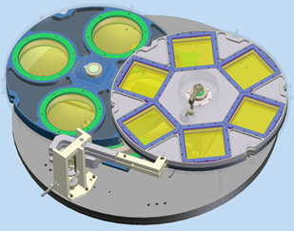

Figure 6.18 The Filter wheels and field flattener wheel with the detent arm assembly.
The two filter wheels are referred to as “Filter Wheel Top” (hereafter FWt) and “Filter Wheel Bottom” (FWb). FWt and FWb are adjacent in the converging telescope beam forward of the imaging arrays with FWt being closest to the telescope.

FWt and FWb have six detented positions each; one being a home position for each. The Field Flattener Field (FFW) resides under the two filter wheels and has four detented positions; one being a home position. Each wheel is driven by its own stepper motor located outside the cryogenic vacuum dewar. Motion from the outside is transmitted into the dewar via ferrofluidic vacuum feedthroughs. A torque converter on the outside transmits the power through a set of gears and shafts to each wheel. A simple digital encoder, external to the dewar, encodes each detented wheel position. This works by utilizing a wheel outside the dewar geared 1:1 with the filter wheels inside the dewar. These external wheels actuate magnetic reed switches with a magnet that rotates to each switch when an internal detent position of the wheel is reached internally. This device is essentially a multi pole switch. Each detent arm is encoded with a micro switch to indicate a detent-in position.

The pupil masking aperture mechanism is driven by an external stepper, which has limit switches and a linear potentiometer to encode position; see Figure 6.19. The potentiometer reading is passed through the AcroMag ADC unit in the FSMC.
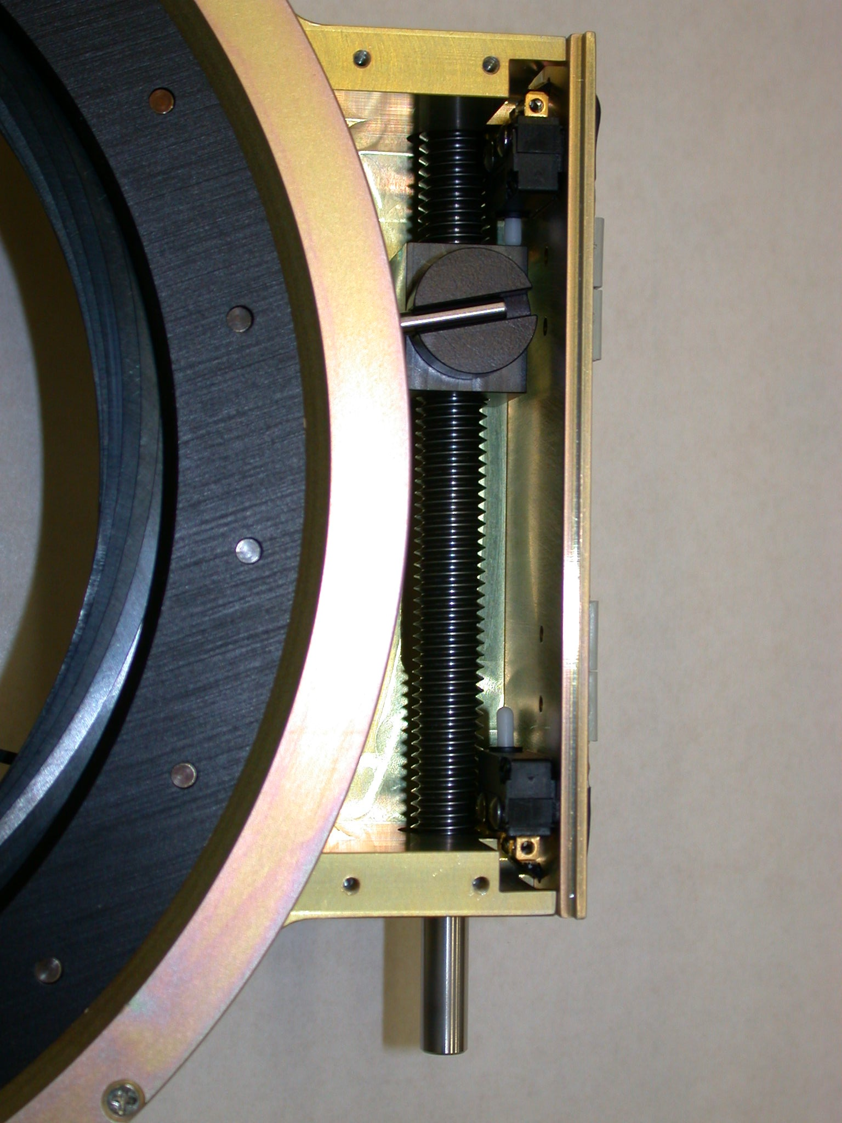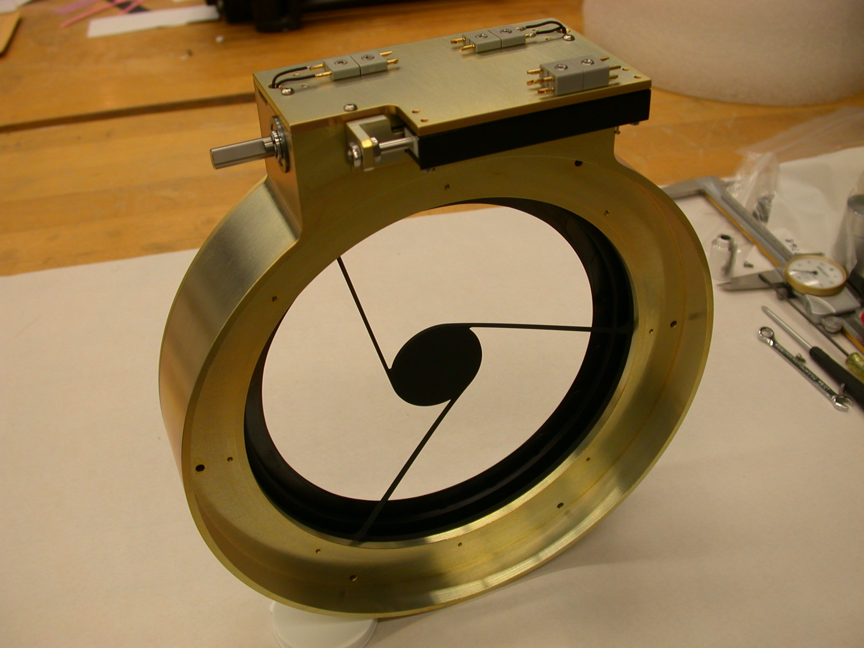
Figure 6.19 Cold Pupil mechanism.

Overview of the FSMC
The FSMC is a full-width 3U rack mounted instrument. The principle active elements are two Nyden MAC-300 stepper motor controllers, six Mycom IMS500-021 stepper motor drivers, an Acromag 962EN six channel Ethernet-based 12 bit ADC and a custom designed Logic Interface Board.

The MAC-300’s are smart, programmable, stepper motor controllers. The Mycom units are basic stepper drivers. The function of the Acromag ADC is to measure a voltage drop across the potentiometer used for the pupil positional encoding. This encoding voltage is in the +/- 5V range (approximately) and may require averaging in software to reduce noise. The Logic Interface Board serves several interfacing and logic decoding functions as discussed below.

Each MAC-300 is capable of controlling up to four stepper motors. The first MAC-300 in the FSMC designated MAC-300 #1 controls steppers for FWt, FWb, FFW, and the detent arm (obsolete), on its internally labeled axes A, B, C, and D, respectively. The second MAC-300, #2 controls the pupil motor and focus motor (obsolete) on its axes A and B, respectively. Communication with each MAC-300 occurs through their RS-232 ports; Motor-Controller-1 and Motor-Controller-2.

The Acromag unit is interfaced to the computer with Ethernet. Channel 0 reads the Pupil encoder voltage and channel 1 reads the focus position (obsolete). Refer to the Acromag manual for programming details.

MAC-300 digital inputs are active low (i.e. logical condition asserted when grounded) and are opto isolated. When these inputs are floated they pull high to within a diode-drop of the FSMC 24V supply, so they must not be simultaneously wired to TTL or CMOS inputs. They are designed to be connected directly to switches which ground their inputs to indicate the relevant condition.

Positional switches are wired to each MAC-300. The home switches from FWt, FWb, and FFW are wired to the NEAR HOME inputs of axes A, B, and C, on MAC-300 #1, respectively. On MAC-300 #2 the forward and reverse limits from the pupil mechanism are wired to the FOR.LIMIT and REV.LIMIT bits of axes A.

In addition to home and limit inputs, each MAC-300 has eight general purpose digital inputs. Thus a system total of 16 digital inputs are available. The MAC-300 input definitions are given in Table 6-4.

Table 6-4 MAC-300 input definitions.
MAC-300 #1 Input Bit Assignments | MAC-300 #2 Input Bit Assignments
Bit 0 FWt Position Encoding Bit 0 (LSB) | Bit 0 Pupil Limit L- (0 in Limit)
Bit 1 FWt Position Encoding Bit 1 | Bit 1 Pupil Limit L+ (0 in Limit)
Bit 2 FWt Position Encoding Bit 2 (MSB) | Bit 2 FWt Home (0 at Home Pos.)
Bit 3 FWb Position Encoding Bit 0 (LSB) | Bit 3 FWb Home (0 at Home Pos.)
Bit 4 FWb Position Encoding Bit 1 | Bit 4 FWt Detent In (0 Denent In)
Bit 5 FWb Position Encoding Bit 2 (MSB) | Bit 5 FWb Detent In (0 Detent In)
Bit 6 FFW Position Encoding Bit 0 (LSB) | Bit 6 FFW Detent In (1 Detent In)
Bit 7 FFW Position Encoding Bit 1 (MSB) | Bit 7 FFW Home (0 Detent In)

FSMC Front Panel Description
The only user controller functions on the FSMC are a power switch and a momentary contact reset button to initialize the MAC-300’s. The reset button should never have to be used at the telescope and is basically for software debugging. Each limit switch is duplicated inside the dewar for redundancy. The selection of which switch to use is made by small locking toggle switches on the front panel. These toggle switches must be not manipulated except by trained and properly informed personnel.

Table 6-5 Motor Controller status LED’s on the front panel.
Status | Meaning
5V POWER | Pilot light for 5V power supply
24V POWER | Pilot light for 24V power supply
ERROR 1 | Indicates Software Error on MAC-300 #1
ERROR 2 | Indicates Software Error on MAC-300 #2
BUSY 1 | Indicates Software Executing on MAC-300 #1
BUSY 2 | Indicates Software Executing on MAC-300 #2
FWt HOME | Indicates FWt at the home position
FWb HOME | Indicates FWb at the home position
FFW HOME | Indicates FFW at the home position
FWt DETENT IN | Indicates the FWt detent is in
FWb DETENT IN | Indicates the FWb detent is
FFW DETENT IN | Indicates the FFW detent is in
DETENT OUT ALL | Indicates all detent arms are out (not implemented)
PUPIL L- | Indicates the Pupil Negative Limit is reached
PUPIL L+ | Indicates the Pupil Positive Limit is reached
FOCUS L- | Indicates the Focus Negative Limit is reached (not implemented)
FOCUS L+ | Indicates the Focus Positive Limit is reached (not implemented)

There are also three LED digits to indicate the numerical position of the wheels. These positions range from 0-5 for FWt and FWb, and 0-3 for FFW. When a wheel is not in a detent position, the digit is blanked and the decimal point flashes at 7 Hz. This signifies a state of motion.

FSMC Rear Panel Description
There are nine connectors on the rear panel of the FSMC. The connector part numbers and detailed pin-outs are given on the FSMC schematic.

- P1: AC power entry module
- P2: Pupil limits and encoding inputs
- P6: FWt reed switch encoding inputs
- P8: FWb reed switch encoding inputs
- P10: FFW reed switch encoding inputs
- P12: Wheel home/detent positions, focus limits, and focus encoding inputs
- RJ-45: 100BaseT connector to communicate with Acromag ADC
- J1: RS-232 interface for MAC-300 #1
- J2: RS-232 interface for MAC-300 #2

Process Controller

Using the Ion Pump
CAUTION, This is a high Voltage Device
The Ion pump is a sensitive piece of hardware that requires special attention and is not included in the general power-up sequence. Refer to Figure 6.20 for the following instructions.
- Close Valve 1. When powered on the Ion pump will immediately evaporate anything on the coils, thus to prevent contamination to the rest of the system the ion chamber is initially isolated.
- Turn on the Vacion Controller located in Rack 1. The LED scale should light up to full scale.
- In approximately one minute the LED scale should drop to below half scale. This means the Ion Chamber has successfully been pumped out and it is now okay to open Valve 1.
The Ion pump will report an independent Vacuum reading to the FourStar display GUI.

Procedure for changing out the Ion Pump
If the vessel vacuum starts to slowly increase it means that the ion pump needs to be replaced. The following instructions must be followed exactly as there is severe risk to the camera if air is allowed in to the cold vessel.
- First, shut off the Vacion controller. And now disconnect the high voltage cable from the Ion Pump.
- Close Valve 1 and Remove the KF fitting and cover from Valve 2. This takes a little force as it is under vacuum. Then, open Valve 2.
- Remove the Ion Pump at the KF fitting, and replace it with the spare.
- Attach a vacuum pump to Valve 2 and pump out the short section of pipe between Valve 2 and the new Ion Pump.
- Close Valve 2 and replace the cover with the KF fitting.
- Reconnect the high voltage cable to the new ion pump and refer to the previous section 6.6.1-Using the Ion Pump.

Figure 6.20 The FourStar Vacuum Valves. The insert shows the front panel of the Vacion Controller which is located in Rack 1.
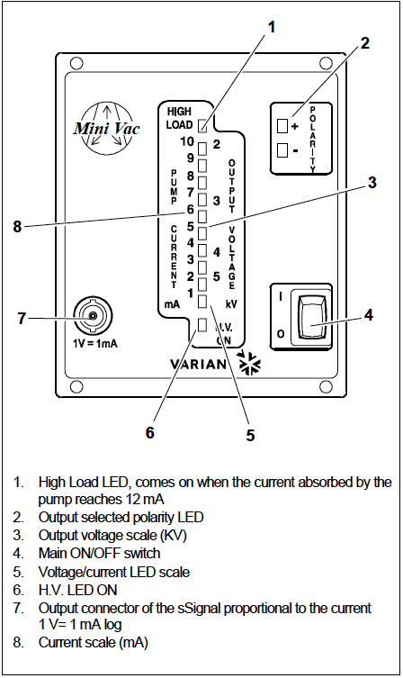
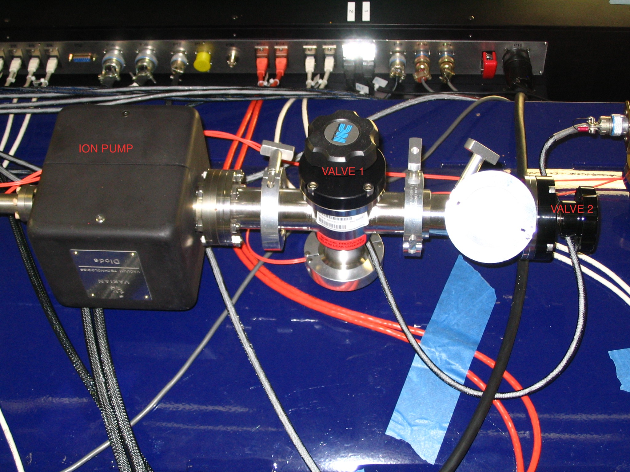

Process Controller Menu Screens
The most current firmware version is V1.56 as indicated on the startup splash screen in the lower right corner. The default screen shows the external temperatures of FourStar. The default screen has incorrectly labeled the sensors; see Figure 6.21. Figure 6.22 shows how the labels should be interpreted.

Figure 6.21 The default Process Controller screen. The labels are incorrect. A readout of -9.0C may indicate that the LEMO connector is either faulty or simply not connected.
VVSECT  1A | VVSECT  1B | VVSECT  1C | RACK  1A | RACK  1B
18.0C | 18.1C | 18.3C | 18.1C | -9.0C
VVSECT  2 | VVSECT  3 | VVSECT  4 | RACK  2A | RACK  2B
-9.0C | 18.5C | 18.6C | 18.0C | 17.9C

Figure 6.22 The correct labels for the Process Controller Screen
VVSECT  1A | VVSECT  1B | VVSECT  1C | VVSECT  2 | VVSECT3
18.0C | 18.1C | 18.3C | 18.1C | 18.0C
VVSECT  4 | RACK  1A | RACK  1B | RACK  2A | RACK  2B
18.0C | 18.5C | 18.6C | 18.0C | 17.9C

The Process Controller has a menu structure to access various items. If the FourStar software is running then the keypad must be unlocked by selecting LN2+Sensors Disable/Enable Connection from the FourStar menu. The keypad can be a bit sticky so it may take a few tries for the numbers to register. Press the CE/E key to access the menuand select an item (quickly or else it goes back to the monitoring screen). The menu items are:

- Monitor Mode
  - Enable Solenoids
  - Disable Solenoids
  - Enable Alarm
  - Disable Alarm
  - Display Status
- Solenoids are OFF
- LN2 Within Normal Bounds
- No Errors
- Keypad is Enabled
- Passthrough Enabled
- Alarm is Off
- Monitor Mode Enabled
- Capacitance Control Enabled
- Sinewave is Active

Hit any key to continue
  - Display Settings
- LN2 Full Setpt: 90
- LN2 Near Empty Setpt: 15
- LN2 Empty Setpt: 10
- LN2 Fill Time (min): 10
- LN2 Hold Time (min): 500

Hit any key to continue
  - Display MAC
00:90:c2:cc:69:61
<Hit any key to continue>

  - Monitor Telemetry
Main Cap = 773pF Inner Cap = 747pF

MainLN2Lvl = 82% InnerLN2Lvl = 54%

Vacuum = 1.83E-06 Torr
Ion Pump = 0.030 mA
T1 = 19.4 C T2 = 19.6C
T3 = 19.6C T4 = 19.3C
T5 = 18.8C T6 = 17.6C
T7 = 23.3 C T8 = 22.3C
T9 = 25.5 C T10 = 23.3C

<Hit any key to continue>
CE/E to Return

- Configure LN2 Fill Parameters
- LN2 Full Setpt(%)
Current Value is 90.00
Enter Data:
- LN2 Near Empty Setpt(%)
Current Value is 15.00
Enter Data:
- LN2 Empty Setpt(%)
Current Value is 10.00
Enter Data:
- Fill Time (mins)
Current Value is 10.00
Enter Data:
- Hold Time (mins)
Current Value is 500.00
Enter Data:

- Fill Mode (1:DR, 0:Norm)
Current Value is 0.00
Enter Data:
- # of samples to read
Current Value is 100.00
Enter Data:
CE/E to Return
- Configure LN2 Sensor Parameters
  - Main Tank Full Sns Cap (pF)
Current Value is 779.00
Enter Data:
  - Inner Tank Full Sns Cap (pF)
Current Value is 755.00
Enter Data:
  - Main Tank Empty Sns Cap (pF)
Current Value is 718.00
Enter Data:
  - Inner Tank Empty Sns Cap (pF)
Current Value is 696.00
Enter Data:
  - Sinewave Frequency
Current Value is 400.00
Enter Data:
CE/E to Return

- Factory Default
  - Load Default Parameters
Setting Default Parameters
</n>Hit any Key to Continue
  - Restore LCD Fonts and Bitmaps
Getting Fonts & Bitmaps
</nHit any Key to Continue>

Finished Uploading Font Futura

  - Restore Keypad Settings
Updating Keypad
</nHit any Key to Continue>
CE/E to Return
- LCD Setting
  - Set Contrast
Use up and down arrows

<Hit Enter to Save>
  - Set Brightness
Use up and down arrows

<Hit Enter to Save>
  - Set Screen Delay
Current Value is 0.00
Enter Data:
CE/E to Return
- Reset Unit

CE/E to Return

Table 6-6 The default Process Controller settings
Setting | Default | Unit 1 | Unit 2
Fill level | 92 | 90 | 90
Near Empty Level | 22 | 15 | 15
Empty Level | 12 | 10 | 10
Fill time | 900 | 10 | 10
Hold Time | 1449 | 500 | 500
Fill Mode | 0 | 0 | 0
# of samples | 10 | 100 | 100
Main Tank Full | 1000 | 779
Inner Tank Full | 1970 | 755
Main Tank Empty | 950 | 718
Inner Tank Empty | 1050 | 696
Sinewave Frequency | 400 | 400 | 400

LN2 SystemHost Commands
ID |  |  |  | Command String | Command Description
0 |  |  |  | NO_CMD
Parameter |  |  |  |  | Command Response | Response Type
ID |  |  |  | Command String | Command Description
1 |  |  |  | SOLENOID_ON | Activate LN2 Solenoid
Parameter |  |  |  |  | Command Response | Response Type
NONE |  |  |  |  | "Done" or "Error" | string
ID |  |  |  | Command String | Command Description
2 |  |  |  | SOLENOID_OFF | Deactivate LN2 Solenoid
Parameter |  |  |  |  | Command Response | Response Type
NONE |  |  |  |  | "Done" or "Error" | string
ID |  |  |  | Command String | Command Description
3 |  |  |  | ALARM_ON | Activates Buzzer in rack
Parameter |  |  |  |  | Command Response | Response Type
NONE |  |  |  |  | "Done" or "Error" | string
ID |  |  |  | Command String | Command Description
4 |  |  |  | ALARM_OFF | Deactivates Buzzer in rack
Parameter |  |  |  |  | Command Response | Response Type
NONE |  |  |  |  | "Done" or "Error" | string
ID |  |  |  | Command String | Command Description
5 |  |  |  | GET_MAIN_LN2 | Read main tank LN2 Level
Parameter |  |  |  |  | Command Response | Response Type
NONE |  |  |  |  | Level in % of toatal (0 to 100) | decimal
ID |  |  |  | Command String | Command Description
6 |  |  |  | GET_INNER_LN2 | Read Inner tank LN2 Level
Parameter |  |  |  |  | Command Response | Response Type
NONE |  |  |  |  | Level in % of toatal (0 to 100) | decimal
ID |  |  |  | Command String | Command Description
7 |  |  |  | GET_VACUUM | Read vacuum gauge
Parameter |  |  |  |  | Command Response | Response Type
NONE |  |  |  |  | Vacuum reading in Torr | float
ID |  |  |  | Command String | Command Description
8 |  |  |  | TAKE_CONTROL | Set Passthrough Mode
Parameter |  |  |  |  | Command Response | Response Type
NONE |  |  |  |  | "Done" or "Error" | string
ID |  |  |  | Command String | Command Description
9 |  |  |  | RELEASE_CONTROL | Unset Passthrough Mode
Parameter |  |  |  |  | Command Response | Response Type
NONE |  |  |  |  | "Done" or "Error" | string
ID |  |  |  | Command String | Command Description
10 |  |  |  | GET_TEMPERATURE | Read thermistor
Parameter |  |  |  |  | Command Response | Response Type
Thermistor# (0 to 9) |  |  |  |  | Temp Reading | float
ID |  |  |  | Command String | Command Description
11 |  |  |  | GET_STATUS | Read status register
Parameter |  |  |  |  | Command Response | Response Type
NONE |  |  |  |  | 16bit status word | hex
ID |  |  |  | Command String | Command Description
12 |  |  |  | SET_LN2_FULL_LVL | Set tank full indication point
Parameter |  |  |  |  | Command Response | Response Type
Percent (0 to 100) |  |  |  |  | "Done" or "Error" | string
ID |  | Command String |  |  | Command Description
13 |  | SET_LN2_NEAR_EMPTY_LVL |  |  | Set tank near empty point
Parameter |  |  |  |  | Command Response | Response Type
Percent (0 to 100) |  |  |  |  | "Done" or "Error" | string
ID |  |  |  | Command String | Command Description
14 |  |  |  | SET_LN2_EMPTY_LVL | Set tank empty point
Parameter |  |  |  |  | Command Response | Response Type
Percent (0 to 100) |  |  |  |  | "Done" or "Error" | string
ID |  |  |  | Command String | Command Description
15 |  |  |  | GET_LN2_FULL_LVL | Read LN2 full level set point
Parameter |  |  |  |  | Command Response | Response Type
NONE |  |  |  |  | % (0 to 100) | decimal
ID |  |  | Command String |  | Command Description
16 |  |  | GET_LN2_NEAR_EMPTY_LVL |  | Read LN2 near empty set point
Parameter |  |  |  |  | Command Response | Response Type
NONE |  |  |  |  | % (0 to 100) | decimal
ID |  |  |  | Command String | Command Description
17 |  |  |  | GET_LN2_EMPTY_LVL | Read LN2 empty set point
Parameter |  |  |  |  | Command Response | Response Type
NONE |  |  |  |  | % (0 to 100) | decimal
ID |  |  | Command String |  | Command Description
18 |  |  | ENABLE_KEYPAD |  | Enable user front panel keypad
Parameter |  |  |  |  | Command Response | Response Type
NONE |  |  |  |  | "Done" or "Error" | string
ID |  |  |  | Command String | Command Description
19 |  |  |  | INHIBIT_SINEWAVE | Disable the exitation signal
Parameter |  |  |  |  | Command Response | Response Type
NONE |  |  |  |  | "Done" or "Error" | string
ID |  |  | Command String |  | Command Description
20 |  |  | SET_FILLTIME |  | Set LN2 filltime
Parameter |  |  |  |  | Command Response | Response Type
Minutes |  |  |  |  | "Done" or "Error" | string
ID |  |  |  | Command String | Command Description
21 |  |  |  | GET_FILLTIME | Read the LN2 filltime setting
Parameter |  |  |  |  | Command Response | Response Type
NONE |  |  |  |  | Minutes | decimal
ID |  |  | Command String |  | Command Description
22 |  |  | SET_HOLDTIME |  | Set LN2 holdtime
Parameter |  |  |  |  | Command Response | Response Type
Minutes |  |  |  |  | "Done" or "Error" | string
ID |  |  |  | Command String | Command Description
23 |  |  |  | GET_HOLDTIME | Read the LN2 holdtime setting
Parameter |  |  |  |  | Command Response | Response Type
NONE |  |  |  |  | Minutes | decimal
ID | Command String |  |  |  | Command Description
24 | SET_MODE_DEADRECKONING |  |  |  | Set system to dead recogning mode
Parameter |  |  |  |  | Command Response | Response Type
NONE |  |  |  |  | "Done" or "Error" | string
ID |  |  |  | Command String | Command Description
25 |  |  |  | SET_MODE_PROCCNTL | Set system to process control
Parameter |  |  |  |  | Command Response | Response Type
NONE |  |  |  |  | "Done" or "Error" | string
ID | Command String |  |  |  | Command Description
26 | ENABLE_SINEWAVE |  |  |  | Enable the exitation signal
Parameter |  |  |  |  | Command Response | Response Type
NONE |  |  |  |  | "Done" or "Error" | string
ID |  |  |  | Command String | Command Description
27 |  |  |  | GET_MAIN_CAP | Reads the main tank capacitance in pF
Parameter |  |  |  |  | Command Response | Response Type
NONE |  |  |  |  | "Done" or "Error" | decimal
ID | Command String |  |  |  | Command Description
28 | GET_INNER_CAP |  |  |  | Reads the inner tank capacitance in pF
Parameter |  |  |  |  | Command Response | Response Type
NONE |  |  |  |  | "Done" or "Error" | decimal
ID |  |  |  | Command String | Command Description
29 |  |  |  | RESET_UNIT | Reset the microprocessor
Parameter |  |  |  |  | Command Response | Response Type
NONE |  |  |  |  | NONE | NONE
ID | Command String |  |  |  | Command Description
30 | GET_ION_CURR |  |  |  | Get ion pump current from controller
Parameter |  |  |  |  | Command Response | Response Type
NONE |  |  |  |  | milli-amps | float

LN2 System Status Register
Val | Description
1h | Solenoid Status, EnabledifTrue
2h | Tripped, Tripped if True
4h | System Error, Enabled if True
8h | Lockout Mode, Locked out if true
10h | Passthrough Mode, enabled if true
20h | Alarm status, Activeted if True
40h | Monitoring Mode, Enabled if true
80h | Dead Recogning Mode, Enabled if True
100h | Sinewave Excitation Status

Temperature Controller
There are two LakeShore 340 Temperature controllers used with FourStar. If either needs to be replaced then a spare can be found and used to replace the failing unit. To replace a LakeShore unit in one of the racks see section 5.2.9. Most of the Lakeshore settings are programmed using communication from the FourStar software but one setting must be set manually: the heater resistance. As stated from the LakeShore 340 Manual;
“To enter a heater resistance, press the Control Setup key and the CONTROL SETUP screen is displayed.
The control loop indicator is highlighted in the upper left hand corner. Use the or key to select Loop 1.
Press the Enter or Next Setting key. The control setup parameters for that loop appear on the screen. Press
the Next Setting key until the Htr Ω field is highlighted. Use the number keys to enter the resistance of the
heater in ohms. Press the Enter or Next Setting key to continue with more settings, or press the Save
Screen key to store the changes in the Model 340. The default setting is 25 Ω.”

Setting | LS340 Rack 1 (Detector) | LS340 Rack 2 (Optics) | LS340 Cleanroom
Htr Ω | 50 | 25 | 12
Max Htr I | 1.00A | 1.00A | 2.00A

Reference Pixel Subtraction
The raw data is reference pixel subtracted on readout. The left and right reference pixels themselves are unmodified so it is possible to undo the reference pixel subtraction (RPS) by applying the algorithm in reverse and then a user specified algorithm may be applied to the raw data if desired. The reference pixels comprise the first four and last four rows and columns. Thus, the active imaging area is the 2040x2040 pixel region: 5:2044, 5:2044.
- First, each of the 32 channel offets (C) are determined from the average of the reference pixels on each side of the channel:
C_{n} = [∑(1:4,1+64(n-1):64n)+∑(2045:2048,1+64(n-1):64n]/512; n=1,32.
- Then the column component (high-frequency) of the RPS is determined from a sliding window average of the reference pixels in the current and (optional: 0,1,2,3,4) two adjacent columns on each side (5 total columns default):
D = [∑(x-2:x+2,1:4)/20-C₀₁+∑(x-2:x+2,2045:2048)/20-C₃₂]/2
- Finally: P_{T x,y} = P_{R x,y} - C_{n} - D. Where P_{T x,y} is the corrected pixel value at x,y; P_{R x,y} is the raw pixel value and C_{n} is the respective channel offset.
Example: P_{T 64,64} = P_{R 64,64}-C₀₁-[∑(62:66,1:4)/20-C₀₁+∑(62:66,2045:2048)/20-C₃₂]/2.
CH 32 | ₂₀₄₈
 | ₂₀₄₇
 | ₂₀₄₆
 | ₂₀₄₅
 | ₂₀₄₄
 | …
 | ₁₉₈₅
OTHER CHANNELS | …
CH 01 | 64
 | …
 | 5
 | 4
 | 3
 | 2
 | 1 | 2 | 3 | 4 | 5 | … | … | 64 | ... | … | ²⁰⁴⁴ | ²⁰⁴⁵ | ²⁰⁴⁶ | ²⁰⁴⁷ | ²⁰⁴⁸
 |  |  |  |  |  | sliding window

Spare parts list
SPD Box (against rear wall)
Load ring | 1 set | Two halves of the FourStar load ring
Light Baffle support structure | 1 set | Two 74-inch x 1”dia rods, Two support braces, screws and clamps.
SPD Box (Bottom 2 Boxes)
UPS Controller | 1
UPS Battery Pack | 1
SPD Box (Box 1)
Thermal Breakers | 2 | Temperature cutoff switch for Electronics Racks Selco SE-L123M
Connector | 2 | LN2 solenoid Rack 2 P14 PT02A-8-4S
Connector | 1 | LN2 solenoid 4-pin male plug PT06A-8-4P(SR)
Stepper Motor | 2 | External replacement Mycom PF 545-BC
Dessicant | 3 packs | Silica gel for cleanroom air dryer DRP-14-10B
Dessicant Bowl | 1 | For cleanroom air dryer SMC 10-AF30-N02B-JZ 150 psi max
Serial-Ethernet Converter | 2 | LakeShore and Motor Controller Lantronix Xpress-DR
Misc NPT to hose adapters | 1 bag | For cleanroom air dryer
Vented SHCS | 3 boxes | 10-32x7/8 8-32x1/2 10-32x5/8
12-pt machine screws | 1 bag | For vessel sections
Cryo Solenoid | 1 | LN2 auto-fill system Valcor Scientific SV955G56HC6
Power connector, Female | 1 | 115 VAC twist lock Turnlok 20A 125V NEMA L520-C
Power socket, Male | 1 | 115 VAC twist lock Turnlok 20 A 125V NEMA L520
Heat exchanger | 1 | Lytron radiator for electronics racks Lytron 4110G10SB-D9
Disk drive | 2 | 1 TB hard drive for RAID chassis
SPD Box (Box 2)
Ion Pump | 1 | Varian Ion Pump
SPD Box (Box 3)
Apple Xserve Parts | 1 kit | Factory spares kit (fans, power supply etc.) for servers
SPD Box (Box 4)
Brocade SAN switch | 1 | SAN switch
SPD Box (Box 5)
USB PCI card | 1
Optolink Media Converter | 1
Power Line Adapter | 1
Fiber patch box | 1
SPD Box (Box 6)
Power Supply | 1 | Power supply for arrays in electronics rack 1 Acopian VA5NT220M
24V DIN power supply | 2 | 24V VDC DIN for electronics rack TDK Lambda DSP60-24
Fans | 2 | Electronics Racks cooling embpapst 4600 Z 115 VAC
Rabbit Controller | 1 | Process controller, Rabbit microprocessor
SPD Box (Box 7)
Circuit boards | 2 | Wheel encoder board
G10 straps | 3 | Radiation shield straps
G10 strap | 1 | Axial constraint for shield
HV connector | 1 | Ion gauge panel
Shims | 4 packs | Camera Module shims, 0.003, 0.004, 0.005, 0.006
Fiber optic feedthrough | 4 | Ferrules for fakestar
Electrical plug | 2 | 4-pin LEMO plug
Electrical panel socket | 2 | 4-pin LEMO Socket
Limit switches | 5 | For brakes and LN2 holster
Hermetic switches | 75 | HSR-0035RT
Ball bearings | 4 packs
Misc washers | 1 pack
Ferrofluidic feedthough | 1 | C64205 50-103978M
Shaft coupler | 2
Shaft | 1
Vented screws & washers | 1 pack | ¼-28vented, G10 washers, Belleville washers
Hermetic electrical connector | 2
Hermetic electrical connector | 2
LEMO sockes on angle bracket | 2 | 3-pin LEMO for temperature
Hook for copper braid | 1
Electrical connector | 2 | For camera module
SPD Box (Box 8)
Ethernet Cables | 8 | Cat 5 ethernet cables
SPD Box (Box 9)
Raid Spares | 1 box | Service spares for RAID
SPD Box (Box 10)
KVM spare | 1 | Minicom KVM spare
SPD Box (Box 11)
Temperature Controller | 1 | Spare LakeShore 340 unit
SPD Box (Box 12)
O-rings | Lots
SPD Box (Box 13)
Heater Pad | 1 | Kapton heater pad Watlow 40V 64W
Motor Controller spares | 1 kit | Electronics rack
Electronics wiring spares | 1 kit | Connectors, etc
Rabbit Programming cable | 1 | Process controller firmware updates
Sensor Electronics | 1 kit | IC’s, empty board, caps, resistors
Logic interface boards | 1 kit
SPD Box (Box 14)
Cables with Connectors | 1kit | For LakeShore 340
Cables and Connectors | 2 | For Variam Ion Pump
Copper Gaskets | 1 kit | Conflat copper gaskets
Fuses | 2 packs | For cold cathode gauge
Hermetic Connector | 1 | 2-hermetic mini-subD HiRose connectors
DB15 connector | 1 | D-sub
Vacuum Gauge | 1 | Pfieffer PTR26 001
Vacuum Gauge | 2 | Varian type 0531
Vaccum Valve Tee | 1 | Nor-Cal ESV-1503T-NWB
Vacuum Valve | 1 | Kurt Lesker SA0150MVQF
Quik-Flange Reducing Nipple | 1 | QF50XQF40C
Misc QF hardware | misc | QF40 O-ring seals, QF40 to QF30 nipple, clamps & caps.
SPD Box (NetGear Box, near top)
Netgear Ethernet switch | 1
SPD Box (3 white boxes on top)
Fiber USB extenders | 2 boxes
Fiber USB extender power supplies | 1 box
SPD Box (Monitor, near top)
17” Flat panel Monitor | 1
Cleanroom Electronics Rack
Motor Controller | 1
Process Controller | 1
Temperature Controller | 1
Data Acquisition PC | 3
Netgear Ethernet switch | 2
Cisco Pix Firewall | 1
FourStar Cleanroom Cabinet
Empty H2RG Pelican cases | 4 | Including anti-static boxes and bags
Spare array cables | 3 | 4” Hirose cables
Spare Jade / ASIC card | 2 / 1 | 2 Jade cards, 1 dual ASIC card
LN2 transfer hose | 1 | 5’ LN2 transfer hose
Indium Foil (in gray box) | 1-bag | Miscellaneous pieces of indium
Filter edge springs (in gray box) | 1-bag | Edge Springs for filters
6” port covers | 2 | Spare port covers for the motor feedthroughs
Kapton Tape | 1-roll | Cryogenic kapton tape
Xserve Disk Drives | 8 | 1 TB disk drives for Apple Xserves
LaCie external hard drives | 10 | 500MB external USB drives for data storage
DVD / Blue Ray discs | many | Writable media for Fourstar blu-ray drive
Fiber optic cable | 4 | Fiber for USB extenders
HP power supply | 1 | Power supply plus cable for Jade card (set to 5V)
MKS vacuum Gauge | 1 | MKS vacuum gauge for FourStar
Spare Jade Sync Cable | 1 | Jade Syncronization Cable (spare)

FourStar Cart 1 Drawer Contents
Drawer 1
Cart jack ratchets | 4 | Ratchets for the 4 jacks
Turn key | 1 | Turn key for the yoke spring
Drawer 2
Allen Key set | 1
Ratchets | 4 | 2 12-pt ratches for the vessel sections, 2 12-pt ratches for the ball transfer locks
Tie downs | 1-bag | Black stick-on squares to attach to FourStar with cable ties
Cable ties | 1-bag | Black cable ties for securing cables
12-pt screw | 1-bag | Extra 12-pt screw for the vessel sections
Guide pins | 2 | Tapered guide pins for the vessel sections and conical adapter
Drawer 3
Camels Hair Brush | 2 | For front window cleaning
Inspection Mirror | 1 | For viewing front window
Keyboard / mouse | 1 / 1 | For use with the Data Array servers (Windows PC’s)
MiniCom cable | 1 | Connects Nasmyth Mac video out to DVI monitor
Cable | 1 | Connects mouse and keyboard to Nasmyth Mac
Drawer 4
Crane straps | 2
Hoist fixtures | 2 | FourStar hoist fixtures
Aluminum + rubber pads | 4 + 4 | Pads for the jacks to sit on

Array Electronics Device Signal Chain
Table 6-7 contains the current device serial numbers along each signal chain. Below the HiRose entries are counters of (approximately) how many times that connection has been made. The recommended maximum value suggested by Teledyne (private communication) is ~20 cycles; i.e. the HiRose connectors should not be removed / re-attached multiple times or the pins will wear.

Table 6-7 Array Device Chain
 | Array #1 |  | Array #2 |  | Array #3 |  | Array #4
SN | 192 |  | 204 |  | 209 |  | 216
4” HiRose | 004-9 |  | 1 |  | 2 |  | 3
# H2RG | ASIC | 7 | 10 | 3 | 6 | 3 | 6 | 3 | 6
ASIC | 4 |  | 4 |  | 2 |  | 2
15” HiRose | 02 |  | 03 |  | 04 |  | 05
# ASIC | JADE | 14 | 7 | 14 | 7 | 14 | 7 | 14 | 7
JADE SN | 67 |  | 65 |  | 69 |  | 72
DA-PC IP | 192.168.1.2 |  | 192.168.1.3 |  | 192.168.1.14 |  | 192.168.1.5

Location of FourStar Documents
The following websites and/or descriptions point to various locations where the engineering documentation for the instrument itself is kept.

Focal plane Mechanisms
http://obs.carnegiescience.edu/instrumentation/FourStar/MECHANICAL/ekoch/4star/index.html
The main location for the mechanical aspects of the focal plane - wheels, detector module, ASICs, etc, is located at the above website. It can be navigated through to bring up drawings, quartering views,
descriptions of commercial hardware, etc. Addenda to this repository are contained in several (hardcopy) notebooks kept in the FourStar documentation area in the ASB.

Vessel Mechanical
http://obs.carnegiescience.edu/instrumentation/FourStar/MECHANICAL/JHU_IDG_PROE/parts.htm
This location contains drawings of the mechanical aspects of the vessel, dewars, lens cells, and everything else having to do with the vessel exclusive of the focal plane area. Two disks containing the same information are kept in the FourStar documentation area.

Electronics
http://obs.carnegiescience.edu/instrumentation/FourStar/ELECTRICAL/links.html
Schematics of the electrical systems of the instrument are available in hardcopy form (in the FourStar documentation area) as well as on the above website.

Commercial units
http://obs.carnegiescience.edu/instrumentation/FourStar/Documents/documentation.html
Manuals and other documentation for the following list of commercial units are available in the FourStar documentation area.

FourStar Contact Information
- Eric Persson persson@obs.carnegiescience.edu
- Andy Monson amonson@obs.carnegiescience.edu cell: 1-626-318-7027
- David Murphy murphy@obs.carnegiescience.edu
- Christoph Birk birk@obs.carnegiescience.edu
- Dan Kelson kelson@obs.carnegiescience.edu
- Alan Uomoto au@obs.carnegiescience.edu

Glossary

Some Abbreviations that may be used in this document:
- FPA: Focal Plane Array
- SCA: Sensor Chip Assembly
- JADE2: JWST ASIC Drive Electronics
- JWST: James Webb Space Telescope
- SIDECAR: System for Image Digitization, Enhancement, Control and Retrieval
- ASIC: Application Specific Integrated Circuit
- H2RG: HAWAII-2 (2048x2048) Reference pixels plus Guideing capability
- HAWAII: HgCdTe Astronomical Wide Area Infrared Imager
- ROIC: Read Out Integrated Circuit
- CMOS: Complementary Metal-Oxide Semiconductor
- LVDS: Low Voltage Differential Signal
- LN2: Liquid Nitrogen
- FS-DA (also called Array Server or Windows PC): FourStar Data Acquisition

FourStar Macros

Using default macros
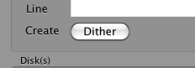
To create pre-packaged dither patterns click on the “Dither” button on the FourStar-Control panel. A panel will appear as shown in Figure 6.23.
The two boxes within the Create-Macro GUI contain the following:
Dither: Defines the dither step details.
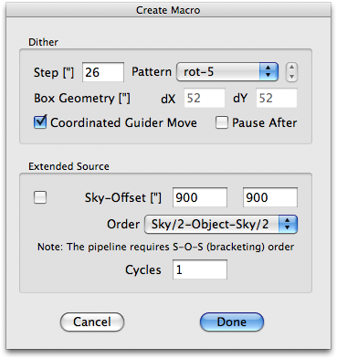
Figure 6.23 Create Macro options box.
- Step [”]: The step size in arc-seconds between dithers; the default is 26 and is generally a good size. There is a 19” gap between the arrays so this will create an overlap.
- Pattern: see Figure 6.24 for example patterns.
  - rot-5: A rotated dice-5 pattern.
  - rot-9: A rotated dice-9 pattern.
  - square-5: A square-5 pattern.
  - square-9: A square-9 pattern.
  - random-N: A random pattern, starting at the current location and returning to the current location
  - poisson-N: A possion random, uniformly spaced dither pattern, starting off the current location.
- Box Geometry [”]: only applicable with the poisson method.
dX: box width of random distribution along the E-W direction
dY: box width of random distribution along the N-S direction.
- Coordinated Guider Move: Select this if you want to use coordinated guider moves. This is used when guiding.
- Pause After: Pause after a move before starting an exposure. Gives the user a chance to verify that the telescope has re-acquired the guide star and everything is okay.
Extended Source: Defines whether to include off-target dithers for background measurements.
- Checkbox: select if you need to move off source to get background; i.e. extended sources.
- Sky-Offset [”]: the amount in arc-seconds to move off source E-W | N-S
- Order: The order to perform the Sky – Object – Sky observations.
- Cycles: The number of times to repeat the S-O-S cycle.

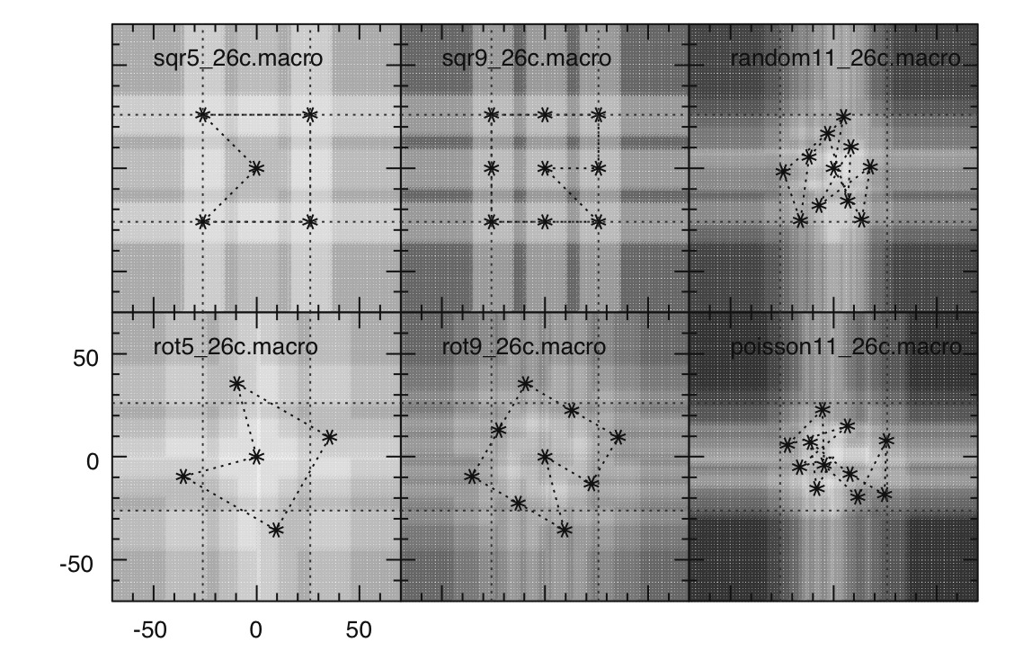
Figure 6.24 Representative dither patterns available.

How to Create or select a custom macro
The default location for macro’s is in the “/Users/fourstar/Library/Application Support/FourStar/” directory, however you can select a macro from any location. Only one command per line and anything following a standard comment card (i.e. #) is treated as a comment and not read. If a command is not valid no warning will be given. Each line does take time to parse so keep the macros simple to improve efficiency.

Macro Commands
guiding 1 # Turn guiding on.
guiding 0 # Turn guiding off.

obstype dark # Set object type to dark. Type must be defined in the menu. Current values:
# test | standard | astro | tflat | sky | dark | dflat
readmode Double # Change read mode to Double. Options are: Reset | Single | Double | Multi N
# where N is an interger of desired fowler pairs.

exptime N # Change exptime to N seconds. N must be a number.
gain LoNoise # Change gain to LoNoise. "LoNoise" must appear as shown in pulldown menu.
gain FullWell # Change Gain to FullWell. If not “LoNoise” then it will default to FullWell.
# i.e. gain k will also set gain to FullWell.

go # Waits until all setting are defined then takes a loop of exposures where the loop
# size is given in the Loops setting.
go N # Waits until all setting are defined then takes a loop of N exposures.

coord -26.0 10.0 # Perform a coordinated offset 26” W and 10” N.
move 10 -26.0 # Perform a non-coordinated offset 10" E and 26" S

filter H # Change FilterCombo to H. Option must appear as shown in pulldown menu.

pause # Pause macro, bring up button to resume when ready.
sleep 10 # Sleep for 10 seconds.
wait # Wait until motion stops.
sync # Wait until motion stops.
exit # Exit the macro. The macro exits at the end so this is really not necessary.

Example macro: rot5_26c
This will use the current ExpTime, Loops, ReadMode, Gain, FilterCombo and obstype as shown the FourStar-Control Panel.
guiding 1
go
coord -9.5 35.5
go
coord 45.0 -26.0
go
coord -26.0 -45.0
go
coord -45.0 26.0
go
coord 35.5 9.5

Example macro: dif2
This is a macro that simply takes an image, performs a coordinated offset, takes another image and returns to the start position; useful for making a quicklook or focus image in FSCOM.
guiding 1
go
coord -10 -10
go
coord 10 10

Example macro: custom
guiding 1 # turn guiding on
exptime 20 # set exptime to 20s
filter J # move to J filter
go 5 # take a loop of 5 images.
coord -26 26 # perform coordinated offset
exptime 10 # change exptime to 10s
filter H # move to H filter
go 10 # take a loop of 10 images
coord 26 0 # perform coordinated offset
filter Ks # move to Ks filter
go # take a loop of 10 images at 10s each (uses last setting and saves time).
coord 0 -26 # perform coordinatec move back to original position.

Read-Out Schemes

The ‘Reset’ mode is an engineering mode that will typically never be used except for diagnostics.

